

**KAMPALA EDUCATIONAL CONSULTANCY (KEC)**0759227628/0781222107

**SOCIAL STUDIES LESSON NOTES FOR PRIMARY SIX TERM 1 - 3**

**TOPIC:LOCATION OF EAST AFRICA.**

* E.A is found in the continent of Africa.
* It’s located in the Eastern geographical region of Africa.
* Countries that make up E.A – Uganda, Kenya, Tanzania, Rwanda and Burundi
* E. Africa lies between Latitudes 40N and 120S and longitudes 270E to 420E.

**UGANDA**

* Uganda has a total area of 244,000sqkm, the smallest.
* It is a land locked country.
* H.E Yoweri Kaguta Museveni is its president.

**KENYA**

* Total area of 585,000 sqkm
* Second largest country in E.A.
* President is H.E Uhuru Kenyatta
* Capital city is Nairobi
* It is not a land locked country.
* Main sea port is Mombasa
* Kenya is the most industrialised country in E.A

T**ANZANIA**

* Total area of 943,000 sqkm.
* Tanzania is the biggest among the E.A countries.
* Capital city is Dodoma.
* Main sea port is Dar-es-salaam
* President is Jakaya Morisho Kikwete
* Islands which are part of East Africa Pemba, Zanzibar and Mafia.

**BURUND**I

* Total area of 27,830 sqkm
* It is a land locked country
* Capital city is Bujumbura
* Current president is H.E Pierre Nkurunziza

**RWANDA**

* Total area of 26,338sqkm
* It is the smallest country in the E.A region
* \it is a land locked country
* It’s capital city is Kigali
* Current president is H.E. Paul Kagame

NB:

East Africa is boarded by 7 countries

Tanzania, Rwanda, and Burundi are countries in East Africa that lie in the southern hemisphere.

**NEIGHBOURS OF EAST AFRICA**

|  |  |  |
| --- | --- | --- |
| **DIRECTION** | **COUNTRY** | **CAPITAL CITY** |
| North | South Sudan  Ethiopia | Juba  Addis Ababa |
| South | Mozambique | Maputo |
| West | DRC | Kinshasha |
| North east | Somalia | Mogadishu |
| South West | Malawi  Zambia | Lilongwe  Lusaka |

* Indian Ocean borders the Eastern part of East Africa.
* Major latitude that crosses East Africa is the equator passing through Uganda and Kenya.
* The equator in Uganda crosses Lake Victoria and George.
* The districts crossed by the equator include: Wakiso, Kasese, Kalungu, Kiruhura, Ibanda etc.
* The equator divides Kenya into almost two equal halves

**THE MAP OF EAST AFRICA SHOWING THE NEIGHBOURS SIZE AND POSITION**

**Lesson Three**

**LATITUDES AND LONGITUDES**

* Reviewing the definition of latitude as a distance of a place from the equator.
* Latitudes are imaginary lines drawn on a map running from East to West.
* Latitude is the distance North or South of the Equator.
* Longitudes are imaginary lines drawn on a map running from north to South.
* Longitude is the distance East or West of the prim meridian

The major latitudes include

* Equator - 0**0**
* Tropic of cancer 23½ ̊ N
* Tropic of capricorn 23½ ̊ N
* Others are Arctic Circle 66½ ̊N and Antactic circle 66½̊ S

**IMPORTANCE OF THE EQUATOR**

It determines the climate of an area.

The equator divides the world into two equal parts.

The equator determines how far North or South a place is i.e. (It is where latitudes readings begin from)

The equator is marked 0**0** because the numbering of all latitudes starts from it.

**THE DIAGRAM SHOWING MAJOR LATITUDES**

Arctic circle – 66½0N

Tropic of cancer 23½ ̊ N

Equator 0 ̊

Tropic of Capricorn

23½ 0S

**66½0S**

**LONGITUDES.**

1. Longitudes are imaginary lines on a map running from north to south.
2. Major lines of longtudes include; Green wich meridian (prime meridian) 0° and International date line-180 East or West

**A DIAGRAM SHOWING LONGITUDES.**

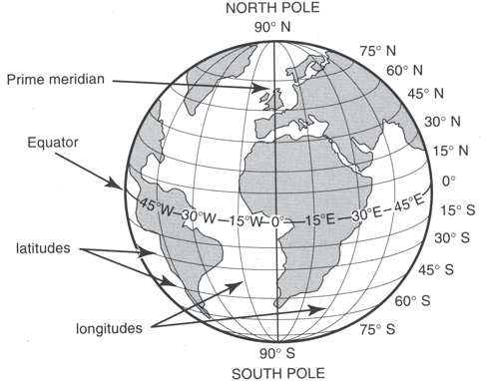

* The prime meridian divides the world into the Eastern and western hemispheres
* It is also used to determine international time
* The International Date Line is used to determine day and dates**.**
* The prime meridian is also called Green witch Meridian because it passes through a town called Greenwich in London (England)
* In Africa it passes through Accra City in Ghana.
* Other countries crossed by the prime – meridian

Include: -

1. Algeria
2. Mali
3. Burkino Faso

**Importance of longitudes**

* They determine how far a place is East or West of the Greenwich.
* Prime meridian is used to determine international time
* The IDL is used to determine days and dates.

**Importance of Latitudes**

* They determine how far a place is North or South of the equator.
* The equator is used t determine climate of an area
* NAB: Both longitudes and latitudes are used to locate places on a map.

**Calculating time**

* Time is calculated from the Greenwich meridian
* Every 150 make an hour, therefore 10 = 4 minutes.
* The world is divided into 24 divisions called Time Zone and each time zone is 150 apart.

NB: A time zone is a region on the globe that experience the same standard time

* East of the Greenwich meridian, we add time while west of the Greenwich, we subtract time.
* East Africa’s time zone is called East African standard time (CEAST)

Example 1

The time in Ghana is 10:00am. Wht time will it be in Uganda which is 450 East?

15 = 1hour

450 = 450

150

= 3 hours

Since East we add 3 hours + 10:00am

Hrs. Min. 13:00

10 00 - 12:00

3 00 1:00pm

13 00hrs

Example 2

The time in Accra is 1:00p.m.

What is the time in Gabon which is 300 East?

15 = 1hour

300 = 300

150

= 2 hours

Since East we add 2hours + 1:00am

Hrs. Min.

1 00

+ 2 00

3 00p.m

Example 3

It is 6:00am in Accra. What time will it be in Liberia 300 West?

150 = 1hour

300 = 300

150

= 2 hours

Since West we subtract 6:00 – 2 hours add 2 hours + 1:00am

Hrs. Min.

6 00

+ 2 00

4 00a.m

**EXAMPLES.**

Its 10:00 am at the GMT.What time will it be if one moves 30° E.ie

$\frac{30}{15}$ =2hrs.

Since movement is to the East.we add 2 hours to the original time

10:00am

⁺02:00

12:00 noon.

The time in Nairobi Kenya is 12:00pm.What time will be if one moves 45° W of the prime meridian.

Working

Time in Nairobi=12:30pm

Time change in 45°

= $\frac{45}{15}$ =3hrs

12:00pm

−03:00∙

09:30am

**QUESTIONS.**

1. Write the following in full

A) GMT b) I.D.L

2. Why doesn’t Rwanda experience the same time with Uganda yet they are neighbours.

3. What is meant by the term time Zone?

4. The time in Accra Ghana is 9.00am. What will it be in Somalia which is 30°E?

5. The time Dodoma is 11:45am.What time will it be in a place which is 60° W.

**MOVEMENTS OF THE EARTH**

**Rotation of he Earth**

* The Earth rotates on its axis from west to East.
* An axis is an imaginary line that cuts through the Earth from the north pole to the south pole.
* It takes 24hours (1 day( for the Earth to make a complete rotation.
* The rotation of the Earth causes day and night.
* It also cause deflection of winds and ocean currents.

**Revolution of the Earth**

* Is the movement of the earth around the sun.
* It takes 365 ¼ days for the earth to revolve around the sun
* This is called a ordinary year.
* The forth year of every four yeast has 366 days
* This is called a leap year
* The revolution of the earth cause seasons i.e.summer, winter, autumn and spring.
* On 21st March and 23rd September, the sun is directly overhead the Equator.
* On these two dates the earth gets equal days and nights i.e. Equinox.
* On 21st June, the sun is overhead the tropic of cancer
* The northern hemisphere will have the summer season while the southern hemisphere will have winter.
* On 22nd December the sun is directly overhead the tropic of Capricorn. The southern hemisphere will experience summer while the Northern hemisphere will experience winter.

**PHYSICAL FEATURES IN EAST AFRICA.**

Physical features are natural land forms of an area.

**EXAMPLES OF PHYSICAL FEATURES IN EAST AFRICA.**

* High lands /mountains
* Rift valley
* Plataeu
* Coastal plains
* Lakes and Rivers
* Plains and inselbergs.

**THE MAP OF E. AFRICA SHOWING MAJOR PHYSICAL REGION.**

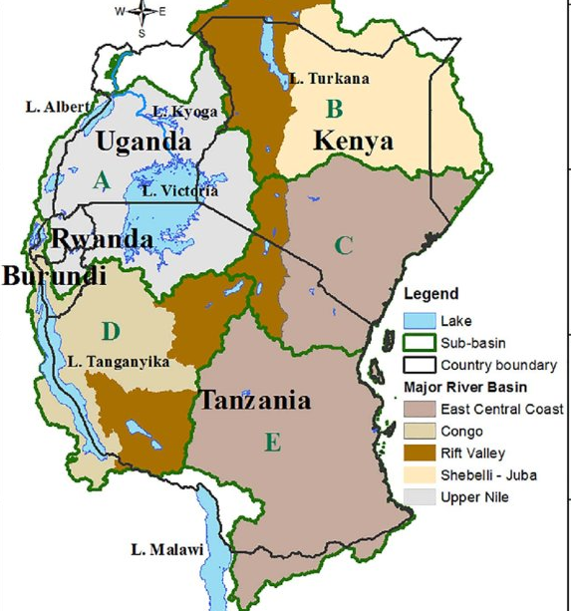

Questions.

1. What are physical features?
2. Mention five examples of natural lands forms inE.A.
3. Identiy any two physical features found on the border of Uganda and DRC.

**HIGHLAND MOUNTAINS**

* These are regions raised between 3000m-5000m above the sea level.
* They are categorised into two depending on their formation ie volcanic and block/horst.

**VOLCANIC MOUNTAINS**;

* These were formed as a result of volcanic eruption.
* Volcanicity is the proccess by which magma (molten rocks) erupts from underground into the earth crust.

**EXAMPLES OF VOLCANOES**.

* Mt.Elgon
* Mt.Mufumbirro
* Mt.Kilimanjaro
* Mt.Moroto
* Mt.Meruetc

Other features formed as a result of volcanicity are;

* Plugs eg Tororo rocks.
* Crater egL.Katwe, Ngorongoro, and Mt.Elgon crater.
* Hot springs egkitagata, Nakuru Hot springs, Sempayahotsprings
* Lava plains.

**TYPES OF VOLCANIC MOUNTAINS IN E.A.**

* Active volcanic mountains (mts that may erupt any time).egmt.Mufumbiro.
* Dormant (sleeping) volcanic mountains (mountains which erupted in the last 500 years and might still erupt in future).eg.Mt.Kenya, Mt.Kilimanjaro, Mt. Meru.
* Extinct (dead) volcanic mountains (mountains which have stoppederupting) egMt.Elgon, Mt. Moroto.

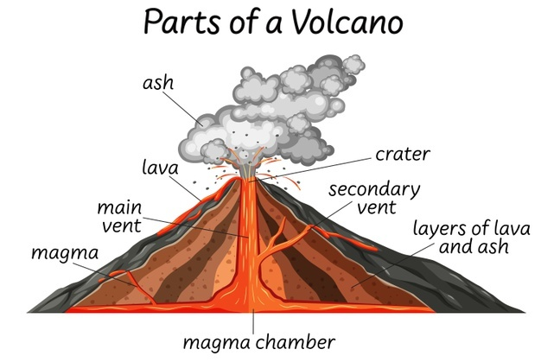

**QUESTIONS**.

1. What is meant by the term volcanic mountains?

2. Identify any two volcanic mountains found inE.A.

3. Why is it not advisable for people to stay near an active volcano?

4. What is Magma?

**BLOCK MOUNTAINS IN E.A.**

* These are mountains which were formed as a result of faulting.
* Faulting is the breaking/cracking the rocks of the earth due to the influence of underground forces.
* Block mountains are sometimes called Horst mountains.

**EXAMPLES OF BLOCK MTS/HORST MTS.**

* Mt.Rwenzori in Uganda.
* Usambara ranges in Tanzania.
* Ulunguru mts in Tanzania.
* Mt. Nyeru in Kenya
* Mt. Rungwe in Tanzania
* Mt. Kipengere in Tanzania

**FORMATION OF BLOCK MOUNTAINS**.

There are two theories that explain the formation of the block mts.

* Tension theory
* Compression theory.

1. **TENSION THEORY**

* It stresses the formation of Block Mountains due to tension forces underground.
* The tension forces pulls the rocks underground apart which causes the central block to remain still while the side block sink thus leading to the formation of horst mts.

**DIAGRAM SHOWING THE FORMATION OF BLOCK MTs**

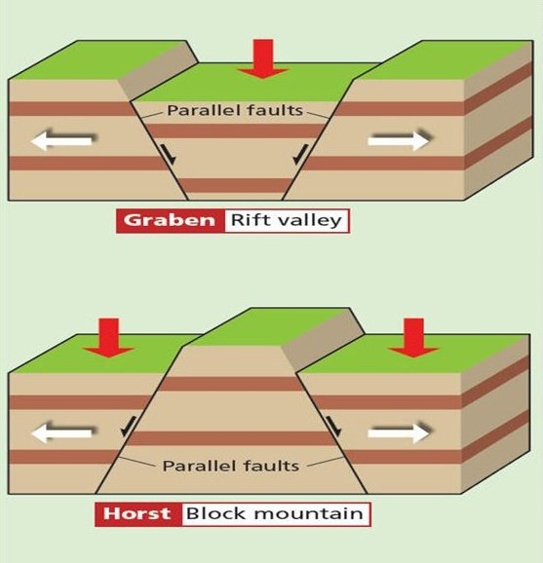

B) **COMPRESSION THEORY**

* It stresses the formation of horst mountains due to Compression forces underground.
* These forces push the rocks underground from opposite direction causing the middle block to be uplifted and weakens other rocks around it which areeroded hence causing the formation of Block Mountains.
* Other features formed by aprocess of faulting are;

1. Rift valley
2. Escarpment
3. Fault lakes(rift valley lakes )

**DIAGRAM SHOWING THE FORMATION OF BLOCK MOUNTAINS USING COMPRESSION THEORY.**

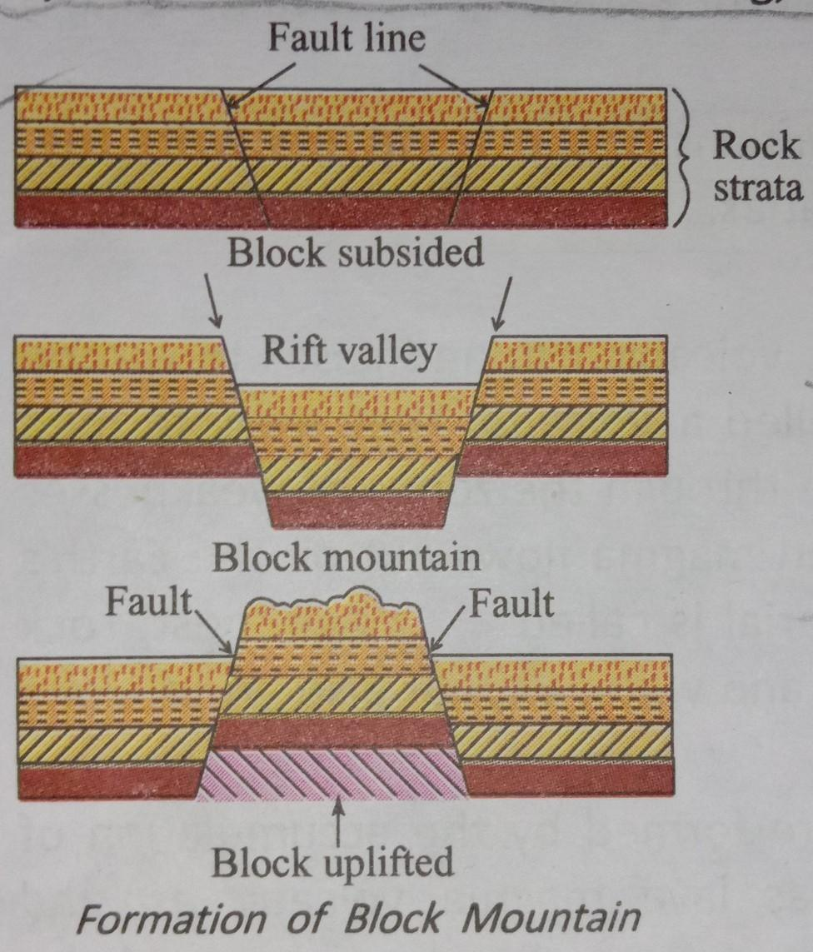

**IMPORTANCES/VALUES OF HIGHLANDS**.

* They help in the formation of rain.
* They are used as mining places.
* They serve as a natural boundary between countries.
* They have features of tourist attractions.
* They are used to construct communication boosters.
* Some Mt. slopes are used for farming.
* They are sources or some rivers.

**PROBLEMS FACING PEOPLE WHO LIVE NEAR MTS.**

* Severe soil erosion
* Landslides
* Barriers to good road network(make road construction difficulty)
* Some active volcanoes may erupt causing death and destruction of property.
* They hinder agricultural mechanisation since there steepy.
* They hinder people settlement.

**Questions.**

1. How was the formation of mt.kilimanjaro similar to that of mt.Kenya?

2. What common feature is found on top of dormant volcanoes?

3. How is the formation of mt.Usambara different from that of mt.Moroto?

4. Give one way in which mts hinder the development of agriculture.

5. State the political importance of mts to EastAfrican countries.

6. State any two economic values of mts in E.Africa.

7. How do mts affect the development of transport system?

**RIFT VALLEY**

* This is along depression on the earth surface with steep called Escarpements. It was formed by faulting.
* The Great African rift valley stretches from Jordan in Asia and enters Africa through Ethiopia and lake Turkana in E. Africa.
* It is divided into two arms (branches) ie.Eastern and western arm.
* The Eastern arm stretches frromL.Turkana in the north to L.Malawi in the south and ends in R.Zambezi in Mozambique.

**Characteristics of a rift valley**

* It is long
* It is wide
* It has steep sides called escarpments.

**LAKES FOUND IN THE EASTERN ARM.**

L.NakuruL.Baringo L. Naivasha

L.Eyasi L. Magadi L. Natron

L.Magadi L. Manyara

L.Natron

* The western arm starts from north of L. Malawi up to the point of Albert.
* Lakes found in the western arm include;

1. L.Tanganyika.
2. L.katwe(though is a crater lake)
3. L.kivu
4. L.Albert
5. L.Edward.
6. Lake George

**NOTE**

The steep sides of a rift valley are called escarpments eg.Butiaba and the Mau escarpments in Kenya.

**ACTIVITIES DONE IN THE RIFTVALLEY;**

1. Fishing
2. Mining
3. Tourism
4. Transport
5. Farming (pastoralism)

**NOTE.**

* The Great EastAfrican rift-valley is one of the physical features shared by the E.African countries .In addition to L.Victoria and East African plateau.
* It is not suitable for human settlement due to warm temperatures experienced there caused by low latitude.

**A DIAGRAM SHOWING THE FORMATION OR THE RIFT VALLEY**.

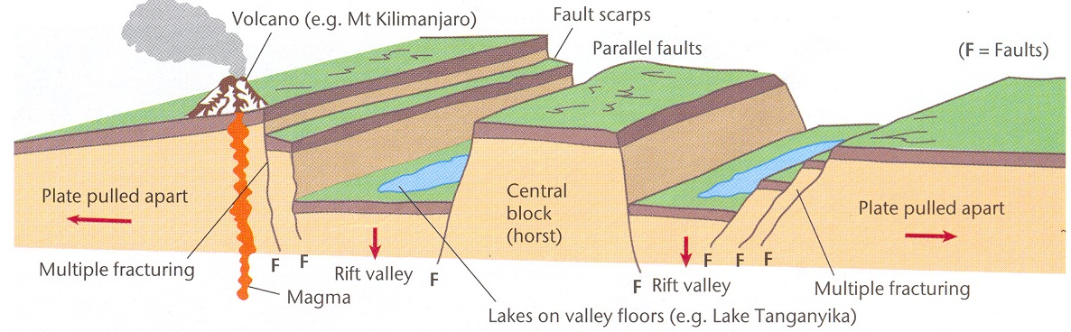

**THE PLATEAU**

* A Plateau is a fairly a raised flat topped piece of land.
* It is sometimes called a table land because of its raised nature and flat top.
* The top of the plateau is interrupted by hills and low lands.
* There are also rivers, lakes in low lands and valleys on the plateau.
* The plateau of E.Africa is divided into two namely;

a**) THE EASTERN PLATEAU**

It occupies Eastern and southern Kenya and comes immediately after the coastal plain its commonly known as Nyika plateau in Kenya and Foreland plateau in TAnzania.

B) **THE CENTRAL PLATEAU**;

It lies much in the central and western part of Basement complex.

**NOTE;**

**ACTIVITIES DONE ON THE PLATEAU REGIONS OF EAST AFRICA.**

* Farming
* Fishing
* Lumbering
* Trade
* Industrialization
* Transport and communication
* Settlement

NB: Nyika means wilderness or open grassland

**A CROSS- SECTION OF THE EAST AFRICAN RIFT VALLEY PLATEAU.**

Ref: Fountain SST book 6.page 8 fig, 5.

**COASTAL PLAINS OF E.AFRICA**

* This refers to the narrow strip or edge of land which boarders the Indian Ocean.
* It widens to the north of Mombasa and south of Dar-es-salam and is about 64km wide and 18m above the sea level.
* It separates the Indian Ocean from the Eastern plateau
* It also contains the island of Pemba, Zanzibar and Mafia.

**FEATURES FOUND ON THE COASTAL PLAINS**

* Rivers
* Coral reefs
* Coastal harbours.
* Beaches
* Sea ports
* Oil refinaries

A Coral reef is limestone rock formedfrom skeleton of dead tiny marine animals called polyps.

* Provides limestone used for making cement
* Serve as a coastal harbour
* Its used for Tourism

Dangers of coral reefs

* Can hinder transport on water

**ACTIVITIES DONE IN COASTAL PLAINS.**

1. Trade
2. Mining
3. Oil refining
4. Tourism
5. Transport and communication.
6. Fishing
7. Lumbering
8. Farming

**QUESTIONS.**

1. Identify four major reliefs regions of E.Arica.

2. Give any two economic values of coral reefs to E.A.

3. State any two economic values of the coastal plains to the people of E.A.

4. Mention two tourist attractions found at the coast of E. Africa.

5. How are coral reefs a hindrance to water transport?

6. Why is Mombasa hotter than Mbale?

**LAKES OF EAST AFRICA**.

A lake is a depression or ahallow on the earth’s surface filled with (by) water.

**EXAMPLES OF LAKES**.

1. L.Victoria
2. L.Tanganyika.
3. L.Kyoga.
4. L.Magadi
5. L.Wamala
6. L.Nabugabo
7. L.Turkana

**TYPES OF LAKES IN E.A.**

1. Depression (basin) lakes/down warped lakes; these can also be called down warping lakes.They were formed by the process of down warping.eg.

1. L.Victoria
2. L.Kyoga
3. L.Kwania
4. L.Amboseli in Kenya.

**CHARACTERISTICS OF BASIN/DEPRESSION LAKES.**

* They have fresh waters because they have outlets.
* They are wide.
* They are Shallow.
* They have swampy surroundings.
* They have irregular shape

**2. RIFT VALLEYLAKES/FAULTY LAKES**

* They are found on the rift valley floor.
* They were formed by the process of poultry.

**Examples.**

1. L.Tanganyika
2. L.Turkana
3. L.Albert
4. L.Edward.

**CHARACTERISTICS OF RIFT VALLEY LAKES**

* They are deep.
* They are long and narrow.
* They have salty water because they don’t have outlets.

Some rift valley lakes have fresh waters b’se they have outlets eg.L.Naivasha, L.Tanganyika, L. Albert, and .L.Malawi.

**TYPES OF LAKES**

**CRATER LAKES.**

These are lakes formed by volcanicity.They are commonly found on top of dormant or deadvolcanoes.

**Examples of crater lakes;**

1. L.Ngorongoro.
2. L.Katwe
3. Mt.Muhavura Crater Lake.
4. Mt .Elgon crater lake

Some times crater lakes can be reffered to as calderas when secondary eruption takes place and they become wide.

**DIAGRAM SHOWING A CRATER LAKE.**

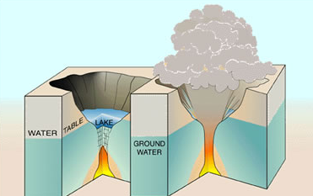

**LAVA DAMMED LAKES.**

These are lakes formed when lava blocks water from the main stream which makes water to be collected in one area/place.

**Examples of lava Dammed lakes.**

1. L.Bunyonyi-deepest in Uganda.
2. L.Bulela
3. L.Mutanda.

**MAN MADE LAKE;**

These are lakes formed by acivities of man eg. Dam construction, brick making, digging, ponds etc.

**Examples**

1. Kabaka’s lake.
2. Kajjansi lake
3. Namungongo Lake.

**OX-BOW LAKES**.

These are lakes formed by rivers meander and deposition.

Oxbow lakes can be seen along river Semliki and river Rwizi

**VALUES OF LAKES TO MAN.**

* They help in formation of rain.
* They attract tourists
* Some are used for mining of minerals.
* They are used for transport.
* They provide water for domestic and industrial use.
* Promote trade between territories.
* They are fishing grounds
* Lake shores are sources of sand

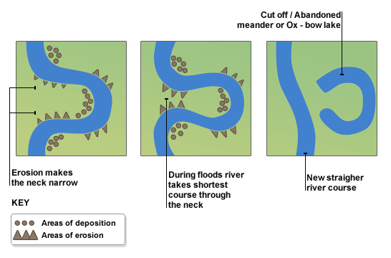

**MAP SHOWING LAKES IN EAST AFRICA**

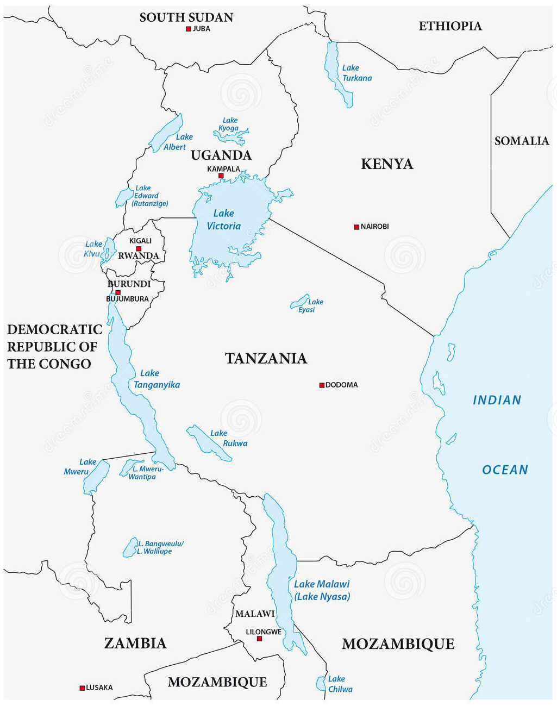

**QUESTION.**

1. Why do many tourists prefer visiting lakes of E.Africa?

**RIVERS OF EAST AFRICA;**

A river is a mass of flowing water on the earth’s surface.

**TERMS USED IN RELATION TO RIVERS;**

1. Source-starting point of A RIVER

2. Tributary-small River joining the main river.

3. Distributaries-small rivers branching off the main rivers.

4. Delta –Division of a river into several channels at its mouth.

5. Confluence Is where two or more rivers meet.

6. Estuary- A wide river mouth.

7. Mouth-End point of a river.

**STAGES OF RIVERS;**

A river is mainly categorised into three major sections naamely.

1. **Upper course (Youth stage)**

* This is the stage where river starts from and normally located on higher altitude.
* Water flows at fast speed in a v-shaped valley
* There is much erosion due to fast flow of water.
* This stage of a river is suitable for H.E.P.generation.

B) **Middle course (Mature stage)**

Is the second stage of a river -.A river changes its shape from V to U shape.The water begins to reduce its speed due to the increased width of the river.

Meanders start developing

|  |  |  |
| --- | --- | --- |
| **UGANDA** | KENYA | TANZANIA |
| R. Katonga | R. Tana | R. PAngani |
| R. Nile | R. Galana | R. Ruvuma |
| R. Kafu |  | R. Rufiji |
| R. Ssezibwa |  |  |
| R. Nkusi |  |  |

C**) Lower course (old stage).**

Water flows at reduced Speed characterised by flood plains, many meanders are seen/developed and Ox-bow lakes are formed in this stage due to a high level of deposition.

Characterised by deltas and estuaries.

**TYPES OF RIVERS;**

There are two types of rivers in E.Africa and these are;

1. Permanent rivers
2. They flour throughout the year.
3. Rivers which flow season to season throughout the year.

**Examples of permanent rivers**

* R. Nile
* R. Rufigi
* R. Pangani
* R. Galana

**EXAMPLES OF SEASONAL RIVERS**

* Rivers which only flow during wet season.ie

1. R.Mpongo and Agogo in Uganda.
2. R.Laghorn and Turkwel in Kenya.

**FORMATION OF RIVERS IN E. AFRICA.**

Most rivers in E.A originates from highlands and large water bodies which are on a higher altitude. some rivers in E.Africa changed their flowing direction long ago due to earth’s movement i.e. uplifting of the western plateau in Uganda made river Kafu, Kagerato flow east wards, it also made river Nzoia, Yala and Mara to flow west wards and drain into L.Victoria.

**NOTE**

* Many rivers originate from highlands areas because of too much rainfall experienced in these regions and melting Ice.
* Most rivers in E.A are not navigable because of many water falls and rapids, some rivers are seasonal.

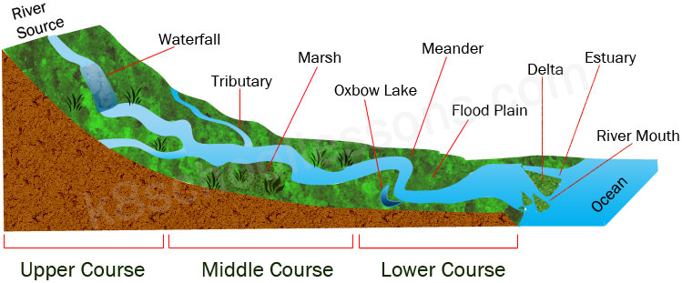

**MAJOR RIVERS OF E. AFRICA.**

A**) R.NILE;**

* It is believed that R.Nile has its source in L.Victoria near Jinja.
* It flows from the south to Northern direction b’se of the plateau of Uganda is tilted/slightly bent to north of Uganda. (Its source is at a higher altitude.)
* It is longest river in the world and Africa in particular.
* It is divided into 3 parts/sections ie Victoria Nile from its source to Albert Albert Nile from L. Albert to Nimule.
* It’s greatly affected by sudds (floating vegetation) in Sudan which greatly hinders navigation.
* It drains through two lakes in Uganda ieL.Kyoga and L.Albert and ends into the Mediterenean Sea in Egypt.

**TRIBUTARIES OF R.NILE;**

* + Bahr-el-Ghazal in south Sudan
  + R.Sobbat from Ethopia.
  + Blue Nile from L.Tana in Ethiopia
  + R. Atbara from Ethopia.
* In Uganda itsdifficult to sail on R.Nile because of;

1. Presence ofwaterfalls and rapids.
2. Resistant hard rocks.

**QUESTIONS.**

1. Give two reasons why navigation on R.Nile between L.Victoria and Albert is difficult.

2. State the economic contribution of R.Nile to industrial development in E.A

3. Name the section of R.Nile where we find Karuma and Murchission falls.

4. Why does the Nile flows towards the northern direction.

5. Mention the two dams located on R.Nile in Uganda.

6. Name the European explorer who was the first to see the source of the Nile.

**RIVER TANA**;

* It starts from the eastern plateau of Kenya and drains into the Indian Ocean.
* It is the main river in Kenya.

A number of dams have been built, they are about seven to generate H.E.P.These are reffered to as Seven folks dam project.

**RIVER RUFIJJI.**

* It starts from the eastern plateau, flows across the coastal plains and drains into the Indian Ocean.
* Other rivers found in Tanzania are; R.Pangani, R.Ruvuma, which makes a boundary between Tanzania and Mozambique.
* On River Rufigi we find Kidatu dam and Fmteradam.

**RIVER KAGERA.**

Kagera originates from Nothern side of L. Tanganyika and drains into L. Victoria. It forms a natural boundary between Tanzania and Uganda as well as Rwanda.

**IMPORTANCE OF RIVERS TO PEOPLE IN E. ARICA.**

* They help in the formation of rainfall.
* They provide water for irrigation.
* They attract tourists.
* They are sources of fish
* Some are used to generate HEP.
* Used for recreation.

**PROBLEMS ASSOCIATED WITH RIVERS AND LAKES**.

* They are breeding places for vectors.
* They can cause seasonal flooding.
* They harbour dangerous water animals.

**QUESTIONS.**

1. Which river forms a natural boundary between Tanzania and Mozambique?

2. Identify the importanceof physical features to man.

3. State any one in which physical features inlfluence each of the following;

1. People 2. Plants 3. Animals

4. How do lakes and rivers contribute towards national development?

**TROPICAL QUESTIONS ON LOCATION OF EAST AFRICA.**

1. State the difference between latitudes and longitudes.
2. List down any two important latidtudes drawn on the map.
3. Point out any two ways of locating places on a map.
4. What is the grid reference of E. Africa on the globe?
5. Which countries border E. Africa on the following directions
6. South West
7. North
8. Why is Uganda referred to as a Land locked country?
9. Which city in Africa is crossed by the Greenwich meridian?
10. Henry is standing at the Park facing the North direction. If he turned 45 ̊clockwise, which new direction will he face?
11. Name any two physical features in E. Africa that are crossed by the Equator?
12. If it 2:00pm at the Greenwich, what time of the day will it be at town R which s 45 ̊E of the Prime Meridian?
13. Apart from telling time, state any other importance of longitudes.
14. Define the term time zone.
15. Write the following abbreviations in full
16. GMT
17. E.A.S.T
18. Give one reason why people in Mombasa see the sun earlier than the people in Kabale.
19. How is the location of Uganda said to be a disadvantage to its economic development?

**REGIONAL GROUPINGS IN EAST AFRICA**

Regional economic groups are also known as common markets.

A common market: is an area where goods, capital services and other factors of production are able to move freely.

**Examples of common markets in E. Africa**

EAC – East African Community

COMESA – Common Market for East and Southern Africa

IGAD – Inter-Government Authority on Development

SADC - Southern African Development Community. It is only Tanzania which is a member.

**Reasons why countries need economic cooperation**

* To promote peace and unity
* To promote friendship, and cooperation
* To ease trade by creating a wider market
* To allow free movement of people and goods
* To promote transport and communication
* To promote industrial growth

**The East African Community**

Background

It started as the East African High Commission in 1948. The headquarters of East African high Commission were in Nairobi, Kenya

Departments run by eh EAHC include;

* East African Railways and harbours
* East African literature bureau
* East African posts and telegrams
* East African income tax department
* Higher education
* Research institution etc

In 1961, Tanganyika withdrew from the commission after becoming independent.

There East African high Commission therefore collapsed.

Later in the same year (1961).The three countries formed the East African Common service organization with its headquarters in Nairobi (Kenya)

It was in operation from 1961-1967. The heads of state formed yet another organization called the East African community.

The East African Community (1967-1977)

* In 1967, the heads of state for Uganda, Kenya and Tanzania met and decided to form the East African Community.
* It was only a body set up to unite the three countries in common matters of interests such as trade, peace, transport and communication.
* The headquarters were set up in Arusha in Tanzania.

Why the cooperation was possible

* The 3 countries being in he same region were close neighbours.
* The 3 state s have the same history that at one time they had been under the control of Britain.
* The 3 countries had gained their independence from colonial rule.

**Founder members of the EAC**

* Dr. Apollo Milton Obote – Uganda
* Mzei Jomo Kenyatta – Kenya
* Mwalimi Julius Nyerere – Tanzania

**Objectives of the EAC**

* To create a wider market for goods from member states.
* To promote peace, unity and cooperation
* To equally share the services of former East African Common Services organization
* To establish similar currency value by validating each country’s currency
* To promote transport and communication
* To establish similar tariffs, customs among the member states.

**Organs of the EAC**

1. The secretariat (Arusha)

* It was responsible for daily running of the community
* It was headed by the secretary general
* The first and last secretary was the Biginvenkya from Uganda

1. The East African Legislative Assembly (Arusha)

It had 36 members. Each country was represented by 9 members elected from the home parliament. It acted as a law making body.

1. The Authority

It was made up of the 3 heads of states ffrom member states

It was charged with general direction and control of the community affairs.

1. The East African court of appeal

It was the highest legal organ. It was responsible for hearing appeals from courts in 3 East African states.

1. The committee of minister

Each member state had 1 minister and a representative to this committee.

**Services provided by the EAC**

* The East African development bank
* Its aim was to provide financial and technical help to member states
* To promote balanced industrial growth through loans.
* Its headquarters were in Kampala.
* East African posts and telecommunication. Its headquarters were in Kampala (function)
* East African railways and harbours (Mombasa)
* The East African examinations council
* The East African school of librarianship (MUK)
* East African harbours cooperation ( Dar-es-salaam)
* East African literature bureau, metrological department and income tax (Nairobi)
* Virus research institution (Entebbe)
* Fresh water fisheries research (Jinja)
* East African civil aviation authority (Soroti )
* East African trypanasomiasis research (Muguga- Kenya)

Note: When the East African Community collapsed in 1977

All the above collapsed except;

* East African Developmetn bank
* East African school of librarianship
* East African civil aviation authority

**Benefits of the EAC to member states**

* It encouraged free movement of goods and people in the region
* There was cooperation , peace nad unity
* It started industrial projects through the EADB
* It encouraged free trade among the member states
* Projects set up provide jobs to people.

**Why the EAC collapsed in 1977**

* Countries failed to contribute to the central treasury
* Different political ideas among heads of state
* Nationalizations of community assets in Kenya and Tanzania
* Misunderstandings among the heads of state especially Amin and Nyerere
* Counter accusation and insecurity which had to border closure
* Harassment of Kenyans in Tanzania intensified hostility

**Revival of the EAC**

It was revived in 1994 by the heads of the three states of East Africa. The treaty to revive the cooperation was signed on 30th Nov 1990 in Arusha.

The following heads of states signed the tripartite treaty

I – Yoweri Kaguta Museveni – Uganda

ii- Daniel Arap Moi – Kenya

iii-Banjamin Mkapa – Tanzania

In 2001, the cooperation became the East African community. On 18th June 2007, the republic of Rwanda and Burundi signed the treaty to join the EAC

their representative were;

Paul Kagam – Rwanda

Pierre Nkurunziza – Burundi

Organs of the revived EAC

1. **The summit**

It consists of heads of states from member states. It gives the general direction to the development of the community.

The summit meets once a year to discuss annual progress reports.

1. **The council of ministers**

It designs policies of the community

It consists of the ministers responsible for regional cooperation from member states

It promotes monitors and keeps under constant review of the implementation of the community programmes.

1. **The secretariat**

It is the executive organ of the community. Its headquarters are in Arusha in Tanzania.

It is headed by the secretary general assisted by the three deputy secretary generals.

The current Secretary general is [Peter Mathuki](https://en.wikipedia.org/wiki/Peter_Mathuki) of kenya

1. **The East African legislative assembly**

It’s the law making organ of the community

Each member states elects 9 members making a total of 45 elected members and 7 ex-official members.

The current speaker of EALA is [[Rwanda](https://en.wikipedia.org/wiki/Rwanda)](https://en.wikipedia.org/wiki/Rwanda) [Martin Ngoga](https://en.wikipedia.org/wiki/Martin_Ngoga) from Rwanda

1. **The East African court of justice**

It tries cases from the courts of the member states.its the highest judicial court among member states

1. **The coordination committee**
2. **The Sectoral Committee**
3. **Autonomous institution e.g. EADB , East African school of librarianship**

Note: The current chairman of EAC is Uhuru Kenyatta

The current secretary general is [Peter Mathuki](https://en.wikipedia.org/wiki/Peter_Mathuki) of kenya

Note: The smallest country in the EA parliament is Rwanda

**Uganda’s representative in the EA parliament**

|  |  |  |
| --- | --- | --- |
| Christopher Opoka-Okumu | Uganda |  |
| [Susan Nakawuki](https://en.wikipedia.org/w/index.php?title=Susan_Nakawuki&action=edit&redlink=1) | Uganda |  |
| [Fred Mukasa Mbidde](https://en.wikipedia.org/wiki/Mukasa_Mbidde) | Uganda |  |
| Odongo George Stephen | Uganda |  |
| Namara Dennis | Uganda |  |
| Musamali Paul Mwasa | Uganda |  |
| Kasamba Mathias | Uganda |  |
| [Rose Akol Okullu](https://en.wikipedia.org/wiki/Rose_Akol_Okullu) | Uganda |  |
| [Mary Mugyenyi](https://en.wikipedia.org/wiki/Mary_Mugyenyi) | Uganda |  |

**Benefits of he revived EAC to member states**

* It helps to create jobs for member states
* It had helped to create a large market for goods
* It has helped to promote peace and unity in SA
* It has introduced free movement of workers and goods

**The current heads of states for EAC**.

| **Name** | **Capital** | **Accession** | **Population**[[39]](https://en.wikipedia.org/wiki/East_African_Community#cite_note-imf_data-39) | **Area (km2)**[[38]](https://en.wikipedia.org/wiki/East_African_Community#cite_note-cia_area-38) | **Head of State** |
| --- | --- | --- | --- | --- | --- |
| [Kenya](https://en.wikipedia.org/wiki/Kenya) | [Nairobi](https://en.wikipedia.org/wiki/Nairobi) | 2000 | 48,756,000 | 580,367 | [**Uhuru Kenyatta**](https://en.wikipedia.org/wiki/Uhuru_Kenyatta) |
| [Tanzania](https://en.wikipedia.org/wiki/Tanzania) | [Dodoma](https://en.wikipedia.org/wiki/Dodoma) | 2000 | 51,605,000 | 947,300 | [**Samia Suluhu**](https://en.wikipedia.org/wiki/Samia_Suluhu) |
| [Uganda](https://en.wikipedia.org/wiki/Uganda) | [Kampala](https://en.wikipedia.org/wiki/Kampala) | 2000 | 45,319,000 | 241,038 | [**Yoweri Museveni**](https://en.wikipedia.org/wiki/Yoweri_Museveni) |
| [Burundi](https://en.wikipedia.org/wiki/Burundi) | [Gitega](https://en.wikipedia.org/wiki/Gitega) | 2007 | 9,879,000 | 27,830 | [**Évariste Ndayishimiye**](https://en.wikipedia.org/wiki/%C3%89variste_Ndayishimiye) |
| [Rwanda](https://en.wikipedia.org/wiki/Rwanda) | [Kigali](https://en.wikipedia.org/wiki/Kigali) | 2007 | 11,887,000 | 26,338 | [**Paul Kagame**](https://en.wikipedia.org/wiki/Paul_Kagame) |
| [South Sudan](https://en.wikipedia.org/wiki/South_Sudan) | [Juba](https://en.wikipedia.org/wiki/Juba) | 2016 | 13,137,000 | 644,329 | [**Salva Kiir**](https://en.wikipedia.org/wiki/Salva_Kiir) |

**Challenges of EAC**

* Production of similar goods leads to shortage of market
* Shortage of funds among member states
* Member states are at different levels of economic development
* Language barrier
* Different currency values there is still absence of a standard currency to be used by the community.
* Different political ideologies

**Major trading partners of he East African Community**

* Japan
* China
* The European Union member states
* The United Arab Emirates
* Saudi Arabia

**Symbols of the East African Community**

* The East Africa Community flag
* It has 6 colours i.e. blue, white, black, green, yellow and red.
* The blue colour represents Lake Victoria

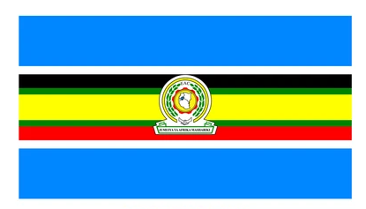

**The coat of arms**

* It has olive branches which represent peace

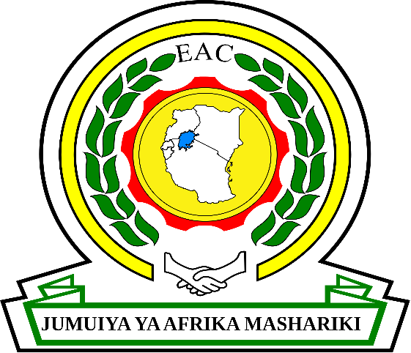

**Note to teachers**

* Research on symbols of a nation for i.e. Uganda, Tanzania , Burundi, Rwanda and Kenya
* Uganda – Tanzania, Burundi too for what each component stands for.
* Other trading blocks involving the EA countries

NB: Learners should draw diagrams for each symbol of the E.A.C.

**A map of the EAC**

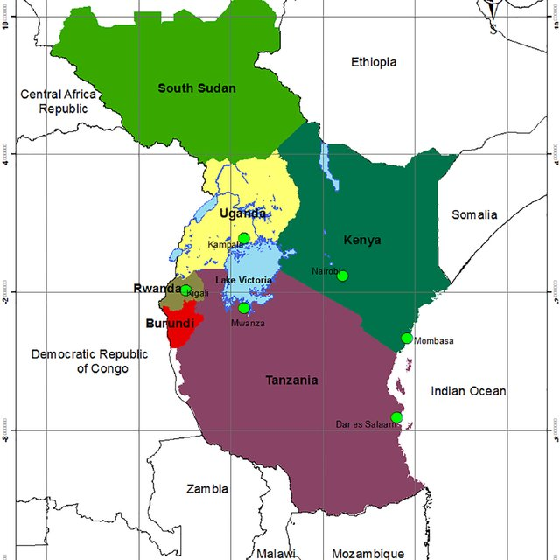

**COMESA**

* Common market for Eastern and Sothernern Africa
* COMESA was originally called Preferential Trade Area (PTA)
* PTA was formed in 1981. It has members in Northern , Eastern and Southern Africa
* COMESA is the largest economic grouping in Africa with over 20 members
* Its headquarters are in Lusaka – Zambia
* It has a COMESA bank in Burundi
* The current chairman of OMESA is President Joseph Kabila from DRC.
* The current secretary general Sindiso Ngwenya from Zimbabwe

**Reasons why COMESA was formed**

* To promote trade by removing trade barriers e.g taxes
* To promote peace, security and stability
* To allow free movement of people and goods
* To promote research in science and technology
* To organize regular investments

**Benefits of COMESA to member states**

* It creates a large market for goods from member states
* It has helped to promote peace and security among member states
* Member states get loan , travellers’ cheques through COMESA bank
* It has promoted trade among member states.

**Problems facing COMESA**

* Most member sates produce similar goods
* Many African countries are poor therefore COMESA lacks funds
* Smuggling of goods deprives government taxes
* Political instabilities in some countries
* Some countries fully depend on agriculture and unable to industrialise

**Member states of COMESA**

Sudan DRC

Uganda Egypt

Kenya Libya

Tanzania South Sudan

Eritrea Ethiopia

Malawi Zambia

Zimbabwe Somalia

Lesotho Swaziland

Why did Tanzania withdraw from COMESA?

* It was costly since Tanzania is a member of many other regional organsations.
* Tanzania never wanted to lose its taxes from non-land locked countries.
* It is intergovernmental authority on development
* Its headquarters are in Djibouti in Djibouti

**Member states of IGAD**

Sudan Somalia

Uganda Ethiopia

Eritrea Kenya

Djibouti South Sudan

**Why IGAD was formed**

* To solve the problem of food shortage and drought
* To promote peace and unity
* To improve transport and community in the region

**Benefits of IGAD to member states**

* It has tried to promote peace and security
* It has tried to control the effects of drought through modern agriculture

**Challenges of IGAD**

* Political instabilities
* Shortage of funds
* Hunger and starvation

**SADC**

* It is southern African Development Community
* Its headquarters are in Gaborone Botswana. Only Tanzania in EA is a member

**THE PEOPLE OF EAST AFRICA**

History is the study of past events.

Sources of hi story

**ORAL TRADITION (LEGENDS)**

Getting information from stories told by the old generation.

**LINGUISTIC**

* Study of people’s languages spoken in particular regions.

**Anthropology**

* Study of people’s culture in terms of dressing, ceremonies, tools etc.
* The people who carry out the study are known as**athropologists.**

**WRITTEN RECORDS**

Getting information from written records ie

Newspapers, magazines, letters etc.

**ARCHAEOLOGY;**

* The scientific study of fossils which are dug from under ground.
* The exercise of removing early remains from underground is known as **excavation.**
* The term given to mean earlyman remains is **Fossils**.
* The people who excavate are reffered to as **archaelogists.**
* The places where excavation was carried out are called **archeological sites.**

**ARCHEOGICALISTS AND THEIR FINDINGS IN EAST AFRICA.**

**DR. LOVIS LEAKEY AND HIS WIFE**

* This is the important and famous archaeologist in the history of Olduvai Gorge in Tanzania in 1959 who was termed as**Zinjanthropus.**
* Zenj was a word to mean black and anthropus means **man**.
* This man fed on roots, berries, insects, and honey.
* Because of the oldest human skull that was found in Africa, it was termed as the cradle land of man.

**DR.PASNANSKY;**

* He found the remains of the chwezi at Bigobbyamugenyi.

**JS KIRKMAN AND CHITIK**

* These ones excavated a number of remains at the coast of East Africa including those of the Portuguese.

**NOTE;**

* All these fossils in east Africa are kept in museums in Uganda, Kisumu and Fort Jesus in Kenya, Darsalam and Arusha in Tanzania.

**ARCHAEOLOGICAL SITES IN EAST ARICA;**

|  |  |  |
| --- | --- | --- |
| UGANDA | KENYA | TANZANIA |
| Bigobyamugenyi | Olorgesaille near L.Magadi. | Olduvai Gorge |
| Nsongezi | Kobi foora near L.Turkana. | Engaruka |
| Sango Bay | Fort Ternan near Kisumu | Isimilia |
| Paraa | Kariandusi near L.Nakuru. | Kalambo |
| Nyero |  | Peninj |
| Rusinga |  |  |
| Ntusi |  |  |
| Magosi |  |  |

NOTE;

* Nyero in Ugandan is well known for rock painting and Bbigobyamugenyi is known for the chwezi.

**IMPORTANCE OF ARCHAEOLOGICAL SITES.**

* They promotestudy and research.
* They provide information about the activities done long ago.
* They promote the tourism industry.
* They help to determine the process through which man developed.

**MAP SHOWING ARCHIEOLOGICAL SITES IN EAST AFRICA**.

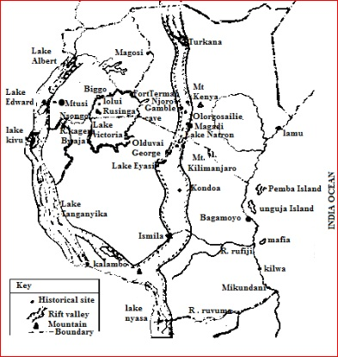

**Questions;**

1. Why is East Africa referred to as the cradleland of man?
2. Why is it important to study about the sites where early man lived?
3. Name the archaeologicalist who discovered the remains of the chwezi people in Bigobyamugeyi.
4. Give one way in which archaeological sites contribute to the development in terms of economy of a country.

**STAGES OF DEVELOPMENT OF EARLY MAN;**

* The early man lived morethan a period of twenty million years ago.Since that time he has gone through a number of changes and these changes are three referred to as **stone age periods**.

**CATEGORIES OF STONE AGE PERIOD;**

**OLD STONE AGE PERIOD;**

* This period is also referred to as the **early stone age period.**
* Man lived a simple life by gathering fruits, digging up roots and hunting animals for food.
* He used simple tools likehand axe and chopper; the hand axe was used for skinning animals, digging up roots and shaping other tools madeout of wood.
* Other important tools used were arrows heads, knives, pick, cleaver and bolas.
* Bolas helped totrap fast running animals.

**DRAWING OF TOOLS USED BY MAN IN THE EARLY STONE AGE PERIOD;**

|  |  |  |  |
| --- | --- | --- | --- |
|  |  |  | Pin on Axe |
| Hand axe | Cleaver | A pick axe | bolas |

**MIDDLE STONE AGE PERIOD;**

* During this period man made a variety of tools out of wood, bones, and horns ofanimals.
* The tools made included knives, spear heads, chisels and scrappers.
* Man started hunting animals using traps during this period.
* Fire became the most important discovery during this period.

**IMPORTANCE OF FIRE TO EARLY MAN;**

* To roast meat
* For warmth
* For protection
* For light in caves
* Scaring away dangerous wild animals
* For boiling poison put on arrow heads.
* Man started to tame animals like the dog.

**TOOLS USED IN THE MIDDLE STONE AGE**

|  |  |  |
| --- | --- | --- |
|  |  |  |
| Spear (tool) | Bow and arrow(Weapons ) | Stone spear (weapon) |

**USES OF THE DOG TO EARLYMAN,**

* Helped earlyman to carry out hunting.
* It gave security to earlyman.
* Helped man to tame other animals.
* At the end of themiddle Stone Age period, man discovered farming which marked the begging of the new Stone Age period.

**THE NEW STONE AGE PERIOD (LATE STONE AGE.)**

* Under this period man became more creative, he began to live in simple huts and tree shelters, started growing crops and keeping animals which made him to lead a settled life.
* Man started using more refined toolswith sharp points and regular shapes e.g. spears, needles and fish hooks.
* At the end of this period, man discovered iron smelting which made him to start using iron tools and this marked thebegging of the Iron Age.

**IRON AGE;**

* It brought a number of changes on the life of man.
* Stronger weapons were made for protection.
* Stronger tools were made for farmingand hunting.
* Ornaments were made which were exchanged with other communities to get items.

The idea of iron smelting was started by the Cushites at Meroe (Ethiopia)

In Uganda, iron smelting was introduced by the Bachwezi

The headquarters of the Bachwezi were at Bigobyamugenyi currently in Sembabule district.

***QUESTIONS;***

1. What is meant by the term stone age period?
2. Identify the most important discovery made during;
3. Middle Stone Age.
4. Old Stone Age.
5. Identify any one change which was introduced by each of the following.
6. Farming
7. Iron smelting
8. State any two ways in which a dog was useful to earlyman.
9. What was the use of each of the following tools to earlyman?
10. Bolars.
11. Chopper
12. Hand axe.

6. How did farming enable man live a settled life?

7. How did iron improve early man’s life?

**TRIBAL GROUPS;(ETHNIC GROUPS)**

**ETHNIC GROUPS INEAST AFRICA**

* An ethnic group is a large group of people who share a common origin and almost speak the same language.
* A tribe is a group of people with the same beliefs, cultures origin and speak the same language.

**MAJOR ETHNIC GROUPS OF EAST AFRICA.**

i) Bantu

ii) Nilotics

iii) Cushites (Hamites)

**BANTU**

* Bantu is the largest groupof people in East Africa and occupy the largest part of the region.
* They speak related languages, characterised by the word NTU. When talking about a person.
* They are believed to have entered East Africa around 1000A.D and originated from Cameroon highlands through the Congo basin to East Africa.
* Their mainocccupation is **farming.**

**EXAMPLES OFBANTU IN EAST AFRICA**

|  |  |  |
| --- | --- | --- |
| **UGANDA** | **KENYA** | **TANZANIA** |
| BagisuBanyoro | Abagusii Kikuyu | Nyamwezi Yao |
| BagisuBanyankole | Akamba Embu | Chagga Hehe |
| Batoro Bakiga | Ameru Pokomo | Gogo Makonde |
| Basoga Bamba | MbereMyikenda | Sukuma Ngoni |
| BasamiaBanyole | Luhya | Zaramo Pogoro |
| Basamia | Mijikenda | Wakuru, Bahaya |
| BaruliBagwere |  | Washamba |

NOTE;

* The Bushmen were original inhabitants of East Africa.

**Questions;**

1. What is an ethnic group?
2. What was the original homeland of the NTU people?
3. Mention four Bantu groups in each of the following.
4. Uganda
5. Kenya
6. Tanzania.
7. What was the main occupation carriedout by the Bantu?

**MIGRATION AND SETTLEMENT OF BANTU.**

* Review of the definitionthe migration and types.
* The Bantu groups were given different names depending on their entry and settlements.

**WESTERN BANTU / INTERLACUSTRINE BANTU.**

* They entered East Africa through north western Tanzania and settled in North and central Tanzania.
* They include Baziba, Sukuma, Nyamwenzi, and Bahaya. Later some of them moved to central Tanzania moved east wards to the coast.
* However those who entered Uganda between Lake Edward and L.Albert like the Baganda, Basoga, Banyoro, etc.areinclusive.

**EASTERN/ COASTAL**;

These moved into central East Africa through the South Estern direction of Tanzania

Around highland areas and around the coast of E. Africa.

Kenda, washamba, Taveta, chagga, Meru, Kikuyu, Taita, Akamba, Pare, Gogo, Zigua, Embu and Zaramo.

**SOUTERN BANTU**.**AND CENTRAL BANTU**

* They entered East Africa through Southern Tanzania that is why the area sometimes called the central Bantu.
* They include Ngoni, Fipa, Yao, Makwa, Makonde, and Hehe.
* The Ngoni were the last Bantu group to enter East Africa.
* They came in the 19th century because of the Bantu inter-tribal wars that had taken place in SouthAfrica as they had been defeated by Shaka Zulu.

**CAUSES OF THE BANTU MIGRATION IN EAST AFRICA.**

* Prolonged droughts in their craddlelands.
* Shortage of land due to population increase.
* Internal and external conflicts
* Famine outbreak
* Outbreak of epidemics
* Love for adventure
* Search for fertile lands.

**PROBLEMS FACED DURING MIGRATION OF THE BANTU TO EAST AFRICA.**

* Shortageofland
* Harsh climate during movement
* Impassible physical features.
* Fatigue (walking longdistances)
* Language barrier.
* Impassable routes
* Poor transport network.

**EFFECTS/RESULTS OF THE BANTU MIGRATION**

* Displacement of the original inhabitants
* New skills such as iron smeltingFormation of newcultures
* There were political, social and political changes.
* Kingdoms and chiefdoms were formed.
* Settled farming was introduced.
* Intermarriages leading to the formation of new tribes and cultures.
* The population decreased in their cradle lands and increased in the new areas.

**MAP SHOWING BANTU MOVEMENT AND SETTLEMENT. (REF. FOUNTAIN SST BK.6 PAGE 35 OLD EDITION**)

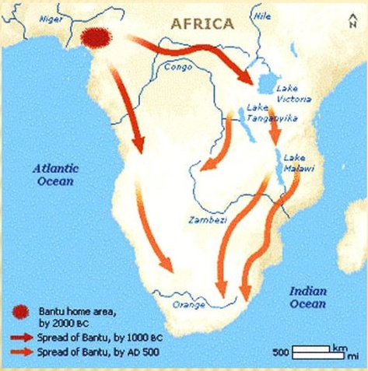

**NILOTICS. (NILOTES).**

* This is the second largest ethnic tribe in East Africa.
* They categorised into three major groups ie;

1. River-lake Nilotics.
2. Plain Nillotics (Nilo-hamites)
3. Highland Nilotes.

* They are Nilotics because they had their origin along the Nile valley at Bahr-el-Ghazel in south Sudan.
* Most Nilotics were pastorolists and used to move from one place to the other with their cattle.

**THE RIVER-LAKE NILOTES**;

* They are also called luo-speakers.
* They include Acholi, Alur, Langi, Japadhola and Jaluo.
* These people are related to the Madhi, Dinka, Shiluk, Nuer and Anwale of south Sudan.
* The original cradle land oftheriver-lake Nilotics was Bahr-el-Ghazel in south Sudan.
* They first settled at Pubungu currently known asPakwach and later split into different groups due to conflicts of their leaders Gipir and Labongo.
* They were called River – Lake Nilotes because they settled near lakes and rivers.

**THE HIGH LAND NILOTES**;

* They were originally pastoralists. Who included ieNandi,Kipsigis,Tugen,Keigo,Dadong,Marakwet,

Teribong, Okweit, Bongmek, Pokot, and the Sabiny.

* The Sabiny are found in kenya and Uganda,theDodong in Tanzania.These people mainly settled along the highland areas are believed to have migrated(originated)from the south

**THE PLAIN NILOTICS (NILO HAMITES);**

* They are believed to have originated from Ethiopia and settled on theplain areas of East Africa.
* They include Masai, Samburu, Jie, Karamojong, itesots and Turkana.
* They major cause of migration was search for water and pasture for their animals.
* Their main economic activity was Nomadic Pastoralism.

NOTE.

* Some of the Itesoand the Masai have changed to crop cultivation because of fertile land, good climate and Population increase.
* They becoming mixed farmers.

**REASONS FOR MIGRATION OF THE NITOLICS**

* Search for pasture and water for their animals
* Overpopulation
* External and internal conflicts
* Famine and drought

**EFFECTS OF THEIR MIGRATION**

* Led to the collapse of the Chwezi denasty
* Introduced short horned cattle
* Led to inter marriages ad hence new tribes
* Introduced chiefdoms

Why did the Nilotics adopt mixed farming after entering East Africa?

State the problems faced by ethnic groups during migration.

**CUSHITES**

Cushites are also known as the Hamites.

* It’s believed that they migrated from Asia and settled in theHorne of Africa where we find countries like Somalia, Djibouti, and Eritrea, later entered East Africa.
* Their main occupation was cattle keeping.
* Today the Cushites mostly lived in the semi-arid landsofcental Tanzania as hunters and fruits gatherers.
* In Kenya, the Southern Cushites are represented by the kinje and Dahalo.
* The last group of the Eastern Cushites includes Galla, Somali, Boran and Rendille.
* In Uganda, they are represented by the Bahima and also keep long horned cattle.
* In Rwanda and Burundi, there the Tutsi and Hutu.

**REASONS WHY CATTLE IS REARED BY THE CUSHITES;**

* For meat
* For Milk
* For Ghee production
* For payment of dowry
* To provide them with skins.

**Questions.**

1. Mention any four results of early migrations into East Africa.
2. How are the Masai similar to the Bahima in terms of economic activities?
3. State any two problems which face the pastoral tribes of East Africa.
4. Give any two values of cattle topastoral tribes of East Africa.
5. State two reasons why the Nilotics migrated into East Africa.
6. Give any one negative cultural practice of the Sabiny people.

**POLITICAL ORGANISATION OF EAST AFR ICAN PRE-COLONIAL SOCIETIES**.

* Pre-colonial societies were the societies whichexisted before the coming of the Europeans colonialsts.
* These societies developed different ways of political orgaisations.
* In East Africa,politicalorganisations was mainly categorised into two;

1. Centralised societies (kingdoms)
2. Decentralisedsocieties (Non-centralied)

**THE INTERLACUSTRINE KINGDOMS**

The word interlacustrine means between lakes.

Interlacustrine kingdoms were the kingdoms formed between the great lakes of East Africa .

**These lakes include:**

* Lake Victoria
* Lake Albert
* Lake Edward
* Lake George
* Lake Kyoga
* Lake Kivu

Bynyoro Kitra empire was a legendary empire because there was no emperor who ruled over it.

It is sometimes called Bunyoro Kitara Kingdom because it was the first in the interlacustrine region.

When it broke up, separate Kingdoms e.g

* Buganda
* Munyoro
* Ankole
* Karagwe
* Wanga
* Rwand and Urundi

**Bunyoro Kitara was ruled under different dynasties ie.:**

* Tembuzi
* Chwezi
* Luo Biito

**CENTRALISED SOCIETIES**

* These societies had well identified rulers to whom the political powers were given by therest of the community.
* The word “centralised” means political powers were centered on recognised rulers.

Examples ofcentralised states were;

1. Buganda

2. Toro

3. Bunyoro

4.Busoga

5.Nyamwenzi

6.Wanga in Kenya

**A table showing societies and titles given to their political heads**

|  |  |
| --- | --- |
| SOCIETIES | POLITICAL HEAD |
| Buganda | Kabaka |
| Nyamwenzi | Ntemi |
| Toro | Omukama |
| Ankole | Omugabe |
| Busoga | Kyabazinga |
| Wanga | Nabong |
| Bunyoro | Omukama |

**ADVANTAGES OF KINGDOMS**

* Promote unity
* Promote culture and morales
* Promote peace
* Prevent power struggle since leaders are hereditary

**DISADVANTAGES OF KINGDOMS**

Promote dictatorship

Promote regional development instead of national development

Promote tribalism

**CHARACTERISTICS OF CENTRALISED;**

* They had one ruler /king given different tittles at the time.
* They had royal regalia.
* Kings could come topower through hereditary.
* Kings had full authority over the people (sujects) and their property.
* Kings were related to people through chiefs.
* They had well established cultural instituions
* Kings expanded by raiding other neighbouringkingoms.
* The burial places or kings were reffered to as royal tombs

**A MAP SHOWING KINGDOMS OF AFRICA. (Ref.MK standard SST Bk 6 pg.83).**

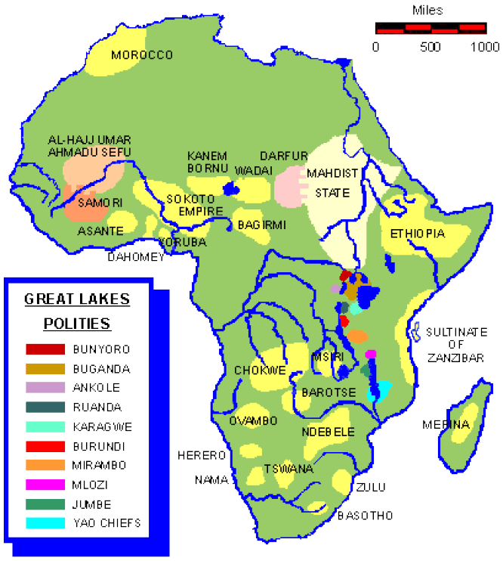

**THE TEMBUZI DYNASTY IN UGANDA**;

* This was the empire to exist in the interlacustrine region of East Africa.
* The word interlacustrine means the region of the great lakes ie around L.kyoga, Victoria, and Albert, Tanganyika.
* This region was extending from Uganda, Tanzania, Western Kenya, DRC, Rwanda and Burundi.
* Bunyoro Kitara Empire is believed to have been founded by the Tembuzi
* These were the fore parents of the chwezi people.
* The word Ruhanga in this case meant God

Tehhierachy of TEmbuzi dynasty

Ruhanga (founder of heTEmbuzi dynasty)

Nkya

Kakama Twale

Baba

Mukonko

Ngonzaki

Isaza

* Tembuzi dynasty contained the Tembuzi people who are believed to be semi-gods, just because they could perform miracles, they could appear and disappear according to legends.
* The story of the Tembuzi people is believed to be a myth and this type of history is referred of the Tembuzi people is believed to be a myth and this type of history is referred to as Mythology.
* The Tembuzi Empire existed for four regimes and their last King was Isaza.
* When Isaza was locked under ground by Namiyonga,theTembuzi people disappeared and went back to heaven
* The Bachwezi became the rulers of the interacustrine region and they were founded by Ndahura,their first King and the grandson of the Isaza.
* The last ruler of the chwezi was king Wamala.

**CONTRIBUTIONS OF THE BACHWEZI IN THE LAKE REGION;**

* These are caterised into social,economic and political contributionns;

**SOCIAL-ECONOMIC CONTRIBUTIONS;**

* They introduced long horned cattle.
* They introduced salt mining at L.Katwe.
* They started coffee cultivation.
* They introduced the idea of barkcloth making.
* They introduced pottery and local games.
* They introduced the building of grass thacthed houses.

**POLITICAL CONTRIBUTIONS**.

* They brought the system of the centralised monarchy.
* They introducedn the heirachy of officials in the palace
* They introduced the idea of building reed palaces (fortified Court yard).
* The Chwezi people left behind their regalia which included Royal stools .These were found at Bigobyamugeyi, Kibengo, Kagogo, Kasonko and Ntusi.
* Iron working strengthened the Chwezi empire by making stronger weapons and tools for cultivation.

**THE COLLAPSE OF THE CHWEZI EMPIRE**.

The chwezi empire which had grown very strong and wide in the region, time came reached its down fall.

**FACTORS THAT LED TO THE COLLAPSE OF THE CHWEZI EMPIRE**

* Out break of epidemics like small pox.
* Prolonged drought.
* Death of their beloved cow Bihogo.
* The empire became difficult to be ruled easily as it expanded.
* The invasion by the Luo made the final collapse of the empire.

**THE KINGDOM OF THE BUNYORO**;

* At the beggining of the 16th century, the Luo migrated from the present day south Sudan to Uganda.They entered Bunyoro Kingdom and adopted the new dynasty reffered to as Bito dynasty.
* The founder of the Bito dynasty was Isingoma RukidiMpuga, son of Kyomya and he was a twin brother of Kato Kimera.
* A separate Bito dynasty was established in Toro in the 19th century by prince Kaboyo and covered much of modern Buganda, Toro and Ankole.
* Kamurasi was one of the kings of this kingdom and he was the father of the greatest King of Bunyoro called Omukama Kabalega.

**POLITICAL ORGANISATION OF BUNYORO KINGDOM**.

* The political organisation of Bunyoro ensured order and administration from the highest to the lowest organ.
* The title given to the king was Omukama.He appointed his primeminister and chiefs to ensure administration to all thelocal areas.
* Cattlekeepingandrustling was their majo r occupation including salt mining.
* They exchanged salt, potatoes, wines, and iron tools for banana and bark cloth Buganda using barter trade systems.
* Bunyoro weakened due to a number of factors e.g
* Internal local conflicts
* Expansion of the kingdom
* Internal conflicts.
* The growth and expansion of Buganda kingdom.

**ECONOMIC ORGANISATION**

* The Banyoro were mainly pastoralists but BiitoBAiru were crop farmers
* They also participated in long distance trade exchanging Ivory wit beads guns and cloth

NOTE.

The current Omukama of Bunyoro is Omukama GafabusaIguru.

**Questions.**

1. State the factor which finally led to the collapse o the Chwezi Empire.

2. Where were the headquaters of the Bachwezi?

3. How the size of the Bachwezi contribute to its collapse

4. What name is given to the strong warriors of Bunyoro?

**BUGANDA KINGDOM.**

* Buganda started as a territory with a small population in the 17th century
* The population 0f Uganda increased as migrants from Busoga, Bunyoro, Mt.Elgon and koki arrived.
* According to the legend,its believed that Kato Kimera was the founder of Buganda kingdom though its challenged by other legends that Kintu was the first Muganda and King of Buganda?
* Therefore, the founder and first king of Buganda was Kintu.
* Buganda grew from a small nucleus of 3 countries i.e. Mawokota, Busiro, Kyadondo, it later expanded to over ten counties at eh time of signing the 1900 Buganda agreement it was 20 counties.

**POLITICAL ORGANIZATION OF BUGANDA**

* It had a centralized system of administration with the Kabaka as the over all ruler.
* The kingdom was divided into countries, sub counties; parishes sub parishes and villages for easy administration.

Administrative structure of Buganda kingdom

Political structure

Clan system Political system

Clan heads king (KAbaka)

Lineage heads chief justice (mulamuzi)

Sub lineage treasurer (Muwanika)

Kinsfolk county chief (Saza chief)

Sub-county chief (Gombola chief)

Parish chief (Muluka chief)

Sub parish chief (Mutongole chief)

Village chief (Omutaka)

**ECONOMIC ORGANISATION**

The Baganda had economic activities like bark cloth making iron smelting rearing of animals and growing of crops, making boats, which helped them in trade and war fare.

They traded in slavery ivory iron ore and shells of animals in exchange for guns, beads and ammunitions from Arabs

**SOCIAL ORGANISATION**

The bagada had strong beliefs in ancestral spirits. They believed in may gods like Musoke, Dungu, Kibuuka, Nagawonye

The Baganda were divided into 52 clans according to animals, birds and plants which were their ttotems.

**FACTORS THAT LED TO THE EXPANSION OF BUGANDA**.

* Strategic position o f Buganda (nearness to L.victoria).This made Buganda to havebetter naval forces and fish from L.victoria.
* Well organised and determined rulers.
* Acquisition of guns from Arabs.
* Good climate and fertile soil that favoured crop growing.
* Well trained soldiers as Abambowa.
* Well organisedcentralised administration.
* The Baganda were united.
* Buganda was small at first and Easy to control

**WANGA KINGDOM**.

* This kingdom was made of the Abaluyia people in the Western Kenya near L.victoria.
* It was the only the kingdom that existed in the present day Kenya.
* The Abaluyia are believed to have migrated from Bunyoro Kitara after its collapse.
* Their main occupaton was farming and the title given to their king was Nabongo.
* One of their Nabong by the names of Mumia is greatly remembered to havecollaborated with the British during the colonial rule.

**QUESTIONS.**

1. How did the location of Buganda contributed to its expansion.

2. Mention the only kingdom which existed in Western Kenya.

3. Give two ways in which the people of East Africa were politically well organised before the coming of the foriegners.

4. How did the coming of foreigners affected the existence of Wanga kingdom.

**KARAGWE KINGDOM**

* This kingdom existed south of Ankole, Toro, and Buganda in Northern Tanganyika near L.victoria.
* It was founded in Bukoba region in Tanganyika.
* It was part of the former Bunyoro kitara kingdom and was occupied by the Banyambo.
* It wasfounded by Ruhinda the founder of Ankole Kingdom who conquered the neighbouring empire to enlarge it. This included Rwandan, Burundi, and Ukerewe.
* King Rumanika was one of the greatest kings of this kingdom and helped many explorers to reach Buganda.
* The kingdom developedas a result of the trade which was existing in this region(long distance route)
* The people were organised under clans and sub-clans who were headed by Muharambwa.
* Karagwe was founded by Ruhinda son of Wamala

**ROLES OF MUHARAMBW**A

* Blessed women to bear many children.
* Blessed hoes and harvest.
* Supervising un occupied land in the area.
* Spiritual leadership

**TORO KINGDOM**

Toro kingdom was founded by prince Kaboyo son of omukamaKyebambeNyamulukura III of Bunyoro.

Toro kingdom broke away from Bunyoro because they were not getting enough services from headquarters.

**POLITICAL ORGISATION**

Toro had a centralised system of government with the omukama as the overall ruler.

* Toro had strong leaders like prince Kaboyo the founder
* Nyaika I successor of Kaboyo
* Kasagama who ruled during colonial rule
* Omukama who ruled during at the time of independence
* OmikamaKaboyo Olimi the father of the current king of Toro

NOTE:

The current king of Toro is Oyo Nyimba KAbambaIguru IV.

**ECONOMIC ORGANISATION**

The Batoro were mainly pastoralists but today have changed to mixed farming.

They also participated in coastal trade with Arabs dealing in iron and ivory.

**SOCIAL ORGANISATION**

They had two classes the Hinda Batoro who were herdsmen and rules and he bairubatoro who were cultivators an seen as inferior

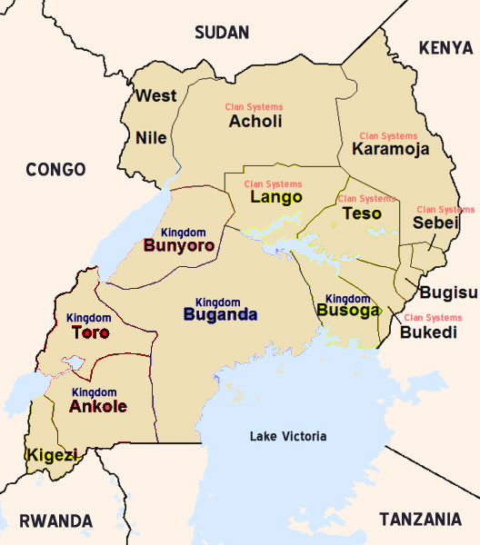

NOTE.

Muharambwa was paid by his subjects with gifts of food items and cowrie shells.

**QUESTIONS.**

1.what title was given to the ruler of the following

a)Wanga b)Karagwe .

2. Who was the founder of karagwe?

3. Give any two roles played by traditional rulers of karagwe.

4. Give any three advantages and disadvantages of kingdoms.

**NYAMWEZI EMPIRE;**

* This empirewas founded in the present day Tanzania and by Wanyamwezipeople.
* These were named Namwenzi by the coastal dwellwers because they came from the direction of the moon and settled in centralTanzania, south of L.victoria.
* The Nyamwenzi are the biggest Bantu grou p in Tanzania.They were originally cultivators but later were taken by trade items e.g salt, spears, livestock, grains and metal ware.
* They dealt in trade items like salt, spears, livestock, grains and metal ware.
* The title given to the leader of the Nyamwezi chief was NTEMI or MUTEMI.

**ROLES OF NTEMI**

* Was a spiritual leader.
* Led prayers and made sacrifices to gods on behalf of the people.
* Was incharge of royal drums.
* Responsible for the well being of the community.
* The Ntemi built a strong state in the region which was crossed by two main caravan routes to the coast via the North Western route through Karagwe to Buganda and Western route to Ujiji to L.Tanganyika and beyond.

**CHIEF MIRAMBO**;

* Mirambo was one of the greatest Ntemi of the Nyamwenzi.
* His capital was at Urambo.
* Urambo was an important slave and ivory market in the region.
* Mirambo started as a small ruler o the chiefdom called Ugowe and then expanded his territory by attacking the neighbouring kingdoms.
* He extended his territory (empire) and controlled the main trade routes from Tabora to Ujiji and Karagwe while collecting taxes.
* He built a large empire which was divided into provinces ruled by Mirambo (Vatwale).
* These were responsible for trade of goods tribute to the capital of kiwere.Kiwere was the administrative centre.

**FACTORS WHICH CONTRIBUTE TO THE SUCCESS OF MIRAMBO.**

Mirambo’s character.

* He was a dynamic chief.
* He was ambitious to expand and develop his empire.
* His ablity to lead soldiers to the war battle.
* His ability to recruit the captives to his army.
* His ability to capture all the trade routes and control trade.
* Mirambo s ability to deploy mercenary soldiers called RugaRuga.
* Acquisation of the guns from long distance traders.
* His ability to acquire the Ngoni tactics of fighting.

**COLLAPSE OF MIRAMBO;**

Mirambo who established a strong empire in the region, time came when his empire collapsed due to;

* The mercinary soldiers had becomeindisplined by stealing people’s property.
* Mirambo had centralised all his powers that during his absence, the system couldnot operate.
* The death of Mirambo weakened the empire as his successor’s couldnot control its property.

**NYUNGU YA MAWE**

* Nyunguyamawe was the successor of Mirambo.
* He was among the famous chiefs of the empire and established his capital at Kiwele.
* He developed a centralised system of administration and divided his empire into seven pronvinces.
* Each pronvince was under the leadership of Mutwale.
* The name Nyuguyamawe means pot ofstones which symbolises his strength and ability to rule the empire.
* Both mirambo and Nnyunguyamawe died in 1884, the same yearMUTEESA 1 of Buganda died.
* Nyunguyamawe was suceeded by his daughter Magalula who was later over thrown by the Germans.

**QUESTIONS.**

1. State any two ways in Mirambo’s character made him successful man.

2. How did the longndistance trade contribute to the growth and development of the Nyamwezi Empire?

3. Give the meaning of the following terms;

a) Ntemib) Nyunguyamawec) Nyamwezi.

**SOCIAL ORGANISATIONS, CULTURE AND CUSTOMS**

1. The most developed social organsation among the East African tribes was the clan system.
2. Clans were headed by clan heads
3. Their responsibilities wre:-
   1. To orgnise clan ceremonies and functions
   2. To settle disputes among clan members
   3. To provide over traditional ceremonies and meetings

**CULTURE**

It refers s to norms and values of a given society

**NORMS**

These are accepted ways of behavior in a given society.

**VALUES**

These are principles or standards of behavior

**CUSTOMS**

These are traditional and widely accepted ways of behavior on doing something in a particular society place etc.

**SOME OF THE NORMS AND VALUES INCLUDE**:

* Beliefs - technology
* Dressing - songs and dances
* Food - art, crafts
* Moral habits - initiation ceremonies
* Politics

**TABOOS**

1. Taboos are used to teach work and discipline to chidren
2. Taboos are social or religious customs prohibiting or restricting prople from a particular thing.
3. Cultural ceremonies are performed for specific purposes for example
   1. Weddings
   2. New harvest
   3. Marriage
   4. Circumcision
   5. Birth and naming of children
   6. Funeral etc.
4. In these ceremonies, love, oneness and concern for one another is expressed.
5. Worship in the ATR was an important aspect of culture.
6. Thee wee however many gods but there was supreme god.

**THE NAMING CEREMONY**

Children in some cultures are named after their ancestors

The first is named after the grand father.

The second is named after the grandmother

**IMPORTANCE OF CULTURE**

* It unites people
* It identifies people
* It promotes discipline and morals
* It promotes peace and harmony

**NEGATIVE EFFECTS OF WESTERN CULTURE ON AFRICAN CULTURE**

Dressing - mini skirts, trousers for girls, open blouses

Marriage - homosexuality, sex workers, lesbians

Language - most children can’t speak their mother tongue

**ZENJI EMPIRE.**

* Itstrecthed from Mogadishu in Somalia, to Sofala in Mozambique.
* Zenji means blacks People.
* Zenji empire means land of black people
* Its headquaters were at Kilwa.
* The trading centre was at Zambia but Malindi, Sofala, Mombasa, were also important trading points.
* This empire was founded by an Arab trader named Hassan Bin Ali in the 10th century.
* Themaineconomic activity in this empire was trade and dealt in selling of ivory, gold, copper, Iron, cowrie shells, and slaves.
* The traders at the coast included Arabs,Indians,Chinese.A number of items were intoducedie Wollen mate,glassesswords,cotton,Silk,drugs,spices, cloves,and were also sold at the coast of East Africa.

**SEYYID SAID**;

* In 1840s Seyyid Seid who was a most powerful ruler in the empire transfered his capital from Muscaat (Omann) to Zanzibar and later became the sultan of the region.
* The word Sultan was the title to Arabs leaders at the coast of EastAfrica.

**REASONS WHY SSEYYID SAID TRANSFERRED HIS CAPITAL FROM MUSCAT TO ZANZIBAR;**

* Zanzibar had good naturalnhabours for his ships.the
* Zanzibar had fresh waters.
* Was strategically located for trade and millitary affairs.
* It had good climate and fertile soils which favourcashcrop growing known as Cloves.

NOTE.

* Zanzibar is the leading producer of cloves in East Africa today which were introduced by SSEYID Said
* Cloves, flowers are used to make perfumes.

**A MAP SHOWING THE COASTAL TOWNS OF ZENJ EMPIRE. (Ref; MK standardsst BK 6 Page 108**

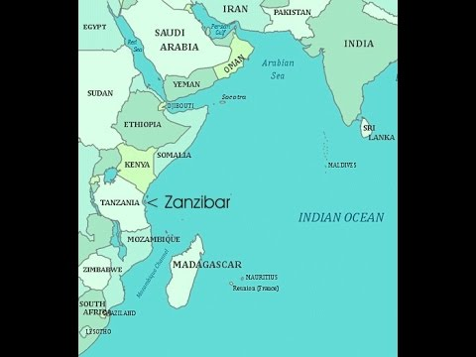

**LONGDISTANCE TRADE;**

* This was the trade which involved traders from the coast of East Africa to move long distances in search for trade items and Customers from the interior ofEast Africa.
* Barter trade is the exchange of goods for goods or services.
* Thetribes involved in the interior of East Africa were Baganda and Banyoro of Uganda,Nyamwezi,Ngoni,Hehe Yao of Tanzania and Akamba,Kikuyu of Kenya.

**TRADE ITEMS COLLECTED FROM THE INTERIOR**;

* Ivory, Turks, hides and skins, salt, slaves, Tusks, Gold
* Slaves were mainly brought to be used as transport means from the coast were sold to other slave traders.
* The traders from the coast were mainly Arabs and introduced a number of items to the interior of East Africa.These items included carpets,spices, clothes,beads, ornaments, guns, mirrors etc.
* The routes of the long distance trade mainly started from the coast through Tanzania to Ugandan.
* From the coast through Kenya to Uganda and back to the coast.
* The most important individuals who participated in this tradewereTiputipu, Msiri and Mirambo.

**EFFECTS/RESULTS OF THE LONG DISTANCE TRADE**.

* The interior of east Africa was opened to the coastal people.
* People in the interior of East Africa became used to the goods from outside east Africa.
* It boasted slave trade with all its negative effects.
* It made the interior kingdoms to grow stronger due to acquisition of guns.
* Developments of the East Africa coastal towns.
* Its encouraged foreigners influence in East Africa.

**ARAB TRADERS;**

* These came from Asia.They mainly came from Saudi Arabia, Persia (Iran).They were blown by the monsoon winds across the Indian Ocean.
* They settled at the East African coast.

**REASONS FOR THEIR COMING.**

1. To trade.
2. To spread Islam.
3. To escape religious wars.

**WHY ARABS TOOK LONG DISTANCE TO MOVE INLAND**.

* Feared hostile tribes.
* Feared thick forests.
* Feared tropical diseases.
* Poor transport.
* Language problem.

**ITEMS OF TRADE OR COMMODITIES OF TRADE**.

1. Guns.
2. Beads
3. Mirrors
4. Clothes
5. Ornaments
6. Cups
7. Plates
8. Glasses
9. Swords.

Items Arabs took from East Africa were;

1. Slaves
2. Tortoise
3. Elephants
4. Leopard’s skins.
5. Rhino horns
6. tusks / Ivory

**TRIBES INVOLVED IN LONG DISTANCE TRADE**

1. In Uganda : Baganda and Banyoro
2. Kenya - Akamba
3. Tanzania - Yao, Nyamwezi, Ngoni, Chagga, Sukuma, Hehe nad the Arabs

**BARTER TRADE**;

* Barter trade is the exchange of goodsforservices without the use of money.
* Early tradersin East Africa used barter trade.

**ADVANTAGES**

* Cheap
* Does not involve use of money.

**DISADVANTAGES OF BARTER TRADE**

* Involves cheating
* Difficult to determine the value and quality of goods.
* Double coincedence of wants / goods

**SLAVE TRADE IN EAST AFRICA**.

* Buying and selling of human beings.
* This trade was brought to East Africa by the Arabs.
* Slavery is the possession of a person by another person

**TRIBES INVOLVED IN SLAVE TRADE.**

1. Yao
2. Nyamwenzi
3. Baganda
4. Hehe
5. Kamba

**WHY SLAVES WERE TAKEN**

1. To work as domestic workers.
2. To work on plantations.
3. To work on mines.

**PLACES WHERE SLAVES TAKEN**;

1. France
2. Britain
3. Holland
4. Portugal
5. Spain
6. America
7. India.

**HOW SLAVES WERE TAKEN.**

1. Through African chiefs
2. Raiding villages
3. Causing tribal wars

Main Slave trade market was at Zanzibar and the main inland Slave market was Tabora.

Main Slave traders include TipuTipu, Abu Saidi, Msiri, Fundikiri.

**MAP SHOWING SLAVE TRADE ROUTES IN AFRICA.**

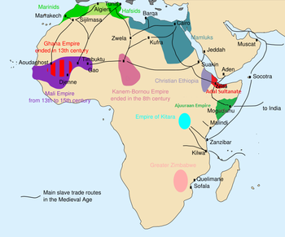

**EFFECTS OF SLAVE TRADE**;

* Depopulation.
* Inter tribal wars led to insecurity.
* Loss of lives
* Seperation of families
* Destruction of families
* Famine
* Hatred amongn people
* Interuption of African Culture.
* Kings and chiefs became rich and Kindoms expanded.

**ABOLTIION OF SLAVE TRADE;**

Move to stop slave trade was started by the British MP Sir William Wilberforce.Others who fought for the abolition includes Granrille Sharp, Thomas Clarkson, Henry Thornton.

**TREATIES SIGNED TO END SLAVE TRADE.**

* Moresby treaty
* Hammerton treaty
* Frere treaty.

**METHODS USED TO END SLAVE TRADE;**

* Signed treaties with african leaders
* Sent Missionaries
* Constructed the railway lines.
* Sending army to control movements of ships on the Indian Ocean.

**WHY SLAVE TRADE TOOK LONG TO END IN EAS T AFRICA**.

* Kings and chiefs were benefiting.
* There was great demand for slaves overseas.
* British had a small army to stop traders from carrying out Slave trade.
* Poor transport.

In Uganda Sir Samuel Baker tried slave trade in Acholi.

**CONTRIBUTION OF THE ARABS TO EAST AFRICA**.

* They linked East Africa to Asia (Saudi Arabia and Persia.)
* Introduced new skills and ideas like stone building.
* They led to growh of coastal townsEg. Kilwa, Sofala, Malindi, Mogadishu
* They introduced Islamic faith
* Introduced new items of trade.
* Intermariages led to birth of Swahili culture
* They estalished a trading empire ie Zenji.
* Introduced Cowrie shells (medium of exchange).

**INDIAN TRADERS;**

* They came from India and Pakistan.
* They had come to construct the Uganda railway and after its completion, some remained behind and opened shops, in Kampala.
* The first shop in Ugnda was opened by Aldina Visram
* They introduced rupees, Indian money lenders were known as Banyans.people like Mehta and Madhvani opened up sugar cane plantations.

**CONTRIBUTION OF INDIANS IN EAST AFRICA.**

* They constructed the Uganda railway.
* They built shops in East Africa.
* They introduced rupees.
* They started banking system.
* They set up industries.
* They set up schools and hospitals.

**POPULATION SIZE AND DISTRIBUTION IN EAST AFRICA**.

Population simply refers to the number of people living in an area.

**POPULATION DISTRIBUTION**;

Refers to how people are scartered in a given area.

**POPULATION DENSITY**

Refers to the number of people living in area per squarekilometre.

**OPTIMUM;**

* This is when the available resources are just enough to satisfy theavailable population.
* This is when the number of people matches with available resources.

**OVER POPULATION;**

This is when the available resources cannot satisfy available number of people.

**POPULATION GROWTH;**

This refers to the rapid growth in number of people in an area.

**POPULATION EXPLOSION;**

This refers to the increase of a number of people in an area.

**POPULATION CENSUS;**

This is the official counting of people in an area.

**NATIONAL POPULATION CENSUS**

This is the official counting of people in a country.

**CENSUS NIGHT;**

This refers to the night before census is carried out.

**ENUMERATORS;**

These are officials who carry out population census.

**POPULATION STUCTURE**;

Refers to the composition of population in terms of age and sex.

**BIRTH RATES;**

Number of birth every year for every one thousand people in the population of a place.

**UNDER POPULATION**;

This is when the existing population can not fully exploit the available resources in an area.

**FACTORS FOR POPULATION INCREASE;**

* Improved diet.
* Improved medical care (health).
* High fertility in women.
* Polygamy
* Early marriages
* Unplanned family sizes.
* Religious beliefs.
* High birth rates and low death rtes
* Immigration
* Ignorance about family planning methods

**FACTORS AFFECTINGPOPULATION DISTRIBUTION**.

* Soil fertility.
* Climate/Rainfall.
* Urbanisation/industrialisation.
* Altitude.
* Historical factors like slave trade.
* Diseases.
* Social services.
* Government poliry

**POPULATION DENSITY**

It refers to the number of people living in an area per square kilometer.

**CIRCULATION OF POPULATION DENSISTY**

PD = total population

Total land area

e.g. place x has 400 people with an area of 10 square

Kilometers Find its population density

PD = Total population

Total land area

PD = 400(people)

10 Sqkm

= 40 people per square kilometer

**SOME DENSELY POPULATED IN EST AFRICA**

1. Shares of lake Victoria
2. Slopes of mountains e.g. Kilimanjaro, Elgon, Mufumbiro etc.
3. Urban araslikeDodoma, Nairobi, etc.

**SPARSELY POPULATED AREAS IN EAST AFRICA**

Semi-arid areas e.g Karamoja sub region north – Eastern Kenya

Miombo woodlands in Tanzania (Infested with tsetse flies)

Kalangala island disriict It has no hydro electricity, poor tansport network, poor communication network.

ADVANTAGES OF A BIG POPULATION

* High taxes
* Cheap / high labour force.
* Big market for goods.

DISADVANTAGES OF A BIG POPULATION

* Shortage of social services
* Poor accommodation
* Easy spread of diseases
* Land shortage
* High crime rate
* Environment degradation

ADVANTAGES OF LOW POPULATION

* Easy provision of social services.
* Enough land to the people
* Low crime rate.

DISADVANTAGES OF A LOW POPULATION

* Low tax base
* Low market for manufactured goods.
* Low labour force.
* Shortage of manpower for security

POPULATION CENSUS

Define: Refers to the general counting of people in an area

**WHY GOVERNMENT CARRIES OUT POPULATION CENSUS**

* For proper planning
* Determine the death rate and birth rate
* To know the number of people
* To know the population structure.

**INFORMATION GATHERED DURING A CENSUS**

Age, sex, Race, Marital status, Level of education, occupation, tribe and religion

**PROBLEMS FACED DURING A CENSUS**

* Bad weather
* Expression (language barrier)
* People give wrong information
* Wide spread illiteracy
* Insecurity in some areas

**POOR TRANSPORT AND COMMUNICATION**

* In Uganda its carried out after every ten years because its is long enough to reduce population change.
* It is expensive to conduct
* Ministry responsible is the n of Finance, Planning and Economic Development.
* The current minister for Finance, planning and Economic Development is ……………………………….

**HARZARDS THAT CHECK ON POPULATION GROWTH**. (NATURAL HAZARDS / IDSASTERS)

* Pests and diseases.
* Floods.
* Earth quakes
* Stronger winds
* Drought
* Volcanic eruption
* Lightening.
* Tsunami /Tarnados.
* land slides (mud slides)

**MAN MADE HARZARDS / DISASTERS THT CHECK ON POPULATION GROWTH**

* Wars
* Road accidents
* Water and food poisoning
* Fire outbreaks
* Transport accidents.
* Population.

**TERM II**

**MAJOR RESOURCES IN EAST AFRICA**

**Major resources of E. Africa.**

A resource is a feature found in the environment used to meet people’s needs.

**Types of resources are**

* Renewable resources
* Non renewable resources

**Renewable resources**

These are resources which when used up can replace themselves after sometime e.g water, plants & animals (wildlife), human resource, land.

**Non renewable resources**

These are resources which when used up can not be replaced e.g minerals like copper, gold.

**Examples of major resources in East Africa**

* Land
* Water bodies (lakes & rivers)
* Minerals
* Climate
* Human resource
* Vegetation
* Animals (domestic & wild)
* Wind

**Land**

This is the most important resource where all resources are found.

**Importance of land**

* All minerals are found in land
* Supports agriculture
* Industries are set up on land
* Most transport facilities e.g. roads are built on land.
* Land supports growth of vegetation which is food for all people and animals.

**Ways in which land is degraded**

* Dumping polythenes and plastics on land.
* Over cultivation
* Swamp drainage
* Deforestation
* Quarrying
* Sand mining.
* Poor disposal of industrial wastes

**Animals**

There are two types of animals i.e. domestic and wild animals.

**Domestic animals** are those kept at home by man e.g. cows, camels, goats etc.

**Wild animals** are those which live on their own in the bush e.g. lions, elephants, hippos, chimpanzee.

**Importance of domestic animals**

* Provide meat and milk
* Used for transport e.g. donkeys, camels
* Used for ploughing e.g. oxen.
* Provide manure
* Provide hooves, hides and skins, horns.

**Forms of animal rearing in E. Africa**

* Dairy farming
* Ranching
* Nomadic pastoralism

**Diary farming**

This is the commercial rearing of cattle for milk and its products.

**A dairy farm** is a farm where cattle are kept on large scale for milk production.

In E. Africa, diary faming is mainly done in the Kenyan highlands

It was introduced by Lord Baron Delamere and later encouraged by white settlers.

In Tanzania, on the slopes of Kilimanjaro

In Uganda, it is done in S. Western Uganda - (kabale and kisoro districts

Modern methods of cattle keeping in Kenya highlands.

* Zero grazing
* Paddocking
* Bucket feeding

**Factors that favour dairy farming in Kenya highlands**

* Cool climate in Kenya highlands
* Presence of good quality pasture.
* Absence of vectors due to low temperature.
* Good transport and communication network.
* Ready market due to a large population.

Products from a dairy farm

Milk, butter, cheese, ghee, yoghurt, ice cream.

**Importance of Dairy farming**

* Provides employment
* Provides milk and its products
* Source of income.

**Ranching**

This is the large scale keeping of cattle for beef.

A ranch is a farm where cattle are kept for beef.

On a ranch, land is fenced and divided into paddocks.

**Products from a ranch**

* Beef
* Hides and skins
* Horns for glue and buttons.

**Examples of ranches in E. Africa.**

* Nyabushozi, Usuk, Kisozi – Uganda
* Kiptei group of ranches – Kenya

**Nomadic pastoralism**

* Pastoralism is the keeping of cattle for survival as a way of life.
* Nomadic pastoralism is the movement of cattle keepers with their animals looking for water and pasture for the animals.

Nomads mainly occupy semi- desert (arid) areas of E. Africa.

**Examples of Nomadic tribes in E.Africa are:-**

* Turkana
* Suk
* Jie
* Masai
* Galla
* Pokot
* Karimojong
* Baron.

**Why do nomadic tribes keep large herds?**

* It is their source of food.
* It is for cultural purposes
* For prestige.

**Problems facing nomadic pastoralists**

* Shortage of water and pasture
* Shortage of veterinary services.
* Animal parasites and diseases
* Cattle rustling among pastoralists
* Prolonged droughts leading to food shortage.

**How can nomads be helped to lead a settled life?**

* Constructing valley dams to provide water.
* Encourage them to set up ranches.
* Provide drought resistant pastures.
* Drilling boreholes.
* Involve in other economic activities.

**How can cattle raiding be reduced among pastoralists**?

Disarming pastoralists

Encouraging them to start settled farming.

**THE CLIMATE OF EAST AFRICA.**

Climate is the average weather condition of a place recorded for a long period of time.

Climatology – Study of climatic conditions

Climatologists – people who study climatic conditions.

Meteorology – study of weather

Meteorologists – people who study weather.

**CLIMATIC REGIONS OF E. AFRICA**

* Equatorial climatic region
* Mountain (Montane / Highland) Climate
* Semi – desert
* Tropical climate
* Coastal climate

**EQUATORIAL CLIMATIC REGIONS**

**Characteristics**

* It is hot and wet throughout the year.
* Has two maximum rainy seasons in a year.
* Receives heavy rainfall all the year between 1750mm – 2250 mm
* High temperatures above 25°C.
* Found in highland areas in south western Uganda. Convectional rainfall is received in

this area.

Ref: Sharing our world book 6 pg 41 climate graph.

Drawing and interpreting the climatic graph of Kisangani (pg 44 bk 7) further research.

This climate is experienced in areas that lie 5°N and S of the Equator.

In E. Africa, it is found near L.Victoria.

NOTE: Explain the effect of North East trade winds on this climate.

Economic activities

* Lumbering
* Tourism
* Farming
* Bee- **keeping (Apiary)**

**MOUNTAIN (MONTANE) CLIMATE**

|  |  |  |  |  |  |  |  |  |  |  |  |  |
| --- | --- | --- | --- | --- | --- | --- | --- | --- | --- | --- | --- | --- |
| Month | J | F | M | A | M | J | J | A | S | O | N | D |
| R/fall in mm | 100 | 100 | 180 | 440 | 510 | 150 | 100 | 100 | 70 | 200 | 270 | 70 |
| Temp | 13 | 14 | 15 | 15 | 13 | 10 | 11 | 13 | 14 | 14 | 14 | 14 |

**Mainly found around mountain regions**

**Receive relief rainfall**

**Temperature is influenced by altitude i.e the higher you go, the cooler it becomes**.

**Mountains with permanent snow are**

* Rwenzori
* Kilimanjaro
* Mt. Kenya

This climate is found in western Uganda, Kenya highlands and southern highlands in Tanzania.

Ref : Sharing our world bk 6 pag 43

Bar graph should be drawn and interpreted accordingly.

**Economic activities**

* Lumbering
* Farming
* Tourism
* Mining
* Dairy farming

Task

Let pupils explain why most rivers flow from mountains.

Why is it difficult to describe mountain climate?

**Tropical climate**

* It is outside the equatorial zone but within the tropic of cancer and Capricorn.
* It covers most plateau lands in E. Africa.
* It mainly support of Savannah vegetation
* Don’t receive rainfall throughout the year
* Has two rainfall seasons btn Mar and May and Sept –Oct.
* Rainfall ranges btn 750 mm – 1000 mm in a year.
* Temps are high throughout the year and convectional rainfall is experienced.
* Temps are high throughout the year with an average of 27°C.
* Also called Tropical continental climate
* It has a wet and dry season.

**Ref: Sharing our world bk 6 pg 42**

Economic activities

* Tourism
* Farming / Crop growing
* Mining
* Cattle keeping
* Semi desert / Semi – Arid climate

|  |  |  |  |  |  |  |  |  |  |  |  |  |
| --- | --- | --- | --- | --- | --- | --- | --- | --- | --- | --- | --- | --- |
| Month | Jan | Feb | Mar | Apr | May | Jun | Jul | Aug | Sept | Oct | Nov | Dec |
| R/fall in mm | 8 |  | 25 | 50 | 25 |  |  |  |  | 25 | 65 | 25 |
| Temp ° c | 28 | 29 | 29 | 28 | 27 | 26 | 25 | 26 | 27 | 27 | 28 | 29 |

* It is hot and dry
* Hot days and cold nights.
* Little amount of rainfall is received.
* Temperatures are high during day.
* R/ fall is less than 500mm per year.
* It is found in N. Eastern Uganda, North and North eastern Kenya and Central Tanzania.
* Temperature range is high.

**Economic activities.**

* Nomadic pastoralism
* Crop farming
* Mining
* Tourism

**The coastal climate region**

* Found in the coastal plains
* Climate is hot and wet
* Receives heavy rainfall through out the year.
* Has two rain seasons i.e May and Oct.
* Temperatures range between 28° C – 30° C

**Economic activities**

* Farming
* Tourism
* Trade
* Fishing

**Problems experienced in Semi-desert areas.**

* Very cold nights and hot days.
* Water shortages.
* Poor social services and veterinary services.
* Insecurity in some parts.

Task (i) Identify solutions to above problems

**Factors influencing climate of E. Africa.**

* Altitude
* Latitude
* Winds
* Human activities
* Vegetation
* Ocean currents
* Nearness to water bodies.
* Relief of an area

**Altitude**

Areas on high altitude are cooler than low lands and receive more rainfall than those on lower altitude hence the higher you go, the cooler it becomes.

**Latitude**

Places near the Equator are hotter and receive more rainfall than places away from the Equator because these areas receive direct rays from the sun.

**Prevailing winds**

Dry winds bring dry weather conditions while wet winds bring rainfall.

**Human activities**

Some human activities favour climate e.g afforestation, agro-forestry etc.

**Vegetation**

Areas with thick vegetation have high rate of transpiration leading to rain formation.

**Nearness to water bodies**

Due to high evaporation rate of water body convectional rainfall is formed.

**Ocean currents**

Some ocean currents are warm and bring rainfall to areas they flow to.

**CAUSES OF WIND & HUMIDITY**

* Wind refers to fast moving air.
* Humidity is the amount of water vapour in the atmosphere.
* Wind is caused by differences in atmospheric pressure.
* Atmospheric pressure is the force exerted by air around us.

**Examples of winds that influence climate of Eat Africa.**

* South – east trade winds
* North – east trade winds

N.B Winds are named according to the direction they blow from.

Explain these

* Prevailing winds
* Inter tropical convergence zone (ITCZ)
* A map of E. Africa showing the above winds.

Ref: Sharing our world bank bk 6 pg 47.

Winds can bring rainfall in an area or bring desert conditions into an area.

**SEA BREEZE**

A see breeze is formed during the day. During day, land is heated faster than water causing warm air on land to rise. The cold air from the sea blows towards land replacing warm air. This is called a sea breeze.

Warm air rises because it is light and replaced by heavy cold air.

Sea breezes are moist and lead to formation of rainfall. (Drawing the sea breeze. MK bk 6 pag 52)

**LAND BREEZE**

At night, land cools faster than the sea land becomes cool while the sea remains warm. Warmer air from the sea rises and cooler air from land blows towards the sea replacing warm air.

This is called a land breeze.

(Drawing land breeze MK bk 6 pg 52)

**Types of rainfall**

* Conventional rainfall
* Relief rainfall / Orographic rainfall
* Cyclonic rainfall / Frontal rainfall.

**CONVECTIONAL RAINFALL**

It is formed when warm air is heated, expands and rises in form of vapour. (evaporation)

Condensation takes place and droplets are formed later falling as rainfall.

Conventional rainfall is common in the afternoons and occurs in areas with high evaporation rates and transpiration e.g around water bodies and forested areas.

It is accompanied by thunder and lightning.

**Diagram of conventional rainfall.**

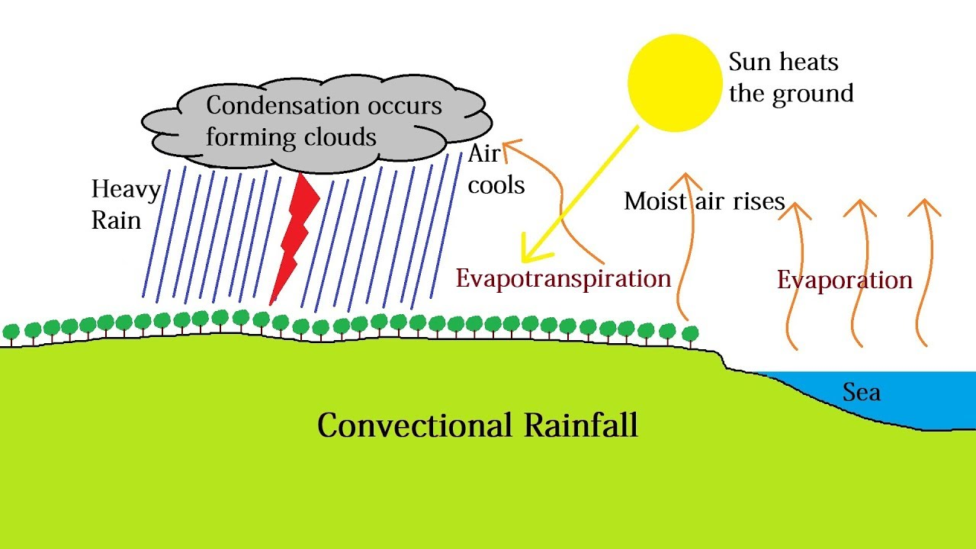

**RELIEF RAINFALL (OROGRAPHIC RAINFALL)**

Mainly received in high land areas (Mountains or hilly areas)

It is formed when moist air (wind) is forced to rise over a mountain, cools and condensation occurs.

Nimbus clouds are formed resulting into rainfall . The side which receives rainfall is known as windward side and the side that receives little or no rain is known as Lee ward side.

**Diagram of relief rainfall.**

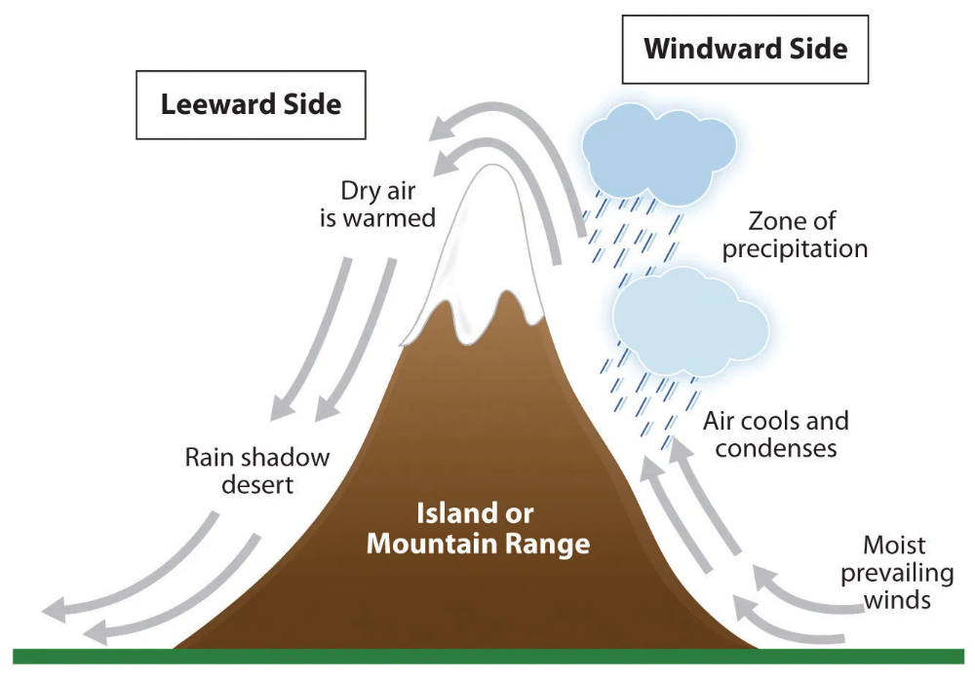

**CYCLONIC / FRONTAL RAINFALL**

It is formed when moist air meets cold air. The warm air which is lighter rises over the cold air when the warm air condenses, it falls as rainfall. The meeting point between warm air & cold air is called a front.

It occurs in the plain region of Karamoja, North and N. Eastern Kenya.

**(Diagram of cyclonic rainfall)**

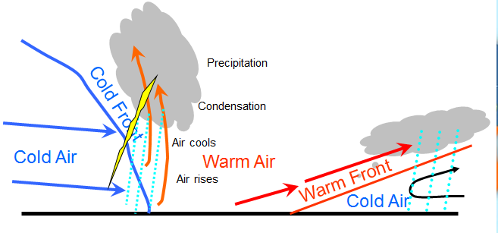

**INFLUENCE OF CLIMATE BY HUMAN ACTIVITIES**

Climate greatly influences human activities and it determines the activities done in an area.

Areas with plenty of rainfall, people carry out agriculture. (Crop Farming).

Areas that get little rainfall followed by long dry period do not favour crop farming and people carry out nomadic pastoralism e.g. in N. Eastern Uganda and N. Eastern Kenya, people here grow short yielding crops e.g. millet, sorghum.

**INFLUENCE OF HUMAN ACTIVITIES ON CLIMATE**

Some activities of man e.g. afforestation, agro-forestry, re-afforestation affect the climate of an area positively and others like deforestation affect it negatively.

**WEATHER RECORDING INSTRUMENTS**

A Stevenson screen keeps delicate weather instruments.

**Problems caused by weather**

* Floods
* Landslides
* Storms
* Drought
* Avoid settling in low lands
* Planting trees to act as wind breaks.
* Discourage deforestation. Use of lightening arrestors

|  |  |
| --- | --- |
| **Instrument** | **Function** |
| 1. Raingauge | Measures amount of rainfall. |
| 2. Wind vane | Shows direction of wind |
| 3. Anemometer | Measures speed of wind |
| 4. Barometer | Measures air pressure |
| 5. Six’s thermometer | Measures the minimum and maximum temperature of the day. |
| 6. Sunshine recorder | Measures the intensity of sunshine. |
| 7. Hygrometer | Measures humidity |
| 8. Windsock | Measures strength of winds. |
| 9. Stevenson screen |  |

**TYPES OF FARMING IN E. AFRICA**

**Subsistence farming**

This is the growing of crops and rearing of animals for home use.

Most farmers in E. Africa practice subsistence farming because it is cheap, it requires a small piece of land, simple tools and cheap labour.

**Disadvantages of subsistence farming**

* Leads to low yields
* Farmers get low incomes.
* Crop disease can easily spread.

**Guarding against disasters above**

* Use of proper farming methods
* Avoid settling near river banks

**Mixed farming**

This is growing of crops and rearing animals on the same piece of land under the same management.

**Advantages**

* Double income got
* Crops are used to feed animals.
* Animal dung provides manure.
* In case of long drought, the farmer depends on animals.

**Disadvantages**

* It is expensive to manage
* Requires skilled labour
* Requires a large piece of land.
* Animals can easily damage crops.

**Plantation farming**

This is the growing of one perennial crop on large scale e.g. cocoa, tea, coffee, sugar cane, rubber, sisal, tobacco.

**Advantages**

* High yields and income.
* Continuous harvesting.
* Provide employment
* Provides raw materials to agro based industries

**Disadvantages**

* It is expensive
* Requires a big piece of land
* In case of a disaster, high losses are realized.
* Requires skilled labour
* Promotes monoculture which leads to soil exhaustion.

**Commercial farming**

This is the growing of crops on large scale for sale.

**Ranching**

This is keeping cattle on large scale for beef production.

Products from a ranch are beef, hides for making belts, bag and shoes, horns for making buttons and glue.

Cow dung fertilizes the soil in making bio gas.

**Diary farming**

This is keeping cattle for milk and its products like butter, ghee , yoghurt, cheese.

**Nomadic pastoralism**

This is the movement of people and their animals looking for water and pasture.

Pastoral tribes are Karimajong, Masai, Turkana.

**Arable farming**

This is growing crop only.

**Floriculture**

This is growing of flowers on large scale for sale.

**Horticulture**

This is growing of fruits, vegetables and flowers for sale.

**IMPORTANCE OF FARMING**

* Source of food
* Source of raw materials for industries
* Source of income
* Source of employment

**Problems faced by farmers**

* Pests and diseases
* Poor farming methods
* Poor soils
* Unstable prices
* Lack of capital
* Poor quality seeds
* Poor storage facilities
* Poor transport

**VEGETATION OF EAST AFRICA**

Review the kinds of vegetation which include natural and planted vegetation.

Vegetation refers to any plant cover of an area.

Types of natural vegetaton in East Africa are

* Tropical rainforests/ Equatorial vegetation
* Semi desert
* Savannna
* mangroove swamp / forests

Characteristics / features of each type of vegetation

Tropical rainforests/ Equatorial

**Characteristics/ features of each type of vegetation**

**Tropical rainforests/ Equatorial vegetation**

* They are evergreen
* Have tall trees
* Have thick undergrowth
* Have buttress roots
* They form a canopy
* Have hard wood trees
* Have climbing plants
* Found in areas with heavy rainfall

**Mountain vegetation (Montane / Highland vegetation)**

It’s composed of snow, bare rocks, heath and moorland, bamboo forests, rainforests and savannah.

It is greatly influenced by altitude.

**Diagram showing Montane vegetation**

Review the definition of grassland and give examples of grass found there.

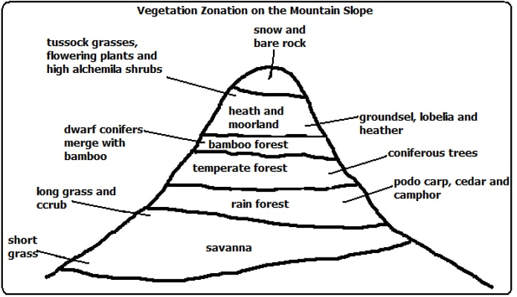

**Tropical grassland/ Savanna**

* Divided into Savanna grasslands and woodlands
* It covers the biggest part of East Africa.
* Scattered trees and shrubs
* Some trees are resistant to dry conditions e.g. Acacia and bamboo.
* Savanna grasslands are sources of pasture for many wild animals.
* Most game parks are found there because there is good pasture, shelter, warm weather and availability of water.
* Covers the biggest part of E. Africa.
* Woodland savanna is known as Miombo woodland in Tanzania.
* The main activity in Miombo is Bee keeping.
* Miombo woodland is sparsely populated due to presence of tsetse flies

**Control of tsetse flies**

* Spraying
* Using tsetse fly traps
* Clearing bushes

**Semi desert vegetation**

* They receive little rainfall
* Trees have roots which go very deep
* Thorny shrubs and cactus trees
* Scattered and short grass
* Trees have thick bark
* In Uganda, it is located in North Eastern part, northern Kenya.
* Some vegetation e.g cactus are able to survive here because they can store water in the thick and fleshy parts.
* Main economic activity is Nomadic Pastoralism.

**Mangroove forests/ swamps**

* Hardwood and water proof timber
* Timber used for ship building
* They grow in or near especially in the coastal region of E. Africa.
* They have buttress roots.

**Planted forests**

* They are planted by human beings
* Provide building material e.g timber and furniture.
* Provide soft wood used in making paper, ply wood and soft boards.
* Species of trees found there are conifers, pines. Eucalyptus, cypress, spruce, fig etc.

**Characteristics**

Trees of the same species are planted in one area.

* There is little undergrowth.
* Planted in straight lines.
* Grow and mature fast.

**Examples in Uganda.**

* Lendu
* Magamaga
* Kakwa
* Kondo
* Mafuga in Bushenyi
* Bugamba in Mbarara.

**FACTORS INFLUENCING VEGETATION DISTRIBUTION**

**Climate**

* Rainfall determines vegetation growth. Vegetation cover varies form place to place depending on rainfall and temperature.
* Areas with reliable rainfall have thick vegetation compared to those with low rainfall that have scattered trees and shrubs.

**Altitude**

* Areas at high altitude experience cool temperatures which have great influence on vegetation. Mountain areas usually have plenty of rainfall and fertile soils.
* Vegetation changes with altitude.

**Soils**

Fertile soils support vegetation growth while areas with infertile soils have poor vegetation.

**Human activities**

Some activities of man support vegetation growth while others hinder vegetation growth.

**Activities that affect vegetation negatively.**

* Human settlement
* Industrialization
* Overstocking
* Deforestation
* Swamp drainage

**Activities that promote vegetation growth**

* Afforestation
* Re- afforestation
* Agro- forestry
* Good farming methods.

**Drainage**

This is the water supply of an area.

Good drainage influences thick vegetation.

**Government policy**

* Government policies can promote vegetation growth.
* Controlling environment degredation through NEMA.
* Supplying trees to farmers.
* Rural electrification reduces deforestation.

**Importance of vegetation to people.**

* Source of food
* Herbal medicine
* Provide building materials
* Fuel (wood & charcoal)
* Modify climate
* Provide shade
* Provide oxygen for human life & animals
* Controls soil erosion.

**Importance of vegetation to animals**

* Source of food
* Habital (home) of wild animals
* Provide shade.

**FOREST CONSERVATION**

This refers to the way of looking after forests in such a way that they aren’t destroyed and used for future generation.

**Ways of conserving forests**

* Afforestation
* Re- afforestation
* Agro – forestry
* Encourage land fallowing
* Setting enforcement bodies to fight forest destructions
* Avoid bush burning
* Controlled grazing
* Provide alternative sources of energy e.g. bio- gas.

**EFFECTS OF POPULATION INCREASE ON VEGETATION**

* Encroachment on forested areas
* Led to charcoal burning
* Encroachment increase has affected vegetation in these ways:-
* Encouraging on forests and grasslands for settlement agriculture and wood fuel.
* Re- afforestation changes vegetation patterns.

**GAME PARKS, ANIMALS AND THEIR IMPORTANCE.**

* Game parks are places where wildlife is protected by government for preservation.
* Wildlife includes insects, birds, plants and animals that live on their own.

Types of animals

* 1. **Herbivores**

These are animals that feed on vegetation (grass) e.g. elephants, giraffes, buffaloes, zebras, etc.

* 1. **Carnivores**

Animals that feed on flesh (meat) e.g. lions, hyenas, leopards etc.

* 1. **Omnivores**

These animals feed on both plants and meat e.g. pigs, warthogs.

**LOCATION OF GAME PARKS IN E. AFRICA**.

**Map of E. Africa showing game parks.**

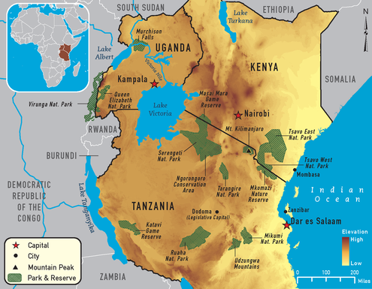

**Game parks and common animals fond there.**

* Mgahinga and Bwindi are famous for mountain gorillas.
* Kidepo for ostriches.
* Murchsion falls for crocodiles and Hippos
* L. Nakuru for flamingoes
* L. Mburo for flamingoes

**Importance of game parks**

* Tourism
* Employment
* Education and research
* Development of infrastructure
* Source of food
* Promotes friendship through tourism
* Conserve wildlife for future generation.
* Promotes the local art and crafts industry.

**Problems facing wildlife**

* Encroachment on game parks
* Poaching
* Wild bush fires
* Animal diseases
* Insecurity
* Prolonged droughts.

**Possible solutions**

* Enforcing laws againstpoaching.
* Provision of veterinary services.
* Providing security
* Discouraging settlement in game parks.
* Encouraging tree planting near game parks

**FACTORS THAT INFLUENCE WILDLIFE DISTRIBUTION**.

* Vegetation
* Government policy
* Security
* Availability of water.

**Other tourist attractions in E. Africa.**

**Physical features**

* Lakes
* Rivers
* Mountains
* Plateaux
* Rift valley
* Beaches
* Beautiful sceneries
* Poor publicity
* Sanctuaries
* Water falls
* Vegetation (forests)
* Historical sites
* Climate
* Religious sites e.g. Namugongo shrine
* Hot springs
* Zoos
* Marine parks.

**TOURISIM (NB:** Teacher should teach tourism i.e. definition importance of tourism)

**Problems faced by tourism industry.**

* Insecurity in the country
* Poor transport
* Poor accommodation
* Poor publicity
* Poor maintenance of tourist centres.
* poaching

**Solutions to problems**

* Providing security
* Proper maintenance of roads
* Building and maintaining hotels.
* Advertise internationally.

**Ways of promoting tourism**

* Adequate publicity in the mass media
* Setting up more tourist sites
* Improving on hotels
* Ensuring peace and security
* Improving social infrastructure
* Encourage people to invest in tourism.

**GAME PARKS AND GAME RESERVES IN E. AFRICA**

* Game Park - area set aside by gov’t to preserve wild life for tourism.
* In a game park, hunting is not allowed.
* Illegal hunting in game parks is called Poaching.
* A game reserve – area set aside by gov’t for future development into a game park or settlement area.
* In a game reserve, hunting is not allowed with permission.
* Most game parks are found in the Savanna grasslands because of good pasture and shelter for animals.
* Animals like chimpanzee, gorillas, are found in forests where they can get fruits, berries for food.

**MINERALS**

A mineral is a chemical compound which naturally occurs in the earth’s crust and forms the basis of rocks.

**Types of minerals**

Metallic minerals e.g copper, tin, aluminium, gold, diamond.

Non metallic minerals e.g phosphates, limestone, salt, petroleum.

**MINING**

Is the digging of mineral ores from the ground. The major minerals in E. Africa are salt diamond, phosphates, gold, soda ash, gemstones, coal.

Map of E. Africa showing mineral deposits)

**Methods of mining**

* **Shaft mining** – It involves sinking of vertical shafts down to the core. It is also called tunnel mining.
* **Open cast mining** – It involves removing of top rock layers covering the mineral ore. It is used to mine minerals that are near the surface.
* **Adit mining**
* **Panning** – It is used to mine gold.

**Importance of mining**

* Provides raw materials to industries
* Employment
* Leads to industrial growth
* Leads to development of roads & railways.
* Minerals are sold to get income.

**Problems created by mining industry**

* Environmental pollution
* Destruction of vegetation
* People can be resettled to open up mines.

**Problems facing mining industry**

* shortage of skilled labour
* shortage of capital
* mineral occur in small quantities
* insecurity in some mining areas

**Problems facing mining industry**

* Shortage of skilled labour.
* Shortage of capital
* Minerals occur in small quantities.
* Insecurity in mining areas.

**WATER BODIES**

1. The major water bonies in East Africa incluke lakes, rivers, oceans and swamps.

2. Water bodies are used for

* Water transport
* Fishing
* Generating hydro electricity (rivers)
* Provide water for irrigation
* Tourism
* Recreation

**3. Fishing in East Africa**

* Fishing is the act of catching fish from water bodies
* The major fishing ground in East Africa is lake Victoria
* Others include: Lake Tanganyika, L. Albert, L. George L. Turkana, River Mile, Indian Ocean etc.

4. **Methods of fishing**

**Traditional methods**

* Using spears
* Using baskets
* Using hands

**Examples of fish caught in East Africa include:**

1. Nile perch (The biggest in East Africa)
2. Tilapia (Commonest fish)
3. Lung fish

**Methods of preserving fish in East Africa**

* Sundrying (Cheapest method)
* Smoking (Commonest method)
* Freezing (Using refrigerators)
* Timing (canning)

**Importance of fishing in East Africa**

* Provides employment chances
* Sources of income
* Provides raw materials to fish processing industries
* Sources of food to people
* Helps to diversify the economy

**Problems facing the fishing industry in East Africa**

* Poor fishing methods
* Presence of water weeds (hyacinth)
* Poor storage facilities
* Shortage of capital
* Presence of dangerous water animals
* Poor transport network to fishing sites

**Solutions to the fishing problems**

* Arrests people who catch young fish
* Provide better storage facilities
* Removing the water hyacinth
* Use refrigerated vehicles to transport fish
* Improve on transport network to landing sites

**INDUSTRIALIZATION IN E. AFRICA**

* Industrialization is the process by which industries are set up in an area.
* An industry is allocation of firms which produce goods and services.
* A factory is a place where raw materials are processed into finished goods.
* A factory is a place where goods are made using machines.

**Types of industries in E. Africa**

**PRIMARY INDUSTRY**

These industries deal with extracting raw materials from the ground or water bodies. e.g.

* Mining
* Fishing
* Farming
* Lumbering

**SECONDARY INDUSTRIES**

These are industries which use raw materials from primary industries to make products.

They include processing and manufacturing industries. Processing industries slightly change the form of extracted raw materials and the final product is of a higher quality and value manufacturing industries use various raw materials to make final products e.g. ship building, car and bicycle making, furniture making, iron and steel working.

**TERTIARY INDUSTRIES.**

These industries provide services to people such as transport, health, office work, education, printing, security, insuranceand banking.

**TRADITIONAL INDUSTRIES**

These are locally established home industries. Here goods are made by use of simple tools and technology and manual labour is used.

Examples are

* Pottery
* Weaving
* Metal working
* Sculpture
* Carpentry
* Bakery

Factors for the location of and industry include:-

* Land
* Labour
* Capital
* Management
* Raw materials
* Transport

**Advantages of industrialization**

* Leads to improved infrastructure; transport and communication.
* Creates jobs
* More good are manufactured
* Creates market for local raw materials
* Promotes agriculture
* Goods become cheaper since they are manufactured within.
* Widens the export base.

**Disadvantages of industrialization**

* Pollution of the atmosphere.
* Contamination of land and water sources.
* Leads to deforestation.
* Displacement of people.
* Noise pollution
* Leads to rural – urban migration.

**FACTORS THAT LED TO THE INTRODUCTION OF SOCIAL SERVICES.**

* Disease treatment.
* Promotion of trade.
* Need to prevent environment degradation.
* Civilization of society.
* Interdependence.
* Need for specialized skills.

**Problems faced by government when providing services.**

* Shortage of funds.
* Corrupt government officials.
* Poor infrastructure e.g. roads, communication network.
* Shortage of skilled labour.
* Low levels of education illiteracy.
* Political instability.
* Rapid population growth.

**What can the government do to improve services.**

* Fighting against corruption.
* Ensuring security in the country.
* Constructing good roads and maintaining them regularly.
* Getting loans.
* Promoting education/training man power on new techniques.
* Sensitizing people about the importance of small families

**CONTROLLING POPULATION GROWTH**

* Family planning.
* Tax benefits to small families
* Education benefits to small families
* Legalization of abortion.
* Discouraging early marriages
* Discouraging early marriages
* Discouraging polygamy
* Teach people the disadvantages of a big family.

I**TRANSPORT IN EAST AFRICA.**

Transport refers to the movement of goods, people and services from one place to another.

**Types of transport**

* Road Transport.
* Railway Transport.
* Water transport.
* Pipeline transport.
* Animal transport mostly used in hilly areas.
* Air transport.

**ROAD TRANSPORT.**

It is the commonest type of transport in East Africa.

**Means of Road Transport.**

Cars, Motor Cycles, Buses, Bicycles, Lorries, etc

Types of Roads.

1. Murram roads
2. Tarmac roads

Murram roads are dusty during the dry season and become muddy and slippery during the rainy season.

**Advantages of road transport.**

* It is common and flexible.
* It is cheaper to construct compared to other types.
* It does not keep a fixed time table.
* It is faster over short distances.
* It has many means of transport.

**Disadvantages of road transport.**

* It is affected by traffic jam in big cities.
* A lot of accidents on roads.
* Roads are easily damaged by bad weather.
* Roads need regular maintenance (expensive to maintain).
* Murram roads to lead to healthy problems.

**Interventions done to solve traffic jam in the city.**

* Widening of roads.
* Use of traffic police, traffic light.
* Discuss aspects of bodabodas in the city with pupils.

**WATER TRANSPORT**

It is one of the cheapest forms of transport in East Africa.

Used to carry fragile goods and bulky goods

It is the slowest type of transport.

**Means of water transport.**

Ships, Canoes, Ferries, Motor boats.

Water transport on some rivers of East Africa has not fully developed due to;

* Water falls.
* Rapids.
* Huge rocks.
* Dangerous water animals.
* Ships operate on large masses like Oceans, Seas, Lakes etc

**PORTS**

Some ports are in the Interior and are termed as inland ports e.g. Kisumu, Port Bell, Mwanza, Jinja Bukakata, Bukoba on Lake Victoria.

Other ports are at the Coast and are called Sea Ports; East Africa has two major Sea Ports i.e. Mombasa and Dar-es-Salam. Port Mombasa for Kenya and Dar-es-Salam for Tanzania.

These ports help to handle imports and exports among East African Countries.

**Advantages of water Transport.**

* It is cheap.
* It is not easily affected by traffic jam.
* It transports fragile and bulky goods
* Less accidents compared to other types.
* Fewer cases of robberies.
* Water ways are not expensive to maintain.

**Disadvantages of Water Transport;**

* It is slow and cannot transport perishable goods.
* It can be affected by storm.
* Fumes from engine of boats and ships pollute the air/water.
* It can be blocked by floating vegetation.
* It is not flexible.
* Facilities at landing sites are expensive to build and maintain.

**AIR TRANSPORT**

Means of air transport are Aeroplanes, Helicopters, Paracutes, rockets etc.

Aeroplanes specifically land at air ports and air fields while Helicopters can land any where.

International air ports in East Africa are;

* Entebbe-Uganda
* Nairobi-Kenya
* Dar-es-Salam and Kilimanjaro-Tanzania

Besides International airports, there are also internal air fields that facilitate national flight with in a country.

**Advantages of Air Transport.**

* It is the fastest of all types.
* Best for transporting perishable goods.
* Doesn’t suffer from traffic congestion.
* Suitable for transporting goods over long distances.
* Operates on fixed time table and no time wasting.
* It is comfortable and less tiresome.
* There is greater security and protection of Passengers.
* IT is not easily

**Disadvantages of Air Transport**

* It is usually affected by bad weather leading to plane crush.
* It is expensive to construct airports.
* It is only profitable for high value goods.
* It is not flexible.

**Railway Transport**

* Railway network in East Africa was established during the colonial times. Colonialists wanted railway transport developed in East Africa.
* It was mainly to link Coastal ports to interior administrative centres.
* It was aimed at collecting raw materials and carrying farm supplies like machinery.
* The first railway line built in East Africa was Tanga-Korogwe from 1893-1902 by the Germans in Tanganyika.
* It was built to provide easy transport for Cash crops.
* Tanzara railway was built between 1970-75 by both Tanzania and Zambia hence, named Tazara, it is also called Tanzam.
* It was constructed to transport copper from Zambia copper belt to Dar-el-Salam port for exportation.
* It connects Zambia to the East African Coast since it is landlocked.
* It was constructed by the Chinese expatriates.

**N.B:** Map showing the East African Railway Network

**Central railway line**

It starts from Port Dar-es-salaam through Tabora to Port Kigoma on Lake Tanganyika

**Kenya –Uganda Railway;**

It started at Mombasa in 1896 by the British.

**Reasons for its construction.**

* To make trade easy.
* To link Uganda to the East African Coast.
* Ease administration in the Interior.
* To encourage white settlers into Kenya.
* To develop Uganda economy.

The British imported Indian Coolies who built the Kenya –Uganda railway. This was so because;

* The natives never wanted to work far from their homes.
* They also never knew the importance of the railway.
* They did not want the railway to pass through their land.

**Problems faced during the construction;**

* Attacks from tropical diseases.
* Attacks from hostile tribes e.g. Masai/Nandi.
* Attacks from Man eater; lions at Tsavo.
* Too difficult and expensive to construct the railway line through rift valleys, mountains and swampy areas.
* Shortage of food.
* Shortage of skilled labour.

**Important personalities during the contruction;**

Sir William Mackinon

* He Suggested the idea of construction the Uganda railways.
* He was the founder of IBEACO.

Sir George White House

* He was the Chief engineer during the construction of the Uganda railway.

Sir William Mac Donald

* He was the Chief surveyor of the area where the railway was to be built.

Col. Patterson

* He killed the two fierce lions (Man eaters) at Tsavo.

Sir Guildford Moles worth

* He was the last engineer to carry out inspection of the already built Uganda railway.

**Results of the Uganda Railway**

* Uganda was linked to the East African Coast.
* Slave trade was stopped.
* Administration to the Interior was made easier.
* Easy transportation of goods and people.
* Led to development of towns where the railway passed.
* White settlers came to East Africa.

**Negative effects**

* Bad Western culture came to East Africa.
* Displacement of people from their land.

**Why the Railway was extended to areas below;**

**Kasese**-To transport Copper to Jinja for smelting.

**Namasagali-** To transport Cotton to Jinja for exportation.

**Pakwach** – To transport Tobacco and other produce to market centres in Kampala.

**Advantages of Railway transport**

* It is very cheap over long distances.
* It transports bulky goods.
* It is not affected by traffic jam.
* Fewer cases of accidents.
* Railway routes are more direct.
* It is not easily affected by bad weather.

**Disadvantages.**

* It is slow.
* It is not flexible.
* Rails are expensive to construct and maintain.
* It has few means (It is not common)

**PIPELINE TRANSPORT.**

It is one of the modern ways of transporting liquids like water and petroleum products.

The first pipeline in East Africa was built by Italian.

It runs from Dar-el-Salam to the copper belts of Zambia.

It was completed in 1986.

There is a pipeline from Mombasa to Eldoret transporting petroleum products.

**Advantages**

* Less labour is used to transport oil by pipelines.
* Less fuel is used to deliver oil from one place to another.
* It reduces traffic jam on roads and railway lines.
* Different types of petroleum can be pumped through the same pipeline.
* It is less costly compared to other types.
* It is quicker and easier than railway and roads.

**Disadvantages.**

* Pipelines are expensive to buy and install.
* They are not flexible.
* Incase of leakage, it takes some time to realize it.
* Pipes are very costly to repair.

**COMMUNICATION**

It is the sending and receiving of messages.

There are two types of communication i.e. modern and local communication.

Examples of modern means of communication include; Radio, Mobile phones, Television, Telegram, Telex, Email, and Internet, Newspapers, Magazines, letter writing etc.

Examples of local means for communication; using drums, Blowing horns, clapping, whistling, using gestures, smoke signals.

**RADIO**

It is he most widely used means of communication in East Africa.

**Examples of radio stations in Uganda include;**

Star FM, CBS, Kngdom FM, Capital FM, Sanyu Radio, Power FM etc.

**Advantages of a Radio**

* Can be used by people who cannot read.
* Provides current news.
* Used for entertainment (music)
* It is affordable.
* Used for announcements.
* Provides educative programs.
* Provides employment to people.
* Used for advertisements.

**Why Radio communication is widely used in E.Africa**

* It covers a wide area.
* It is fast
* It is cheap/affordable.
* It caters for the dumb and blind as well.
* It allows use of variety of language.

**Disadvantages of a Radio.**

* Information cannot be stored for future use.
* Can sometimes give false information.
* Some programs on radio teach immoral behavior.

**NEWSPAPERS**

Newspapers published in Uganda include;

New Vision, Bukedde, Orumuri, Rupiny, Etop, Monitor, Red Paper, Weekly Observer. Let pupils identify government and private newspapers.

**Advantages of Newspapers**

* Provides current news.
* Can be stored for future use.
* Announcements.
* Advertisement.

**Disadvantages.**

They some times show pornography.

Publish false information.

Used by only literate people.

Expensive to buy on daily basis.

Take long to reach remote areas.

**TELEPHONES;**

It is the fastest means of communication used in East Africa.

Telephone companies in Uganda are;

MTN- Mobile Telephone Network.

AirTel- Uganda Telecom Limited (UTL), , Orange, Smile etc.

**Advantages of Telephone;**

* It is very fast.
* Gives immediate feedback.
* It saves time.

**TELEVISION**

**Examples of Television Stations in Uganda are;**

UBC, TV, WBS, LTV, Record TV, NTV, Top TV, NBS, Bukedde, E.A TV, DSTV.

**Advantages**

* It provides both sound and pictures.
* Provides current news.
* Gives entertainment.
* Announcements.

**Disadvantages;**

* Showing pornography.
* They are expensive.

**DEVELOPMENT OF SOCIAL SERVICES IN EAST AFRICA**

Social services are services provided to the public by government and non-government organizations.

Examples of social services include; Health, Education, transport, Communication, Security, religion.

Social amenities are services provided to people to improve their welfare with a pay e.g. Piped water, electricity, garbage collection.

**EDUCATION;**

There are two types of education thus;

Formal and informal education

Before the coming of European, people were getting informal education from their homes, elders acted as teachers while fire places were classrooms, subjects taught include; music, games, cooking, hunting, crafts, culture, grazing etc.

**Formal education**;

It was started by European missionaries.

Subjects taught include; reading, writing, arithmetic, geography, religious education etc.

All the first schools, in East Africa were started by missionaries e.g. Namilyango -1902.

Mengo -1903, Budo- 1906 and Gayaza- 1905.

**Importance of education;**

* It provides us with knowledge and skills that enable us to live better lives and utilize the environment more usefully.
* We get professionals like Doctors, teachers, Engineers, etc that sustain our economy.
* It eradicates illiteracy.
* Ways government is promoting education in Uganda today.
* Explain universal Primary Education.
* Give other alternative forms of education in Uganda.

**MEDICAL CARE**

When people are healthy, they are able to work and contribute to economic development.

Places that provide health services include;

* Hospitals
* Health centres
* Dispensaries
* Clinics

The earlier medical centres in East Africa were setup by European missionaries e.g. Mengo-1897, Nsambya and Rubaga hospitals

The first government hospital in Uganda was Entebbe Grade B hospital

The biggest hospital in Uganda is Mulago which was commissioned by governor Sir Walter Coutts.

**TERM III**

**THE ROAD TO INDEPENDENCE**

**EXPLORERS IN EAST AFRICA**

Explorers were a group of people who came to East Africa to find out more about East Africa’s physical features and customs of people.

They came from Europe mainly sent by the Royal Geographical society.

The first group of explorersto come were Portuguese explorers

They wanted to find a sea route to India

**Why did European Explorers come to East Africa?**

* To find the source of R. Nile
* To find trade opportunities (market for their goods)
* Too pen up way for missionaries
* To find chances for acquiring colonies

**THE PORTUGUESE EXPLORERS**

* These were the first European t come to East Africa
* They came from Portugal whose capital is Lisbon
* They wanted to find the sea route to the far east (India)
* They wanted spices and silk from India and China due to the good climate that favoured their growth.
* At first they brought spices over land through the black sea ports
* The journey overland was long, slow difficult and tiresome making spices very costly to transport.
* The Otto man empire (Turkey) was the enemy of Europe and China and prevented trade overland
* Prince Henry the navigator of Portugal started a school for sailors at Port Sagress.
* He wanted to send them as far as India. Before, several Portuguese navigators had tried to find a way to India but failed.
* Henry taught his sailors not to be afraid of Africa and African ways.

**Reasons why sailors were afraid of going very far**

* They feared that big oceans would break their ships
* They thought that they would never find their way back and die of thirst and hunger
* They thought that the world was very flat ta edges were covered with mist and clouds
* They feared that big sea animals would swallow their ships.

**Bartholomew Diaz**

* Africa was called a dark continent because little was now about its interior.
* Bartholomew Diaz was the first Portuguese to attempt to find the sea route to India
* He set off with some others sailoros from Lisbon. On their way off the coast of South Africa (Cape Town) their ship capsized off the coast,
* They were able to swim a shore to Cape Town Diaz became the first Portuguese explorers to reach the southern part of Africa.
* It was at first named the cape of storms butKing Emmanuel renamed it the Cape of Good of hope because he had hope of finding India.

**Vasco Da Gama**

* He started his journey at Lisbon in 1497 and found the Sea route to India.
* .He discovered that Arabs were already trading there (at the coast of E. Africa)
* .He was not welcomed by Arabs at the coast.

**Qn.:** Why didn’t Arabs welcomed Vasco Da-Gama at the coast?

* Arabs feared Europeans interference in their trade
* Arabs disliked Christian religion spread by Europeans.
* The only coastal town that welcomed him was Malindi
* The Sultan of Malindi gave him a guide called Ahmed-bin-Majid who led him to India.
* Vasco-Da-Gama reached Calcutta (Coast of India) in may 1498
* The Portuguese set up their headquarters at Mozambique.
* In East Africa, Mombasa their headquarters where they build Fort Jesus for protection.
* Today it attracts tourists who ring income
* It is a source of employment
* (Map showing Vasco –da-gama’s sea route to India)

**Portuguese conquest of East Africa**

**Qn.: Why were the Portuguese interested in the East African coast?**

* They wanted to control the coastal trade
* They wanted to create a resting base for their sailors
* They wanted to spread Christianity
* They wanted to break Moslems domination at he coast
* The Portuguese made a second visit to East Africa in 1502.
* They were now invaders and colonizers
* They took over control of the coast from Arabs and occupied the coast for 200 years.
* Later they were fought and defeated by Oman Arabs

Qn.: Why were the Portuguese successful in their conquest?

* They used surprise attacks and were united.
* They had superior weapons
* They used better military tactics

**Results of the Portuguese rule**

* They introduced Christianity
* They built Fort Jesus at Mombasa
* They introduced new crops of maize, pawpaws
* They set up trade links between Africa Coast and India
* They enriched the Kiswahli language by adding new words e.g. Meze (table)

**Negative**

* The wars led to destruction of property
* The wars led to loss of lives
* They led to decline of the coastal trade
* Heavy taxes charged by Portuguese affected trade
* Coastal tows were left in ruins

**Decline of the Portuguese rule**

* The coming of rivals from Britain and France weakened them
* They were affected by malaria, Diarrhea and dysentery
* The Portuguese officials were corrupt and incompetent
* They had few administrators
* They wee hated for being cruel
* Portugal was small and couldn’t all her colonies.

**OTHER EXPLORERS IN EAST AFRICA;**

**Henry Murton Stanley**

* He made three journeys to East Africa (1871-72).
* He came to look for Dr.David Livingstone.
* He was sent and sponsored by the Daily Telegraph of London and New York Herald in America.

**2nd Journey (1874)**

* He was sent to complete the work of Dr.David Livingstone.
* He sailed around Lake Victoria in order to prove whether it was the source of the Nile.
* He wanted to draw the map of Lake Victoria.
* He reached Kabaka’s palace in 1875 and was welcomed by the Katikiro called Mukasa on the Kabaka request.
* Katikiro called Mukasa on the KAbaka’s request
* He wrote a letter to England inviting Missionaries to come to Buganda.
* The letter was taken by a French man called Lenant De Bellfonds.
* He went to western Uganda and became the first European to reach the foot of Mt.Rwenzori and named it as mountain of the moon.
* He saw and named Lakes Edward and George.
* He later moved to Congo to trace the source of River Lualaba in central Africa.
* He proved Dr.Daivd Livingstone who first reported that river Lualaba was linked to River Nile Wrong.
* Instead R.Lualaba was linked to River Congo.

**3rd Journey**

* In 1887, he was sent to come and rescue Emini Pasha from the Equatorial province.

**John Speke and Richard Burton: (1856-58)**

* They had been sent by RGS to find the source of River Nile.
* They reached Zanzibar in 1856 and got permission from the Sultan who gave them porters.
* They left Bagamoyo in 1875 through Tabora where they were welcomed by the Arabs.
* They moved westwards to Lake Tanganyika and reached Ujiji.
* They became the first Europeans to see Lake Tanganyika.
* They went back to Tabora where Richard Burton fell sick.
* John Speke moved northwards to reach the shores of Lake Victoria on 30th July 1858.
* John Speke became the first European to see Lake Victoria and named it after Queen Victoria of England.
* Before, it was called Lake Nyanza in Tanganyika and Nalubale in Uganda.
* He believed it was the source of the Nile.
* He returned to Tabora and told Burton about his findings but they disagreed and returned to European as enemies. Also called Lake Ukererwe in Tanzania.

**John Speke and Jame Grant (1860-63);**

* Speke was sent back to prove whether Lake Victoria was the source of the Nile with James Grant.
* They were accompanied by the gunmen Sid Bombay and Mwinyi, Maburuki from the coast of East Africa.
* They reached Karagwe Kingdom and were welcomed by King Rumanika.
* Here Grant fell sick and Speke left him behind to continue to Uganda.
* Grant joined him later. Speke was the first European to come to Uganda. He arrived at Muteesa’s palace
* Exchanged gifts and Speke gave him riffle (gun) and other gifts like Knives and clothes.
* Speke reached the source of the Nile on 28th July, 1862.
* He named the falls at the source as Ripon Falls after Lord Ripon the President of RGS in Britain.
* It was the RGS that had paid for the two journeys Speke and his friends had made to East Africa.

**Sir Samuel Baker (1862-65)**

* He came with his wife to Africa and tried to find the source of the Nile from its mouth.
* He was also sponsored by RGS. He started his journey from Egypt following the Nile southwards.
* In 1863, he met John SPeke and Grant at Gondokoro in Southern Sudan who told him that they had found the source of the Nile. Baker continued southwards to reach the Palace of Omukama Kamurasi of Bunyoro. He became the first European to see Lake Mutanzigye in 1864 which he named Lake Albert after the husband of Queen Victoria of England.
* He became the first European to see and name Murchison falls. Murchison was the president of RGS after Ripon.

**Joseph Thompson**

* He was the first European to find the direct route from the coast to Lake Victoria through Masai Land.
* He reached Mt.Kenya, Lake Baringo, and Mt.Elgon.

**Dr.Fisher**

* He was a German Scientist who reached and named Lake Naivasha from the Coast via Kilimanjaro.

**Count Teleki;**

* He was a Hungarian who reached and named Lake Rudolf (Turkana) and Lake Stephanie on the Ethiopian frontier.

**Dr. David Livingstone**

* He is regarded as the greatest explorer to Africa.
* He made several journeys to Africa and spent a lot of his life time on the African continent i.e. from 1841-1873 when he died.
* During his third journey, rumours spread that he had died in Africa. H.M Stanley was sent to look for him. He met him at Ujiji on the shores of Lake Tanganyika in 1871. He refused to go back to Europe because he hoped to find the source of the Nilehe thought that the Nile was linked to Tanganyika.
* He was later proved wrong Dr.David Livingstone died in 1873 in Zambia near Lake Bangweulu. His body was carried to the coast by his two faithful servants Chuma and Susi. His body was laid to rest at Westminster Abbey in London (UK).

**Problems faced by Explorers**;

* Poor roads
* Shortage of supplies
* Hostile tribes
* Tropical diseases
* Crossing rivers and mountains
* Thick forests

**Effects of the explorers;**

* Opened up Africa to Europe.
* Renamed many features in East Africa.
* Opened up way for the coming of other Europeans.
* They found the source of the Nile

**Christian missionaries in East Africa;**

Missionaries are people who came from other countries to spread Christianity. The main groups that came to East Africa are; protestants (Anglican) and Roman Catholics.

They came from Britain, france, Germany and Italy

**Reasons why they came;**

* To spread Christianity.
* To fight slave trade.
* To teach reading and writing.

**John Ludwig Krapf;**

* He was the first Christian missionary to come to East Africa in 1844. he belonged to the church missionary society.

**Contributions.**

* Established the first mission station at RabbaiMpya at Mombasa-kenya.
* Translated the New Testament into Swahili.
* Wrote a Swahili dictionary and grammar book.
* First European to see Mt.Kenya and River Tana.

**John Rebman;**

* He joined Krapf in 1846 and was sent by the CMS. He moved and was the first European to see Mt.Kilimanjaro.

**Jocob Erhardt**

* He Helped in establishing Rabai Mpya and drew the first Sketch map of East Africa which helped encourage the penetration of missionaries to East Africa.

**Missionary groups that came to East Africa;**

* 1. Church Missionary Society
  2. Holy Ghost Fathers
  3. Universities Mission to Central Africa.
  4. London Missionary Society
  5. White Fathers
  6. Mill Hill Fathers

**Problems missionaries faced**

* Tropical diseases
* Unfriendly tribes and leaders.
* Language problems
* Poor roads.
* Shortage of supplies.
* Un favorable climate.
* Rivalry among communities.

**Achievements (positive)**

* Built hospitals
* Brought new crops.
* Introduced formal education
* Introduced new practical skills
* Taught Christianity
* Fought slave trade
* Resettled freed slaves.

**Negative**

* Distorted African culture.
* Brought disunity in East Africa.
* Involved themselves in local politics.
* Paved way for colonial rule.
* People became less obedient to local leaders after converting to Christianity.
* Pupils should explain how missionaries influenced socially, economically, and politically in East Africa.

**THE COLONIALIST /ADMINISTRATORS**

**Terms**;

**Colonialism**: This is a weak country controlled by more superior/strong country with interest of permanent settlement.

**Colony**: A country ruled by another mostly for investment.

**Protectorate**: this is a superior country which controls an interior country.

**Mandate**: A country ruled by another one on behalf of an organization.

**EGYPT ATTEMPTS TO COLONIZE UGANDA;**

* Khedive Ismael of Egypt made Sir Samuel Baker the first governor of the Equatorial Province (area in northern Uganda and southern Sudan) Baker established his headquarters at Gondokoro.
* He built forts like Patiko and Foweira and fought against slave trade in Acholi.
* Sir Samuel Baker was sent to colonize Uganda for Egypt because Egypt wanted to control the Nile from its source and also control trade in East Africa.
* The second governor of the Equatorial province was Col.Charles Gordon who built fort Mruli near Masindi.
* Dr. Emin Pasha was the third governor of the Equatorial province, he built Fort Wadelai. In 1881 the Sudanese soldiers revolted against Egyptian rule. The Equatorial province was cut off communication with Egypt.

**COLONIALISTS FROM EUROPE**;

**Sir William Mackinon**

He founded the IBEACO in 1888. The main aim was to establish trade with Britain. He wanted to promote good administration in East Africa and his company became a channel of extending British colonial rule. The company representatives signed treaties with local chiefs.

**Dr. Carl Peters**

He was a German colonialist. He arrived in Zanzibar in 1892 with the aim of establishing German rule in East Africa. He made several treaties with native chiefs in Tanganyika and established German rule. Indirect rule was used through Akidas and Jumbes.

**Captain Fredrick Lugard**

* He came to Uganda in 1890 to represent IBEACO. He signed a treaty of protection with King Daniel Mwanga of Buganda. He also signed treaties with Ntare of Ankole and Kasagama of Toro. He built his headquarters at Old Kampala.
* Returned to Britain in 1893 and campaigned for retention of Uganda as a British Protectorate.

**Sir Gerald Portal**

He was a British colonialist sent to Uganda in 1882 to study the political situation and advise whether Britain should take over its administration from the IBEACO. He signed a protection treaty with Mwanga in 1893 and recommended that Britain should retain Uganda as its protectorate and that the railway line should be built from Mombasa to Uganda. Fort Portal in Western Uganda is named after him.

**Establishment of colonial rule in East Africa The scramble and partition of East Africa**

* Scramble was the quick rush and struggle for territories by the Europeans in East Africa.
* Partition was the peaceful orderly sharing of East Africa’s land amongst the strong European countries.
* Spheres of influence were territories which each strong European country had to control over after the Berlin Conference.
* Kenya, Zanzibar and Uganda were regarded as the British Spheres of Influence while Tanganyika was regarded as the German Sphere of Influence.

**Reasons for the scramble of East Africa**

* They wanted to get raw materials from East Africa.
* Britain and Germany also wanted market for their finished goods.
* They wanted to create employment for people in their home countries.
* They wanted to invest their surplus capital.
* They wanted to gain home prestige (political fame).
* They wanted to stop slave trade and introduce legitimate trade.

**THE PROCESS OF THE SCRAMBLE**

* The progress of scramble
* The scramble of East Africa took place through signing agreements which could permit the Germans and British to control land in East Africa.

**COLONIALISTS WHO SIGNED TREATIES WITH EAST AFRICAN CHIEFS;**

**Dr.Carl Peters**

* He was a German colonialist and a trader.
* He arrived in Zanzibar in 1884.
* Established a trading company called GEACO (German East Africa Company) and was able to establish Germany rule in Tanganyika through signing treaties with the native chiefs in places of Usagara, Ungulu and Ukam.uZIGUA
* In 1889, he arrived atwind along the coastof Kenya, sailed along R.Tana with an Intention of making Kenya a German Colony.
* In 1890, Dr.Carl Peters made an agreement with Buganda and Wanfa Mukulu to enable them (Kenya and Uganda) to become German spheres of influence.
* Peters signed a protection treaty with Kabaka Mwanga in 1890 to indicate that Buganda was to be under the protection of Germans.

**Captain Fredrick Lugard**

* He was a representative of IBEACO in Uganda as well as the first administrator between 1890-93.
* He built a fort at Old Kampala and signed treaties of protection with some traditional leaders of Uganda i.e. Kabaka Mwanga who had refused at first because they had already signed with the Germany leader.
* He restored King Kasagama of Toro to his throne and signed a treaty with OmugabeNtare of Ankole in the same year.

**Sir Harry John Stone**

* He was an English scientist who had come to East Africa to study the life of plants and animals.
* He picked interest in the region around Mt. Kilimanjaro and was assisted by the Chagga people to sign a treaty with some local chiefs of the land at Taveta.
* He requested the British government to take control of that land which he refused at first and later accepted.
* He signed the 1900 Buganda agreement on behalf of he British

**Effects of the scramble**

* It led to the formation of the Berlin Conference.
* It led to partition of East Africa.
* It led to Union of centralized monarchies.
* It made Africans to lose their independence.
* It speeded up the process of colonization.

**Map showing the European sphere of influence;**

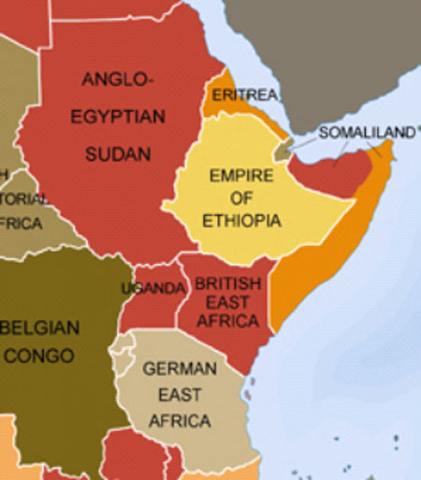

**THE BERLIN CONFERENCE OF 1884-1885**

* This was a great meeting held in the country of Germany city of Berlin by the strong European nations.
* It was chaired by the German leader Chancellor Otto Von Bismarck
* German, France, Italy, Britain, Belgium, Spain, Portugal, Belgium
* The main objective of this meeting was to promote peaceful partitioning of Africa.

**Resolutions of the conference**

Any powerful country was free to claim land in Africa.

* Once land was claimed, it was supposed to be governed and no other European country was to claim for it.
* For extension of any rule in Africa, other European countries had to be informed.
* The colonial powers had to stop slave trade in their colonies.

**Effects of Berlin Conference**

* Africa was partitioned by the Europeans.
* Colonial rule started in Africa.
* Africans lost their independence.
* Europeans started setting up businesses in Africa.

**THE PARTITION OF EAST AFRICA**

* Partition was the peaceful and orderly sharing (division) of East Africa by powerful European nations.
* The partition of East Africa was categorized into two, the first partition was made after signing the Anglo-German agreement of 1886.
* This agreement made the British and Germans to divide East Africa between themselves.

**Effects of the Anglo-German agreement 1886;**

* It made the Sultan territory to be identified at the coast including the islands of Pemba, Mafia, Lamu, Mogadishu. Etc.
* The territory between R.Ruvuma and South of R.Tana was divided by an imaginary line which marked the present day Kenya and Tanzania.
* The Northern was given to the British and Southern to the Germans.
* It made Uganda to be untaken by either Germany or Britain.

**THE SECOND PARTITION OF EAST AFRICA**

It took place after the signing of the 1890 Anglo-German Agreement which was also referred to as the Heligo Land treaty.

**EFFECTS OF THE ANGOLA GERMAN AGREEMENT 1890**

1. Zanzibar and Pemba became British Protectorates
2. Ii) Britain took Uganda in exchange for Heligo Island
3. Germany surrendered Wifu to Britain

**Formation of the LEGCO in Uganda;**

1. Write LEGCO in full.
2. Why was LEGCO formed in Uganda in 1921?
3. Why did it take long for Africans to join LEGCO in Uganda?
4. Identify the first three Ugandans to join the LEGCO in 1946.
5. Compare LEGCO to parliament of Uganda today.
6. What new name was given to LEGCO after independence?
7. How did the first Africans join the LEGCO?
8. Why did the people of Buganda resist sending representatives to the LEGCO at first?

**THE NAMIREMBE AGREEMENT**

1. What was the major cause of the Kabaka crisis of 1953?
2. Why did Sir Andrew Cohen exile Mutesa II in 1953?
3. What agreement was signed to return Sir Edward Mutesa II from exile in 1955?
4. Name the people who represented each of the following during the signing of the Namirembe agreement, Buganda government/British.
5. Why were political parties formed in 1950s?
6. What was the first national political party (in full) to be formed.

**PRIMARY SIX TROPICAL QUESTIONS**

**THE E.A.C**

1. Name the regional body that joins the three countries that are found in East Africa.
2. List down four reasons why East African community was formed.
3. Which body was replaced by East African community?
4. List down three founder members of the East African Community.
5. Outline four organs of the East African Community.
6. Who was the president of Uganda by the time the E.A.C collapsed?
7. Give two reasons why East African Community collapsed.
8. Where are the headquarters of the E.A.C?
9. Who is the current chairman of the E.A.C?
10. Name the two countries that join EAC AFTER Tripartite treaty.
11. Outline four benefits of E.A.C to Uganda as a member state.
12. When was the E.A.C revived?
13. List down the names of heads of state who revived E.A.C.
14. Name the Law making organ of E.A.C.
15. Who is the current secretary general of East African community?
16. Outline at least two symbols of E.A.C.
17. Mention three challenges of the E.A.C.
18. What is the meaning of olive branches on the E.A.C coat of arms?

**METHODS USED TO ESTABLISH (EXTENDED) COLONIAL RULE IN E.AFRICA**

**-** Using military force

- Signing treaties

- Through trading companies

- Using missionary work

- Through collaborators

**SYSTEMS OF ADMINISTRATION IN EAST AFRICA**

1. Direct rule
2. Indirect rule

**INDIRECT RULE**

This is a system of rule where colonialists ruled through ideal chiefs and kings

- It was introduced by Captain F.D Lugard

**Reasons why the British used indirect rule**

1. It was cheap to use local leaders
2. Shortage of man power
3. To control rebellions
4. To solve the problem of language barrier

**Effects of indirect rule**

* African customs wee preserved
* Africans learnt new systems of administration
* It reduced rebellions
* It solved man power problems.

**DIRECT RULE**

* it is where the colonialists used their own officials to rule the natives.
* It was mainly by the Germans
* They used the Akidas and Jumbas to rule Tanganyika

**Reasons why the Germans used direct rule**

1. They believed in their superiority over Africans
2. They wanted to promote Germany culture
3. They wanted to fully exploit East Africa’s resources

**Disadvantages of direct rule**

* Traditional rulers lost their powers
* It promoted rebellions among Africans
* It undermined African cultures
* It created hatred between Africans and German colonialists

**Colonial administration in Kenya**

* Kenya was declared a British colony in 1895
* The head of the Kenya colony was at first a commissioner and later governor (1906)
* The first British governor was called Sir James Sadler
* The last British governor was called Sir M J Macdonald
* The major issue during colonial times in Kenya was the Kenya highlands that were once owned by the Kikuyu
* The Legco in Kenya was formed in 1906 but the first representative was appointed in 1944 called Eliud

**Mathu**

White settlers in Kenya were encouraged and led by Lord Baron Delamere

**COLONIAL ADMINISTRATION IN TANZANIA**

* Tanganyika was declared a German colony in 1890
* The Akidas and Jumbes were appointed to replace traditional rulers

**Qn:**

* Why Tanganyika had many rebellions
* Germans had no respect for the natives
* They never allowed natives to grow cash crops on their own
* Africans were forced to work on whites plantations
* Germans wee harsh towards natives.

**HOW GERMAN RULE IN EAST AFRICA ENDED**

* In 1914, Germany started world War I Germany East 1918
* Germany lost all her colonies including Germany East Africa
* Tanganyika was given Britain by the league of Nations as a Mandate territory ie. Tanganyika was ruled by Britain on behalf of he league of Nations
* German East Africa changed its name to Tanganyika in 1919

Qn:

* Why was the league of Nations (LON) formed?
* To prevent any other world war from braking out
* The first British governor ofTanganyika was Sir Horace Byatt
* The last British governor of Tanganyika was Sir Richard Turnbull

**COLONIAL RULE IN RWANDA AND BURUNDI**

* Rwanda and Burundi were both colonized by Germany
* The Germans used indirect rule to administer Rwanda and Burundi
* Having lost the First World War, Germany lost Rwanda and Burundi to the league of Nations.
* Rwanda and Burundi were handed over to Belgium as mandate territories.

**Qn: Why did attain independence earlier than Uganda and Kenya?**

* Tanganyika was mandate territory
* TANU put a lot of pressure on UNO to grant it independence
* Julius Nyerere co-operated with the lost governor of Tanganyika Richard Rurnbull.

Qn: Give three economic policies during colonial rule

* Compulsory cash crop growing
* Hut and gun tax payment
* Fertile land was given to white settlers

**AFRICAN REACTION TO COLONIAL RULE**

* Some Africans collaborated
* Other Africans resisted

**Examples of collaborators include**:

* Laibonlenana of Masai
* Nabong Mumia of Toro
* Sir Apollo Kaggwa of Buganda
* Omukama KAsagama of Toro
* Nuwa Mbaguta of Ankole
* Semei KAkungulu

Qn: **Why some Africans collaborated**

* They wee too weak to resist
* They wanted protection from colonialists
* Enemy tribes had resisted

Qn.: **How did Semei Kakungulu help the British to establish their rule in Uganda**?

* He replied to capture Mwanga and Kabalega.
* He signed treaties with local leaders

Qn.: **Why did Omukama Kasagamacollaborate with the British?**

* He wanted to get protection against Kabalega.
* He wanted to get guns to maintain peace.

Qn.: **How helpful was Lugard to Toro Kingdom?**

* He restored Kasagama to his throne
* He drove Kabalega out of Toro Kingdom.

**Nuwa Mbaguta -** Promoted education and building of roads in western Uganda.

**RESISTORS TO COLONIAL RULE**

* Chief Awich of Payera
* Kabalega of Bunyoro
* Mkwawa of Hehe
* General China and Dedan Kimathu of Kenya

Qn.: Why did the Africans resist colonial rule?

* To maintain their military superiority and might
* Enemy tribes had collaborated
* To preserve their independence
* They never wanted to lose their land

**RESISTANCE TO COLONIAL RULE IN KENYA**

**The Nandi was resistance**

* The Nandi didn’t want the British to take their land
* They never wanted the railway line to pass through their land
* The need for independence

**The Mau-Mau Rebellion**

Mau-Mau was a Swahili slogan for Muzungu Arudi

**UleyamwafricaApate Uhuru**

* The major cause of the rebellion was the Kikuyu wanted to regain their land
* Mau mau rebellion was also known as the land and freedom movement

**Military leaders**

* Dedan Kimathi
* General China (WarihiuItote)

**Political leaders**

**- Jomo KEnyata**

NB: The main political movement which fought Kenya’s independence was Mau-Mau movement.

Qn.: Why did Mau Mau rebellion take long?

* It had skilled fighters from World War II
* Fighters used to hide in mountains and thick forests
* It united many Kenyans and supported by the police.

**Causes of the Mau-Mau rebellion**

* Natives wanted to regain their land
* The need for independence
* Un balanced representation in the Legco
* Kenyans wanted to grow cash crops on their own
* Low wages given to workers on plantations.

**RESULTS OF THE MAU MAU REBELLION**

* Many people lost their lives
* Destruction of property
* Led to displacement of people
* It sped up Kenya’s independence struggle
* White settlers lost hope of dominating Kenya’s politics

**RESISTANCE IN TANGANYIKA**

* Tanganyika was the most affected country by rebellions in East Africa
* It was under Germans who were harsh to the natives
* Germans used forced labour on plantations and gave them low wages.

**THE ABUSHIRI REBELLION**

* It was staged by the people of Pagani
* It was led by Abushiri Bin Salim and Heri
* TheGerman soldier defeated Abushari who was captured and later hanged at Bagamoyo

**CAUSES OF THE REBELLION**

* High taxes were imposed on goods
* Germans were abolishing slave trade
* The Arabs no longer had control over the coastal trade
* The Germans were not respecting Islam and Arabic practices.

**EFECTS OF THE REBELLION**

* It led to death of people
* Trade came a stand still
* It led displacement of people
* Led to destruction of people’s property

**THE HEHE REBELLION**

* The rebellion was led by chief Mkwawa against the Germans
* The Germans were defeated by the Hehe fighters at Iringa
* Germans defeated chief Mkwawa in 1894
* Mkwawa hanged himself in 1898
* His head was cut off and taken to Germany for scientific research on African brains.

**Causes of the Hehe rebellion**

* The taxes on trade caravans
* Need for independence
* Mkwawa wanted to maintain Hehe superiority

**Effects of the rebellion**

* People lost their lives
* It led to displacement of people
* It led to destruction of property
* Led to famine

**The Maji Maji Rebellion 1905 – 1907**

* It was called Maji –Maji because fighters behaved in magic waters that would give them protection against Germany bullets.
* It was staged inKilosa and Mrogoro and later spread to the southern parts of Tanzania
* Prophet KinjekitileNgwale of Ngarambe village provided magic waters mixed with herbs that would turn German bullets into water.
* They got this water from river Rufigi
* The main cause of Maji maji rebellion was forced cotton growing yet sells were poor.

**CAUSES OF THE REBELLION**

* The Germans were harsh and corrupt to the natives
* Natives were forced to work on cotton plantations
* High taxes
* Low wages that were paid to natives.
* Need for independence

**EFFECTS OF THE REBELLION**

* A lot of property was destroyed
* People lost their lives
* Led to wide spread famine
* Crops were destroyed
* The spirit of nationalism was raised
* Public facilities were preserved
* Germans made changes in their administration

**ROAD TO IINDEPENDENCE IN UGANDA**

* In 1921 the Legco was formed to make laws
* It was during the time of governor Robert Thone Coryndon
* The first three Africans were appointed in 1945
* The first National Political party to e formed was UNC by I . K .Musaazi
* It was to unite people and demand for independence
* 1n 1946, the Uganda African Farmers Association was formed to demand for fair prices of cotton.
* In 1953, Sir Andrew Cohen exiled Sir Edward Muteesa II

Qn.: **WHY WAS SIR EDWAARD MUTEESA II EXILED?**

* HE demanded for Buganda separate independence
* He refused the Lukiiko to send representatives to the Legco.
* He rejected the proposed East African federation
* In 1954, Democratic party was formed by Joseph Kasolo and Matayo Mugwanya.
* DP won the first election in Uganda under Benedicto Kiwanuka (1961)

Qn: Why was the Namirembe agreement signed in 1955?

To bring back Muteesa II from exile

Qn.: Who signed the Namirembe Agreement on behalf:-

* Buganda kingdom - Micheal Kintu
* The British - Sir Keith Hancock

Qn.: Which political party led Uganda to independence Uganda people’s congress

Write short notes about he following:-

* I K Musaazi
* Dr. Apollo Milton Obote
* Bendcto Kiwanuka
* Sir Edward Muteesa II

**Political Parties in Uganda**

* Uganda National Congress (UNC)
* It was the first National Political party to be formed in Uganda (1952 March)
* It was formed by Ignatius Kangave Musaazi

**Why was UNC formed?**

* Too unite Ugandans and demand for independence
* To put the economy in the hands of Ugandans
* To promote democracy
* In 1958, UNC split up into two UNC and UPU (Uganda people’s union)
* In 1960, the two parties joined to form UPC under the leadership of Dr. Apollo Milton Obote

**Democratic Party**

It was formed by Joseph Kasolo and Matayo Mugwanya in 1954.

In 1956, Mataryo Mugwanya became its leader

In 1958, Bendicto Kiwanuka tookoover leadership

**Objectives of DP**

* To fight for independence
* To fight for equal representation in Legco for Catholics

**UPC (**Uganda’s People’s Congress)

It was formed by Dr. Apollo Milton Obetoe 1960 to fight for independence.

* The first general elections were held in 1961,
* DP under BEnedicto Kiwanuka was these elections
* Uganda got self governance in 1961 and Ben Kiwanuka became the first chief (Prime) minister of Ugnda
* In 1962, second general elections were held
* UPC, DP and KY participated in the elections
* UPC made an alliance with KY and won DP in the elections
* Obote became the first executive prime minister when Uganda got independence
* Sir Edward Muteesa II became the first president of Uganda without executive powers.
* Uganda got independence on Monday 9th Oct. 1962
* In 1966, Milton Obote over threw hispresident who fled to London.
* Milton Obote became the President of Uganda
* In 1967 Obote introduced a new constitution which abolished Kingdoms in Uganda and declared Uganda a republic.

**The struggle for independence in Tnganiyika.**

Mwalimu Julius Kambarage Nyerere

i. He was one of the founders of the Tanganyika Afnean Association which aimed at fighting for independence.

ii. He changed **TAA** to **TANU** - Tanganyika African National Union.

iii. He became a member of the Legislative council of Tanganyika in **1957**.

iv. He became the first prime minister of Tanganyika when **TANU** won the general

elections in 1960.

v. in 1961, Tanganyika became independent and Nyerere became the first executive prime minister.

vi. Tanganyika was made a republic in 1961 and Nyerere was elected president.

vii. He aimed at creating a united country so encouraged the leaders of Zanzibar-to join

Tanganyika and formed one nation called Tanzania. Nyercre's challenges

1. He was disliked by the British colonial government.

2. He was disliked by the foreign investors because he tried to make Tanzania a socialist country.

**Qtn: What is a socialist country?**

A country where the government owns most of the big companies.

Qtn: Why did the British colonial government hate Julius Nyerere?

He used to make strong remarks against the British colonial government during the United Nations Trusteeship Council (UNTC)

NB: U.N.T.C was the body which supervised over Britain's rule in Tanganyika.

Osca Kambona

i. He was the secretary general of the Tanganyika African National Union (T.A.N.U) ii. He worked hard with Julius Nyerere to gain more members for the party

iii. He worked with T.A.N.U until 1967 when he left the country.

Abeid Karume

i. He was the head of the Zanzibar Afro- Shirazi party which was formed in 1957 (ZAS) ii. Him with the Zanzibar National party demanded for independence.

iii. With Nyerere Abeid Karume discussed the joining of Zanzibar with Tanganyika to form one nation (Tanzania)

He became the first vice president of Tanzania with Rashid Kawawa.

Qtn: State the date when Tanganyika attained independence

**Richard Turnbull**

1. He was the British governor who granted independence to Tanganyika.

2. He did this because he did not wanted Tanganyika to have the same experience he had witnessed in Kenya during the MAU MAU rebellion.

**The struggle for independence in Kenya.**

Mzee Jomo Kenyatta

* + - 1. He was one of the founders ofKikuyu central association (K.C.A) formed in 1920.

Aims of the Kikuyu Central Association

a) To make sure that Africans are allowed to grow cash crops.

b) To force the colonial government to translate the colonial laws into kikuyu language for people to understand.

c) To fight for the return of the fertile land which had been given to the white settlers.

2. Jomo Kenyatta owned a newspaper called Mwiguithania (unity) through which he spread the ideas of the KCA.

3. In 1946, he became the chairman of the Kenya African Union (KAU) which he later changed to Kenya African National Union (KANU)

4. He was one of the leaders of the Mau Mau rebellion wars of independence.

5. He was arrested and imprisoned from 1952 - 1961.

6. In 1963, General elections were held in Kenya between KANU and KADU where KANU won making Jomo Kenyatta the first prime minister of Kenya. (12the December 1963) Kenya attained independence.

7. He worked hard to create one unite country with peace and prosperity. He became president in 1964 when Kenya became republic-

8. He died in 1978 and was replaced by Daniel Arap Moi as president of Kenya.

**Harry Thuku**

1. He formed the young kikuyu association which was later changed to East African Association (EAA) to allow members out of the kikuyu tribe to join.

2. He protested about the British were governing Kenya.

3. He was imprisoned from 1922 — 1931.

4. When he was released, he joined KASA, KAU and KANU.

5. He died in 1970. Tom Mboya

1. He was a member of the Trade Union Movement in Kenya.

2. He founded the Kenya Local Government Worker's Union (KLGWU)

3. He was also one of the founders of the K.A.N.U.

4. m 1953, he united all the trade unions into a united Kenya federation of labour (K.F.L)

5- In 1957, he became the representative of Nairobi to the Legco.

6. After independence, he became the minister of economic planning.

7. He was assassinated in July 1969.

**Oginga Odinga**

1. In 1945, he founded the Luo Thrift and Trading corporation which helped African small business.

2. He founded the Luo Union.

3. As an elect to the legco in 1957, he worked with Mboya to have Kenyatta released from prison.

4. He was the vice president of K.A.N.U and became Kenya's vice president after independence.

5. He founded the Kenya People's Union in 1967 which opposed KANU the party in government so he imprisoned for 2 years.

6. In 1992, he was elected to parliament and became the leader of the Ford Kenya Party.

**Ronald Ngala**

1. He helped to start the Mijikenda union in 1994.

2. He was elected to the legco in 1957.

3. He founded the Kenya African Democratic Union (K.A.D.U) but did not lent long since its members joined K.A.N.U in 1964.

4. He was a minister in independent Kenya until he died in a in a car accident in 1972.

Dedan Kimathi

1. He was one of the leaders of the Mau Mau freedom fighters.

2. He fought as a guerrilla in the forest of the Aberdares from 1952 to 1956.

3. He was captures by the British forces in 1956 and was executed on the 151 February,

1957

**Warihiu Hote**

1. He was commonly known a General China.

2. He was one of the most important military leaders of the Mau Mau rebellion.

3. He was captured by the colonialists, tried and sentenced to death.

**James Gichuru** He was among the founder members of the Kenya African Union (K..A.U) and became its chairman in 1945. 2. He also became the president of K.A.N.U after its formation.

He was elected to parliament in 1957.

2. He was one of the founder members of K.A.D.U who became minister in the K.A.N.U government.

3. He became the vice president in 1967.

4. When Jomo Kenyatta died, Arap Moi became the president in 1978.

5. He made K.A.N.U the only political party in Kenya and banned other parties.

6. He was elected as president in 1983, 88, 92 and 1998.

**Qtn: Write short notes about:**

a) Richard Tumbull

He was British governor who granted independence in Tanzania.

**2. List any four contributions of Julius Nyerere to Tanganyika**

i) He led Tanganyika to independence.

ii) He united Tanganyika and Zanzibar to form Tanzania.

iii) He was the founder of Tanganyika African National Union (TANU)

iv) He made Kiswahili a national language of Tanzania.

v). He was one of the founder members of EAC and OAU.

**NB** He retired from being a president of Tanzania in 1995 and was replaced by Ali Hassan Mwinyi

Then Benjamin Mkapa, Jakaya Kikwete.

**Qtn: Identify only one failure of Julius Nyerere**

He promoted Ujama villages which led to massive poverty.

**Qtn:What do you know about Arusha declaration?**

**Qtn: Results of the Arusha declaration**

i. The government over banks and private business.

ii. People were put in Ujama villages.

Qtn: How did the policy of Ujama come to an end?

Qtn: How is the presence of white settlers affecting the Kenyans?

i. They took their fertile land.

ii. They undermined their cultures.

Qtn: Why did the white settlers dominate the Kenyan highlands?

Presence of fertile soils and reliable rainfall for farming.

Qtn: Why did the people of Kenya fight for independence?

i. To regain their fertile land.

ii. They were over taxed by the colonialists.

iii. Their culture was undermined by the British.

iv. They wanted to regain their economic strength.

**Qtn: State two problems the Africans faced during their fight for independence.**

i. Loss of lives.

ii. Destruction of property.

iii. Imprisonment of their leaders.

**Qtn:-Write the following in fall**

KANU KAU LEGCO

TANU D.P U.P.C UNC KADU TAA

**Qtn: Why were each of the following rebellions called by their specific names?**

i. MauMau

ii. Maji Maji

iii. Nyangire

Complete the table below;

|  |  |  |
| --- | --- | --- |
| country | Colonial master | Date of independence 1st president |
| Uganda | Britain | ^"October, 1962 |
| Kenya | Britain | \2^ December, 1963 |
| Tanzania | Britain | 9th December, 1961 |
| Rwanda | Belgium |  |
| Burundi | Belgium |  |

**Struggle for independence in Rwanda and Burundi**

i) By the time the colonialists came, Rwanda -Burundi was ruled by the Tutsi Monarchy.

ii) They were largely supported by the Germans and later by the Belgium colonialists.

iii) This brought great hatred between the two tribes i.e Tutsis and Hutus.

iv) In an effort to end this dominance in 1956 Gregoire K-ayibanda founded the party called PARMEHUTU which led the Hutu emancipation movement.

v) In reaction, in 1959 the Tutsi also formed a party called UNAR to counter fight the PARMEHUTU.

vi) When the Tutsi Mwami (king) Mutara III Charles died, some Tutsis thought that he had been just assassinated and he was replaced by his half brotherMwamiKigeli V.

vii) In November 1959, Tutsis tried to assassinate Kayibanda and the death of Dominique Mbonyumutwa sparked off violent retaliation called the “wind of destruction".

viii) Between 20,000 to 100,000 Tutsi were killed by the Hutu and this caused an increase of Tutsi refugees in the neighboring countries.

ix) The Tutsi Monarchy came to an end in 1960 when the Belgian government agreed to hold democratic municipal elections in Rwanda- Burundi were the Hutu majority elected the Hutu representatives.

x) At the urging of the UN, the Belgian government divided Rwanda Burundi into two separate countries ie Rwanda and Burundi 1961.

xi) On 1st July 1962, Belgium with UN's oversight granted full independence to the two countries.

xii)Kayibanda became the first Rwanda's elected president.

xiii) Today, Rwanda is ruled by the Tutsi majority following the Genocide that took place in Rwanda in 1994 that left thousands of the people dead.

**Current political parties in Uganda. Kenya, Tanzania, Rwanda, Burundi.**

|  |  |
| --- | --- |
| COUNTRY | POLITICAL PARTIES |
| UGANDA | NRM, CP, FDC, DP, JEMA, PPP, UPC, Federal Alliance, NUP |
| KENYA |  |
| TANZANIA |  |
| RWANDA | Rwanda Patriptic Front |
| BURUNDI |  |

**Challenge of post independent east Africa.**

1. Constant civil wars
2. Struggle for power
3. High rates of corruption
4. Poor roads
5. Low levels of technology
6. Low life expectance
7. Many outbreaks of epidemic diseases.
8. Dependence on loans
9. famine

**qtn: what is a republic?**

A country ruled by a president.

**Impacts/effects/results/outcomes of colonialism in East Africa**

**Positive effects**

1. They built hospitals eg Entebbe hospital
2. They built schools
3. They built factories and industries.
4. They built roads.
5. They built administrative centres.
6. They encouraged cash crop growing.
7. They fixed political boundaries.
8. They introduce new systems of administrations eg direct and indirect rule.
9. They stopped slave trade.

**Negative effects**

1. It led to rebellions in East Africa
2. The East African states lost their independence.
3. The African Kings and Chiefs lost their powers
4. They imposed harsh administration on Africans.
5. They imposed heavy taxes on Africans.
6. They undermined the African culture.

**DEMOCRATIC RULE IN EAST AFRICAN COUNTRIES**

1. What do you understand by the term democracy?

i) Democracy is the government of the people, by the people and for the people.

ii) Democracy is the type of government that allows all people to participate in the political affairs of their country.

**2. Mention the different ways democracy is exercised in the countries of East Africa.**

a) Through elections of the leaders.

b) Through freedom of press.

c) Through freedom of movement.

d) Through freedom of speech.

e) Through freedom of association.

f) Through freedom of owning property.

g) Through freedom of worship.

h) Through freedom of expression.

**DEMOCRATIC PROCESS AND ELECTIONS IN EAST AFRICA**

1. What is an election? "

An election is an act of giving people a chance of choosing leaders of their own choice.

**2. What is the minimum age at which one should participate in a National election?**

At 18 years of age.

3. Define the following terms as used during elections.

**i) Ballot paper**

This is a special paper that is used during elections.

**ii) Ballot box**

This is a special box where voters cast their votes.

**iii) Polling station**

Is a place where voters go for elections / a place where voters go to cast their votes.

**iv) Presiding officer**

Is a person who heads all the election activities at a polling station.

**v) Returning officer**

Is the title that is given to the person who head the election exercise in a division / district. vi) **Electoral college**

This is where a- special group of people is chosen, to represent others during- an election vii) **Universal Adult suffrage**

This is an election where all voters in an area are allowed to participate.

**4. What are the qualities / characteristics of a good voter?**

i) Should be 18 years and above.

ii) Should be a citizen of that area / country.

iii) Should be a registered voter.

**5. Which body is responsible for organizing elections in a country**

The electoral Commission.

**6. Under which ministry in Uganda is the electoral commission?**

Ministry of Justice and Constitutional affairs.

**THE ELECTORAL COMMISION**

1. This is the body that is responsible for organizing elections in a country.

**2. Who is the chairman of the electoral commission in Uganda?**

Eng. Badru Kiggundu

**3. Why should a country have regular elections?**

i) To promote peaceful change of leadership.

ii) To promote democracy in a country.

**Mention the duties of the electoral commission.**

1. To organize and conduct free and fair elections.
2. To conduct civic education.
3. To provide election materials.
4. To declare the election results.
5. To register voters.
6. To demarcate constituencies.
   * + 1. **What is a referendum?**

This is an election that is held for people to decide on a particular issue in a country.

* + - 1. **What was the purpose of the recently concluded referendum in southern Sudan?**

They wanted to determine the independence of Southern Sudan from Northern Sudan,

* + - 1. **What is a by-election?**

A by-election is an election that is carried out to fill a vacant post.

**Under what conditions can a by-election be conducted in a country?**

1. When an elected leader has died.
2. When an elected leader has resigned.
3. When an elected leader has run mad / insane.
4. When an elected leader has been convicted and sentenced to imprisonment.
5. When the election results have been nullified by courts of law.

**What is a re-run as used during elections?**

This is an election that is repeated after the winning presidential candidate failing to meet the required number of votes by law.

**NB:** Only the winning presidential candidate and his run-up stand for this kind of election.

**Identify some political groups of leaders who acquire offices through elections in Uganda.**

1. The Local Council executive committee chairman.
2. The members of parliament.
3. The youths council representatives
4. The president.

When did Ugandans participate in their first National elections / general elections?

In **1961.**

What was the purpose of the first general elections in Uganda?

They wanted to choose the leader of self-government.

**Which political parties participated in the first general elections in Uganda?**

Democratic party led by Ben Kiwanuka.

Uganda People's Congress led by Dr. A.M Obote.

Kabaka Yekka led by Sir Edward Muteesa II.

**Mention some of the current political parties in Uganda.**

National Resistance Movement Organisation (N.R.M.O)

Democratic party (D.P)

Uganda People's Congress (U.P.C)

Forum for Democratic Change (F.D.C)

Conservative party (C.P)

Social Democratic Party (S.D.P)

People's Progressive Party (P.P.P)

People's Development Party (P.D.P)

**Mention the special groups of people represented in parliament.**

1. The Army-U.P.D.F
2. The youths.
3. People with disabilities.
4. The workers.
5. The Women

**17. Identify the types of voting in Uganda.**

a) Presidential elections.

b) Parliamentary elections.

c) By-elections,

4) Local council elections.

e) Referendum.

18. Discuss open voting, voting by proxy and voting by secret ballot.  
 The above are the three methods of voting in East Africa.

**POLITICAL AND CIVIC EDUCATION**

1. What is Civic education?

This is the process of sensitizing the electorates on what to do during the voting exercise.

**2. What is the importance of Civic education in a country?**

a) To help voters to elect wisely, (vote for issues not WOLOKOSO)

b) To minimise / reduce the number of invalid ballot papers.

c) To know the candidates in the race of elections.

d) To know-when the elections will take place.

**3. Identify some of the organizations that help to conduct Civic education in Uganda.**

i) The electoral commission-

ii) Uganda Joint Christian Council - UJCC.

iii) Uganda Watch

iv) Citizen Coalition on Electoral Democracy - CCED.

v) Uganda Human Rights Commission.

vi) Inter Religious Council.

**4. Mention some of the challenges of the electoral process in East Africa.**

i) Lack of enough funds.

ii) Electoral violence in some areas.

iii) Some candidate present false documents during registration.

iv) Bribing voters by some candidates.

v) Imbalance of featuring all candidates by the media.

vi) Rigging of elections.

vii) Interference by central government / The electoral commission is not independent enough.

viii) Use of abusive langu age during campaigns.

ix) Lack of enough Civic education.

x) Irregularities during registration of voters.

**SOLUTIONS TO THE ABOVE CHALLENGES**

i) The government should provide enough funds before time of elections.

ii) The government should improve on security during elections.

iii) National council of higher education should improve on the way of verifying academic papers.

iv) The E.C should provide enough sensitization / Civic education to the electorates.

v) The media should feature all candidates evenly.

vi) By enforcing strict laws against rigging of elections.

vii) The electoral commission should be fully independent from central government.

viii) The electoral commission should get enough machinery and time for proper registration.

**CITIZENSHIP**

1. Who is a citizen?

A citizen is a person who belongs to a particular country and enjoys full constitutional rights.

2. Identify the types of citizenship in Uganda.

a) Citizenship by birth.

b) Citizenship by Adoption.

c) Citizenship by descent.

d) Citizenship by registration.

e) Citizenship by naturalization.

**3. What do you understand by each of the following types of citizenship?**

i) By birth

This refers to the person who is born in a particular country.

ii) By adoption

This is when children of not more than five years found in Uganda and whose parents are unknown become Ugandans by adoption.

iii) By descent

This refers to a person who "was born in another country but whose ancestors are Ugandans.

iv) By registration

This refers to a person who acquires citizenship by registering with the immigration department in the country.

v) By naturalization

This refers to a situation where a country declares a certain group of people who are foreigners

citizens. This type of citizenship is cased due to change of international boundaries.

**4. How can one loose his / her citizenship in Uganda?**

i) By spying the government of Uganda for other countries. ii) By joining an army of an enemy country to Uganda. iii) By becoming a citizen in another country.

**NB:** The Uganda constitution prohibits dual citizenship.

**Types of citizens**

1. There are three types of citizens in a country and these include;

i) Good citizens

ii) Bad citizens

iii) Passive citizens

**2. What do you understand by each of the above types of citizens.**

i) A good citizen: This is one who is law abiding, honest and hardworking.

Good citizens work for the promotion of their lives and others for the advancement and betterment of their country.

ii) Bad citizens: These are law breakers such as the increases number of corrupt officials.

iii) The passive citizens: These are citizens who are carefree, they are neither good or bad e.g under multi-party system of government they don't belong to any political party.

**BASIC HUMAN RIGHTS**

1. What are human rights?

These are freedoms that every person must enjoy.

**2. Mention some examples of human rights in East Africa.**

a) A right to life.

b) A right to own property.

c) A right to government of their choice.

d) Freedom of speech.

e) Freedom of association.

f) Freedom of press.

g) Freedom of movement

h) Freedom of assembly

**Identify some of the organizations that help to promote and protect people's rights in Uganda.**

1. Uganda Human rights commission.
2. Federation of Uganda Women's Lawyers.
3. Amnesty International.
4. Slum Aid project and responsibilities.

**Mention the duties of a good citizen**

1. To pay taxes in time.
2. To help to keep law and order.
3. To take their children to school.
4. To be law abiding citizens.
5. To promote and respect other people's rights.
6. To create and protect a clean and health environment.
7. To participate during National elections.
8. To respect National attributes.
9. To be patriotic and loyal to Uganda and to promote its well being.
10. To foster National unity and to live in harmony with others.

**RESPONSIBLE LIVING IN THE EAST AFRICAN ENVIRONMENT**

**Vocabulary**

1. Environment, conservation, degradation, modification, reclamation, draining, drainage, surroundings, waste, recycling, reuse, dispose responsibility, irresponsibility, pollutants, extinction, impurities.

Our Environment.

1. Environment are the things around people.

2. People live in either the natural environment or man made environment.

3. Natural environment is the type of environment that exists by itself while maamade environment is the environment that is made by people.

4. Natural environment include land, vegetation, drainage features, relief features, animals, the atmosphere or space and all its components.

5. Manmade environment includes things that people have put in place to aid their life e.g roads, schools, hospitals, gardens, homes, industries, factories, e.t.c.

**Importance of the environment**

1. Different types of environment have different values.

2. In term in under the topic natural resources, we discussed the importance of different types of resources which make the environment of people.

**Question:**

**1. Outline any three importance of each of the following environment of people.**

1. Water bodies
2. Air
3. Relief features
4. Swamps-
5. Vegetation
6. Land
7. Animals

**Environment practices**

1. In trying to use or exploit the environment, people have practiced various activities that have either modified, maintained or degraded the environment.

Environmental degradation

Environmental degradation are practices that lead to the damage, waste or loss of the environment.

OR

The over use or misuse of the environment.

**Practices that lead to environmental degradation**

1. They are categorized into two:-

a) Natural practices

b) Man made practices

**Natural practices that lead to environmental degradation**

i) Earthquake- They happen so suddenly without any warning.

It is not easy to guard against them but only to minimize the damages caused.

2. Volcanic eruptions

3. Droughts

4. Lightning

5. Floods

6. Landslides

7. Strong winds (storms)

**Manmade practices that lead to environmental degradation**

1) - Devegatation: This is the destruction of plant lif&in an area.

Devegatation can be done through, deforestation, bush burning, swamps drainage, overgrazing.

2) Soil degradation which can be done through; land fragmentation, mining, brick making, poor farming methods.

3. Wetland degradation where wetlands like lakes, rivers or swamps are destroyed through dumping wastes, soil into them.

4. Poaching which is the illegal hunting of animals from a reserved area. ( agamepark or a game reserve)

5. Air pollution where people contaminate space, water or land with smoke, poisonous fumes and noise. , •

6. Silting of water bodies the washing of soil into a water body by erosion.

**Effects of environmental degradation -**

i) Soil exhaustion / deterioration.

ii) Death of animals and crop failure

iii) Soil erosion

iv) Drought and famine

v) Silting of me water — the washing of soil into water bodies by erosion-

NB:

Silting destroys water catchment.

1. It leads to creation of shallow lakes
2. Reduces the lifespan of water bodies.
3. Leads to floods of the surrounding areas.
4. Loss of wildlife living in wetlands and on land (extinction)
5. Shortage of fish in water bodies.

**Qtn: What is pollution?**

When the environment made unclean / contaminated with impurities that affect the quality of air.

**Qtn: Identify any three types of pollution.**

i) 'Water pollution

ii) Air pollution

iii) Noise pollution

iv) Soil pollution

**Qtn: How is the environment polluted?**

i) Through depositing water into water bodies.

ii) Through extracting industrial or mechanical fumes into the environment.

iii) Releasing raw human wastes into the environment.

iv) Disposing rubbish into the environment.

**Qtn: How can we controlpollution?**

i) Planting vegetation to avoid dusty environment

ii) Recycle plastics, glass and metallic materials. ^

iii) Use manure instead of artificial fertilisers.

iv) Avoid bush burning.

vi) Make proper garbage and sewage disposal.

**Qtn: What are the effects of pollution?**

i) Noise pollution leads to stress and permanent damage to the hearing system.

ii) Water pollution leads to water borne diseases.

**Proper use of the environment Environmental conservation**

Environmental conservation is the proper use / management of the environment in order to protect

it from destruction.

It is the protection of the environment from damage, waste or loss.

**Ways of conserving the environment**

i) The environment can be conserved through the following ways.

**a) Vegetation**

a) Afforestation

b) Re-afforestatioa

c) Gazetting forests

d) Use of alternative sources of energy.

**Fish**

a) Restock over fished areas. .

b) Enforce laws against catching immature fish.

c) Protecting fishing areas.

d) Practice fish fanning.

e) Control water pollution which kills fish.

Soil

a) Planting cover crops.

b) Terracing in hilly areas.

c) Mulching

d) Contour ploughing

v) Crop rotation

**Wildlife**

i) Fencing endangered species

ii) Banning the hunting of wild animals.

iii) Enforcing laws against trade m wild animal products.

iv) By establishing more game reserves.

**Water**

i) Protecting water sources from pollution.

ii) Planting trees in catchment areas to sustain water supply.

iii) By controlling soil erosion on river banks to avoid silting.

iv) By recycling waste water to make it safe for reuse

**Proper management of waste in the environment**

This means making good use of waste materials.

**How do we put waste material into use**

i) By recycling material like plastic, glass and metals to make new products.

ii) Waste material that can decompose should be turned into composite manure which improves on soil fertility.

iii) Animal dung can. be used as manure.

iv) Animal dung can also be used in biogas production.

1. Sawdust, wood shaving and coffee husks can be used as fuel.

**PRIMARY SIX TOPICAL QUESTIONS**

**PEOPLE OF EAST AFRICA**

1. Why is East Africa reffered to as the Craddle land of man?
2. Why is it important to study about sites where early man lived?
3. Give one way in which archaeoogical sites conrtibute towards the economic development of a country.
4. What is an ethnic group?
5. Where was the original homeland of the “NTU” people?
6. Mention four bantu tribes in each of the following countries
7. Uganda
8. Kenya
9. Tanzania
10. State the factor which finally led to the collapse of Chwezi empire.
11. What name was given to the strong worriors of Bunyoro?
12. What titile was given to the ruers of the following
13. Wanga kingdom
14. Karagwe Kingdom.
15. Give any three advantages and disadvantages of kingdoms.
16. How did the long distance trade contribute to the growth and development of Nyamwezi empire?
17. What is long distance trade?
18. Give one way how slaves became useful to long distance trade.
19. Give two advantages and disadvantages of barter trade.
20. Define the following terminologies
21. population
22. population density
23. population distribution
24. population growth
25. Outline 3 factors influencing peoples’ settlement in an area.
26. What is the meaning of the following terms?
27. Population census
28. population explosion
29. population increase
30. population structure
31. over population
32. under population
33. enumerators
34. optimum population
35. Outline four factors for population increase.
36. Give four reasons why the government of Uganda carries out population census.
37. Mention four factors affecting population distribution
38. List down four advantages of low population
39. Through which programme has the government of Uganda tried to control the increasing population?
40. List down problems faced by areas with high population.
41. List down harzards checking people in East Africa.
42. Natural harzards
43. Man madeharzards
44. Give two examples of information taken during population census.

**TROPICAL QUESTIONS**

**PHYSICAL FEATURES OF EAST AFRICA.**

1. What are physical features?
2. Which physical feature covers the biggest part of East Africa?
3. Define coral reefs?
4. State any way how each of the following features were formed.
5. inselburgs
6. metamorphic rocks
7. Name any two examples of physical features that are present in the rift valley.
8. How do we call the steep sides of the rift valley?
9. List down anytwo examples of salty lakes in E. Africa.
10. List down two examples of snow cappedmountans in E. Africa.
11. State any one reason to explain wy the nmountains named in NO.8 above are snow caped.
12. Give two characteristics of rift valley lakes.
13. What is another name for Block Mountains?
14. Name the natural force tat led to the formation of block mountains.
15. How is the formation of Mt. Rwensori different from that of Mt. Elgon?
16. Point out any two factors that enabled the formation of volcanic mountains.
17. Give anoter word to mean “ a mountain peak”

**PHYSICAL FEATURES II**

1. Define a river
2. Name the following
3. The longest river in E. Africa
4. The biggest river in E. Africa.
5. Which rivers in E. Africa makes the boarders between the following countries?
6. Uganda and D.R. Congo
7. Uganda and Tanzania
8. Tanzania and Mozambique
9. Outline two reasons why water transport is not possible along the rivers of E. Africa.
10. Give two economic importance of R. Tana to Kenya.
11. Give one ake in E. Africa which is well known for ts bird speicies of Flamingo.
12. Which is the
13. Biggest lake in E.A
14. Longest lake in E.A
15. Deepest lake in E.A
16. List down two parts on L. Victoria that are found in Tanzania.
17. What is an ox- bow lake?
18. List down two important mnerals that are got from a lake.
19. Give another name for depressional lakes.
20. Point out two main examples of economic activities done by mosy people living near lakes.
21. State two major problems tat are faced by mostlakes in E. Africa.
22. Give one reason why there is no fish in lake Katwe.
23. What is a dam?

**MAJOR RESOURCES OF EAST AFRICA**

**TOPICAL QUESTIONS**

1. Give the meaning of the term resources.
2. What are renewable resources?
3. What are non-renewable resources?
4. Identify any four major resources in E.Africa.
5. State any two ways in which land is important to people.
6. Give any two ways in which land is degraded.
7. State one reason why people Keep animals at home.
8. List down any two forms of rearing animals in E.Africa.
9. What is a dairy farm?
10. Identify any two factors that favor dairy daily farming in the Kenya Highlands.
11. Mention any two dairy products.
12. What is ranching?
13. Give any two products got from a ranch.
14. Define pastoralism.
15. What is Nomadic pastoralism?
16. Why do nomads usually occupy the drier areas of E.Africa?
17. Name three pastoral tribes in E.Africa
18. Give two reasons why nomadic tribes keep large herds of cattle.
19. Suggest two problems facing pastoral tribes in E.Africa.
20. In which way can pastoral tribes be helped to live a settled life?
21. What is a game park?
22. How is poaching dangerous to wildlife.
23. a) What type of vegetation is suitable for wild animals in E.Africa?

b). Give two reasons to support your answers given (a) above.

1. State two problems facing wild animals in game parks.
2. What is mining?
3. Name any four minerals found in E.Africa.
4. What is open cast mining?
5. Give two ways in which the mining industry is of great importance to our economy.
6. In which one way is the mining industry be a disadvantage to the people around?
7. What are primary industries?
8. State four factors for setting up an industry?
9. Write down any two advantages of industrialization.
10. In what two ways is industrialization a disadvantage to our environment?

**TROPICAL QUESTIONS VEGETATION OF EAST AFRICA.**

1. What is vegetation?
2. State any two components of vegetation.
3. Give two factors that affect vegetation in East Afrcia.
4. Name the vegetation that covers the largest part of East Africa.
5. What is a swamp?
6. How does vegetation affect animal life in an area?
7. Mention the vegetation that grows well at the coastal areas of East Africa.
8. What are decidious trees?
9. How is vegetation important to herbalists?
10. Why are Bwindi forests said to be impenetrable?
11. State any two commercial importance of forests?
12. Name the body which was set up in Uganda to protect forests.
13. Why are tropical rainforests ever green?
14. Give any two tree species which normally shed off their leaves during the dry season.
15. Which type of forests provides us with hardwood timber?
16. Why are mostgame parks located in the savanna grasslands?
17. Give any two characteristics of trees in the Equatorial rainforests.
18. Why are Mangrove forests reffered to as swamps?
19. Identify any one danger of high rate of deforestation.
20. Give two reasons why people cut down trees.
21. What is agro- forestry?
22. How are Agro- based industries important to the local population?
23. Why are Agro based industries called so?
24. Of what great value are forests to carpenters?
25. Apart from Mabira forest, name one other natural forest in Uganda.
26. Name two sub divisions of Savanna vegetation.
27. Why is Miombo woodland sparsely populated?
28. Give one are in Uagnda where Savanna grasslands are common.
29. What determines the height of grass in the Savanna grasslands?
30. Give one reson why mountain gorillas are common in Bwindi and Mgahinga National parks?
31. How does altitude affect vegetation?
32. State the main economic activity carried out in the tropical regions.
33. Give one reason why the government of Uganda is against deforestation.
34. What activity is carried out in the dry areas of East Africa?
35. State one value of National Game parks in East Africa.
36. What are game parks?
37. How do game parks differ from game reserves?
38. Mention the largest game park in East Africa?
39. Why are crocodiles not found in Kidepo Valley National park?
40. Name any two large land animals which tourists come to see in E. Africa.
41. What general name is given to animals which feed on vegetation?
42. Explain why animal grazing patterns can change from time to time.
43. Identify any three tourist attractions in E.A.
44. Tourism is a business of providing services like, transport, accomodation and entertainment to people who visit place for pleasure. State three factors hindering the development of tourism industry in Uganda.
45. How is tourism industry important to East African governments?
46. Suggest one reason that has made rain forests on the shores of L.Victoria reduce.
47. Give two human actvities that can conserve the envronment.
48. What general name s gven to the plant cover over land?
49. Name the main activity carried out in the thick forests of East Africa.
50. Suggest two measures that the government can employ to dscourage industrial development in swamps.
51. Why are children encoraged to plant trees at school?
52. Why do trees grow tall in the tropical forests?
53. Why is tourism reffered to as an industry?
54. Why is tourism regarded as an invisble export?
55. How do Agro based industries benefit from the local population?
56. Which plantation forest is located in west Nile forest?
57. Name the two types of forests.
58. What are natural forests?
59. Give one way in which forests are important to farmers.
60. Identify one problem faced by people who settle in tick forests?
61. What is re- afforestation?
62. Explain how tse-tseflies hinder cattle rearing?
63. Suggest any two ways in which vegetation affects climate of an area.
64. Suggest one way in which forests support tourism.
65. Mention any two trees found in plantation forests.
66. Identify the main economic activity carried out in Miombo woodland.
67. Suggest one way in which man can use forests without causing defforestation.
68. Why is there scanty vegetation in the desert?
69. Why are there fewer trees in tropical regions than in Equototial regions?
70. Which economic activty is mainly carried out by people who live in the deserts of Africa?
71. What is environemntal degradation?
72. Which type of vegetation is found in Kalangala?
73. Why are there many Equotorial forests along the Equator?

**I.R.E LESSON NOTES**

**TAWHID (FAITH)**

**Prophet / Messenger**

* A prophet is a person who recieves messengers or instructions directly from Allah.

Some of the prophets of Allah and their duties

**Muhammed**

* He was the last prophet in Islam
* He received the holy Quran from Allah.

**Musa**

* He received the Tauret
* He delivered (led) Allah’s people from slavery (deliverance)

**Isa**

* He received the Injir from Allah
* Accomplished the prophetic mission.

**Adam**

* He was the first prophet in Islam
* Took part in creation.

**Ibrahim**

* He built the Kaaba.
* Hold strong faith in God.

Ismael Sulaiman (wisdom)

Yahaya Ayub (Patience)

**Duties of prophets**

* Preach Islam in public
* warn people aganst doing evil.
* Bring messages from Allah to people.

**Qualities of a prophet**

* Trust worthy and sound mind
* Good behaviour
* Protected from evil actions
* Truthful
* Could do miracles by the grace of Allah.

**Dress for prayer.**

* Before a moslem goes for prayers, the following should be observed.
* The place must be free from dust.
* Cover all private parts (man- narvel to knees, ladies whole body except palms and face)
* Cleanliness of the dress.

**Conditions that can spoil salat**

* vomiting
* talking
* eating
* laughing
* dancing
* sleeping
* bleeding
* fainting

**Swallah time table**

|  |  |  |
| --- | --- | --- |
| Prayer | Time | Rakas |
| Subhi (fajr) | 5:00am – 6:30am | 2 |
| Dhur (zuhr) | 1:00pm – 4:00pm | 4 |
| Aswir | 4:00pm- Sunset | 4 |
| Magrib | Sunset – 7:30am | 3 |
| Isha | 8:00pm - midnight | 4 |

**Conditions one must fulfill before perfoming prayer.**

* Must have intentions
* Must face the Kaaba
* Must pray from a clean place.
* Dress decently
* Must get ablution.

**Note**

During prayers, women are separated from men to avoid temptations.

**Impurities in Islam**

These are unclean things which should not be eaten or be cleaned from bodies and dress.

**Examples of impurities**

* Faces
* vomits
* alcohol
* puss
* blood
* pork
* urine
* nose of a dog

**Hadith**

Prophet forbedmuslims from (making) takking alcohol or be involved in any activity involving alcohol.

**Importance of worship in Islam (Prayer)**

* To fulfill one of the pilars of Islam
* To get rewards
* To be forgiven
* To strengthen one’s fourth

To renew our faith

**HISTORY OF ISLAM**

**Early converts in Islam**

A convert is a person who has turned to another religion.

The first people to believe in Muhammed’s message were:-

1. **Khadija**

Wife of prophet Muhammed.

First woman to accept Islam.

1. **Zaid Ibin Hadith**

He was the first slave to accept Islam

1. **Abubaker**

He was a close friend to Muhammed

First man to be converted to Islam.

1. **Abu – bin Abufahib**

He was the first convert among the youth

**The suffering of the prophet and the early converts to Islam.**

* Prophet Muhammed told the Meccans to worship Allah only.
* He preached against evil practices.
* The people of Mecca were not happy with his teaching.
* As a result, the people of Mecca tried to stop Muhammed from spreading Islam.

**Prophet Muhammed and his followers underwent the following sufffering.**

* Mud and stones were theown to Muhammed.
* Thorns were laid in their path.
* Some new converts were beaten up.
* They tried to kill Muhammed.

**Effects of the suffering of Muhammed and his followers.**

**Wars broke out.**

* Some muslims left Mecca and went to another country. (Ethiopia)
* Muhammed and his followers left Mecca and settled in Medina.

**Reasons why the Meccans rejected Islam**

* Muhammed never respected their gods.
* Meccan chiefs feared that Islam would reduce their respect.
* Traders feared to lose support from Idol worshippers who used to buy their goods.
* Slave masters feared to be equal to their slaves as Islam preached equality of people.

**Lessons we learn from the suffering of prophet**

* Muhammed and the early converts.
* One must be ready to face problems in order to spread Islam.
* People who believe in Allah will always succeed.
* We sould never give up our struggle to spread the word of Allah.

**RELIGIOUS EDUCATION LESSON NOTES**

**THEME:** God Created me

**LESSON1:**

* I am a unique person
* Things that make a person to be unique
* God has made each of us different by an equally important part of his body.
* God gave us a heart.
* God gave us knowledge which help us to understand and decide the wrong and right things.
* God gave us talents. A talent is a special gift from God. These talents are to be used properly to serve God. i.e. Singing hymns, Performing Plays which deliver good news, making craft which can be put in worshipping centres.

**Love:** it can make us co-operate as Christians to share the word of God, help one another and to be sympathetic to others.

**Strength**: It means power to do work and to serve God.

Strength can help Christians to build worshipping places, help others and to preach the word of God.

**Weakness:** This means being unable to do something. It is good as a Christian to identify your weakness and seek help, identify others’ weaknesses and advise them in relation to God (Cor.12:14-21).

**Questions**

1. Identify the unique things that God gave you.
2. Identify some of the weakness you may have.
3. What should we do as Christians to solve the above weaknesses?
4. What is a talent?
5. Give any two talents that were given to you by God.
6. Suggest any one way each of the above talents can be used to serve God.

**God Created Me**

Our Senses

Senses are the five powers your body uses to get information about the world around you.

**Examples**

**Hearing:** This sense enables Christians to listen carefully to whatever is talked about, understanding it and to do what God wants them to do. E.g. when you go to church, listens to God’s words attentively and follow what God wants you to do.

**Tasting:** We taste things by the use of the tongue. We should only taste what God wants us to taste. Christians should not taste alcohol because the Bible condemns it. Christians should not taste or smoke drugs e.g. Cigarettes, Cocaine etc.

A Christian’s body is regarded as God’s temple and should be kept clean.

**Seeing:** This refers to the use of eyes to watch things. (Christians should not watch things which distance them from God. i.e. Pornographic movies, witch craft materials and even participating in it.

**Touching:** The use pf hands to hold something. God gave us hands to use them to serve him. Christians should not use their hands to steal, murder, torture, fight or insult others.

**Smelling:** The use of the nose is to feel something. God gave us the nose for breathing. Christians should not use their noses for taking drugs and decorating them for attraction.

**Question:**

Mention the five senses which God gave you and show how you can use them to serve God.

**I AM A BOY OR A GIRL**

God created boys and girls differently with equal dignity

**Responsibilities for girls**

* To help their mothers in doing Kitchen work i.e. Peeling or preparing meals at home.
* To nature the young ones like their mothers.
* To serve food in absence of the mother.

**Responsibilities of Boys**

* To take care of animals at home.
* To help the father in fulfilling some domestic work.
* They contribute to the security of the family.

**Similar Responsibilities for boys and girls (children)**

* To maintain general cleanliness of the home.
* To take care of the home properly.
* To take the young ones to church.
* Enforcing discipline among the young brothers and sisters.
* Helping parents in doing house work.

**Questions**

1. Who is a child in a home?
2. Give any two roles of a child in a home.
3. State two good things a child can do to please God.
4. Mention two things children do at school and do not please God.
5. Give two importance of school rules and regulations.
6. State any one good thing a child should do to some one who does a wrong thing to him/her.

**Roles of a father**

Building the home

Providing security to the family

Leading the family I a Godly way.

**Roles of a mother**

* To nature the children
* To prepare meals for the family.
* To wash clothes of the family.
* To serve meals at home.

**Roles of father and mother (parents)**

* Enforcing discipline among the children
* Paying school fees.
* Providing meals /food to the family.
* Providing medical care to the family.
* Protecting children and family property.

**Questions.**

* 1. Give two roles of; a) Mother

b) Father

c) Parents at home.

* 1. Why should children respect their parents? (Give 2)
  2. Write down four basic needs of man.
  3. Give one effect of parents neglecting their duties at home.

**HUMAN QUALITIES**

Human qualities are essential values expected in a person.

**Qualities of a good Child.**

He/she should be;

* Obedient to parents and community.
* Disciplined
* Trustworthy
* God fearing
* Hardworking
* Honest.

**Qualities of a good parent**

* He/she should be caring /responsible
* He/she should be hardworking.
* He/she should teach children about God.
* He/she should be loving.
* He/she should be exemplary

**Questions**

* 1. Identify four qualities expected of a good child.
  2. Why should parents be exemplary in doing good?
  3. What can a good parent do in order to help children know God?
  4. Give any two parents who helped their children to know God according to the Bible.

**MY SELF AND SCHOOL COMPANIONS**

The word companion means a friend or anybody who you live and share with.

**Qualities of a good friend (companion)**

A good companion should be;

* Helpful
* Loving
* Caring
* Able to share
* Able to advise and guide
* Sympathetic
* God fearing
* Empathetic
* Able to forgive and forget.

**Questions**

* 1. Give any three importance of having friends at school.
  2. Mention any two things you would consider when getting a good friend.
  3. How did Jesus Christ Show his friendship to man.
  4. List two things which can make people to separate.
  5. How did Judas Iscariot spoil his friendship with Jesus Christ?
  6. How did Adam and Eve break their relationship with God?

**MY SELF AND MY GIFTS**

A gift is a special item or thing given to someone as an appreciation. The gift can either be physical or spiritual.

The physical gifts are;

**Mouth**: Speaks gently to other people.

**Eyes**: To see, identify and communicate.

**Ears**: Help us to listen to people in trouble.

**Hands**: Help to assist people in need.

**Legs**: To help us move to scr…..others and spread God’s word.

**Tongue**: Enables us to speak out meaningful things.

**Heart**: Enables to keep our bodies functional.

**THE SPIRITUAL GIFTS**

**Emotions**: Help us to control our tempers and be helpful to others.

**Love:** Help us to keep peace and harmony.

**Talents:** help us to glorify God.

**Life**: Enables us to live and serve God.

**Mind**: Help us to think, understand, reason, plan choose to do or not to do.

**Questions;**

1. Draw each of the physical gifts which was given to you by God.
2. Explain how each of the above gifts can be used to serve God.
3. Identify any three spiritual gifts which God gave to us.

**MYSELF AND WORK**

Work is something we do daily in order to satisfy our needs.

Work enables man to get food.

**Examples of work**

* Farming Transport and communication
* Teaching
* Building
* Trading
* Fishing
* Carpentry

**Values /importance of work**

* To get money
* In order to earn a living
* To serve others
* To create or make things.
* To care for God’s creation.

**READING**

Genesis 2:4-9,15

Note that every living creature does some work.

God himself worked by creating the universe and told Adam to work for food he was to eat.

God gave us different gifts to enable us work and live happily in the world.

Jesus helped his father in Carpentry and his mother in pottery thereby embracing work.

**Questions**

1. Define work.
2. Give three reasons why people work.
3. Mention any four examples of work
4. How did Jesus show that work was for every body?
5. How long did God spend in his work of Creation?
6. What was the work of Joseph Jesus’ earthly father?
7. How are gifts important to man?

**EVIL AND SUFFERING**

I meet suffering

Suffering refers to a state of being unhappy and in pain.

Suffering in the world began after Adam and Eve had disobeyed God in the Garden of Eden.

**Causes of suffering**

Sin that is caused by;

* Adultery
* Theft
* Murder
* Disobedience
* Accidents which can lead to suffering and death
* Civil wars
* Loss of parents
* Drought and floods leading to famine
* Fire

**Examples of Suffering**

* Diseases
* Hunger and starvation
* Death
* Stress and worries Poverty
* Failing exams
* Abortion.

**People who can help us out of suffering;**

* Health workers
* Parents counselors
* Religious leaders
* Teachers.

**Questions**

* 1. How did the disobedience of Adam and Eve cause the suffering of Man?
  2. What is the end result of Sin?
  3. How can Christians today overcome suffering?
  4. How can you help people suffering?
  5. Why was death and suffering of Jesus Christ necessary for Christians?

**THE GOOD SAMARITAN**

A good Samaritan is a person who gives voluntary services to people in need.

The Samaritan gave first aid to the accident victim; he took him to an inn (hospital) for the treatment. (Luke 10:30-35)

Jesus also did voluntary work by;

* Preaching Good news
* Caring for the sick (healing)
* Raising the dead
* Solving people’s problems
* He died for sinners (greatest service to us) Mathew 9:18-38

**Examples of voluntary activities offered at school**

* Sweeping the compound and classrooms
* Cleaning toilets
* Taking care of school properly
* Reporting indiscipline cases.
* Caring for the sick.
* Collecting books for marking.

**Questions**

* 1. How can schools encourage children to carry out voluntary work.
  2. Mention three ways in which Jesus showed love to the people near him.
  3. Give one lesson we can learn from the acts of the good Samaritan.
  4. What was the most important service Jesus performed for man?

**VOLUNTARY SERVICE IN THE CHURCH**

Voluntary services can help churches to grow.

In the church, voluntary services include the following;

* Cleaning the compound
* Building the church
* Providing furniture to church
* Directing people where to sit (church wardens)
* Singing during church services
* Reading the Bible
* Collecting offerings.

The church also provides voluntary services to people. They include;

* Offering sacraments
* Caring for orphans and widows
* Caring for the homeless.
* Comforting people who have lost their loved ones.
* Offering relief supplies to disaster victims.

**Note:** The church offers the above services by using money got from: free offerings by Christians, donations and church projects. (Samuel 2:18-20)

**Questions**

1. How is the church helpful to war victims?
2. Mention three voluntary services the church offers to Christians.
3. Give two ways in which the church has contributed to the economic development of the nation.
4. Identify one major source of income in the church.
5. How can a young Christian help in the running of the church?
6. Which NGO in Uganda is concerned with the welfare of Orphans and widows?

**THE NEED OF A REDEEMER**

* A redeemer is a person who saves us from sin.
* Jesus was sent to the world to save mankind from sin. He was the redeemer.
* Sin came into the world after the disobedience of Adam and Eve.
* Jesus redeemed us by dieing for our sins on the cross.

**Prophet Isaiah proclaimed (fore told) the coming of the** Messiah in the Old Testament.

Prophet John the Baptist Preached about preparation for the Messiah in the New Testament.

**Questions**

1. What message was brought by angel Gabriel to Mary?
2. Why was the birth of Jesus Christ important to Christians?
3. Why did Joseph and Mary take Baby Jesus to Egypt?
4. Why did the parents of Jesus Christ go to Bethlehem?
5. Mention one thing which took place on Holy Thursday.
6. Why did Judas Iscariot betray Jesus Christ?
7. What happened to Jesus in the garden of Gesthemen?
8. Why was the death of Jesus Christ good for Christians?
9. Why is death important in Christianity?

How did Judas Iscariot meet his death?

**R.E TOPICAL QUESTIONS**

1. Identify three features that make man to be unique compared to other creatures.
2. Define a talent.
3. State two ways in which talent can help to promote your faith as a Christian.
4. Why is it necessary for a Christian to know his/ her weaknesses?
5. State one way Christians can try to solve the above weaknesses.
6. Give one way each of the following talents can help a Christian to serve God.
7. Singing
8. Drama
9. Dancing
10. Apart from singing hymns, how else can a Christian spread Good news to others?
11. Identify any two special (unique) things God gave to you.
12. What are senses?
13. Mention five powers that your body uses to get information around you.
14. State the sense that helps a Christian to
15. Listen to God’s words
16. See God’s creation.
17. Identify any two ways in which a Cristian may misuse the following senses.
18. Touching
19. Smelling
20. Suggest one way a Christian can use the senses God gave him / her to serve God.
21. Why should a Christian keep his / her body clean?
22. State three things which can stop a Christian’s body from being God’s temple?
23. Mention any two roles of girls in a home.
24. Point out three responsibilities of boys in a home.
25. Apart from boys abd girls, mention two other members of a family.
26. State three similar responsibilities of boys and girls in a home.
27. Who is a child in a home?
28. Identify any three things a child can do to please God.
29. State two bad acts that a child can do and annoys God.
30. What is in the Bible that is similar to school rules and regulations?
31. State two roles of
32. Father
33. Mother in a home.
34. Mention two ways in which parents can promote discipline among their children.
35. Suggest three similar responsibilities of a father and mother in a home. (parents)
36. State four qualities of a good child.
37. Mention three things that can spoil the relationship between a child and his / her parents.
38. Identify five values that are expected of a good parent.
39. Give any two reasons why parents should be exemporary to their children.
40. Suggest two things parents can do in order to make their children know God.
41. Who is a comparison?
42. State three qualities of a good companion.
43. Why is it important for a child to have friends at school?
44. Last two things that can make one and his / her companion separate.
45. What destroyed the relationship between
46. Adam, Eve and God
47. Judas Iscariot and Jesus Christ
48. In what way did Jesus Christ show his friendship to man?
49. What is a gift?
50. Mention three physical gifts that God to you.
51. What spiritual gift enables man to glorify God?
52. How do spiritual gifts differ from physical gifts?
53. Define work?
54. State one reason why man does work.
55. What shows that God also did some work?
56. Identify three examples of work man does in daily life to earn a living.
57. Why is it important for man to work?
58. Mention three kinds of work that Jesus as a child involved himself and his parents.
59. State any one reason why God gave us different gifts.
60. What was the work of Joseph (Jesus’ earthly father)
61. How many days did God spend in his work of creation?
62. On which day did God rest from work?
63. What caused the suffering of man?
64. How did sin come into the word?
65. Name the creature blamed for the suffering of man.
66. Who was the first person to commit sin?
67. What did Adam and Eve do that led to suffering?’
68. State three ways of suffering of man.
69. How did Adam and Eve disobey God?
70. Identify three groups of people who can help us out of suffering?
71. Why is suffering of man attached to Adam and Eve?
72. What is the end result of sin?
73. Apart from disobedience, name three other sins that can cause suffering of man.
74. What immediate punishment did God give to Adam and Eve aftersinning?
75. Name the punishments God gave to the following for eating the forbidden fruit.
76. Snake (serpent)
77. Adam
78. Eve
79. State any two lessons we learn from the story of a GoodSamaritan.
80. Mention three ways in which Jesus also behaved as a GoodSamaritan.
81. Mention four examples of voluntary activities children pupils to do voluntary work.
82. Suggest two ways schools can encourage pupils to do voluntary work.
83. How did Jesus show love to people who lived near him (Give 3)
84. What was the greatest service Jesus offered to man kind?
85. Mention two examples of voluntary services people offer to church.
86. State three examples of voluntary services the church gives to people.
87. State the various ways through which the church gets money.
88. Mention four ways in which the church has promoted economic development in Uganda.
89. Apart from the church, give any other two organisations that offer voluntary services to people.
90. Who is a redeemer?
91. Of what importance was the birth of Jesus Christ to Christians?
92. Name the prophet in the Old Testament who proclaimed the coming of the messiah.
93. What did Prophet John the Baptist preach about in the New Testament?
94. What message did Angel Gabriel bring to Mary?
95. Why is death important to Christians?
96. Identify one thing (event) which took place on Holy Thursday.
97. How did Judas Iscariot meet his death?
98. Why did the parents of Jesus Christ go to Bethlehem?
99. Why did Joseph and Mary take Baby Jesus to Egypt?
100. Who is a prophet?
101. Name the prophet who received the holy Quran.
102. Why is prophet Musa known as the prophet of deliverance?
103. State three duties of a prophet.
104. Mention any four qualities of a prophet.
105. Why did prophet Ibrahim build the Kaaba?
106. Name the prophet in the Quran who is known for his wisdom.
107. Match correctly the items in List A to those in B.

LIST A LIST B

Mohammed Took part in creation

Adam Patience and Endurance

Ayub Accomplished the prophetic

mission.

Isa Received Zabur

Musa Led Allah’s people out of

slavery

Dauda Last prophet in Islam.

1. What are impurities?
2. State three qualities for a place where prayers can be held.
3. Identify four conditions that can spoil salat (Prayer)
4. Write the five daily prayers Muslim perform everyday in their order.
5. State two conditions one must fulfill before performing salat.
6. State two conditions one must fulfill before preforming salat.
7. State the reason for separating women from men during prayers.
8. Of what importance is prayer to a Muslim?
9. Which prayer do moslemsconduct at sunset?
10. Where do Muslims face during prayers?
11. Identify three body parts Muslims wash during ablution?
12. Who is a convert?
13. State four problems faced by early Muslim converts while at Mecca.
14. Who was the first woman to accept the teaching of Mohammed?
15. How did Khadija help Mohammed in his work of spreading Islam?
16. Give one reason why Meccans hated ProphetMohammed and his teaching?
17. What was Mohammed doing before he started preaching Islam?
18. Mention three reasons why the Meccans rejected Islam.
19. What lessons do we learn from the suffering of ProphetMohammed and his converts?